**COGNITIVE PSYCHOLOGY**

**CH.5 ATTENTION AND PERFORMANCE**

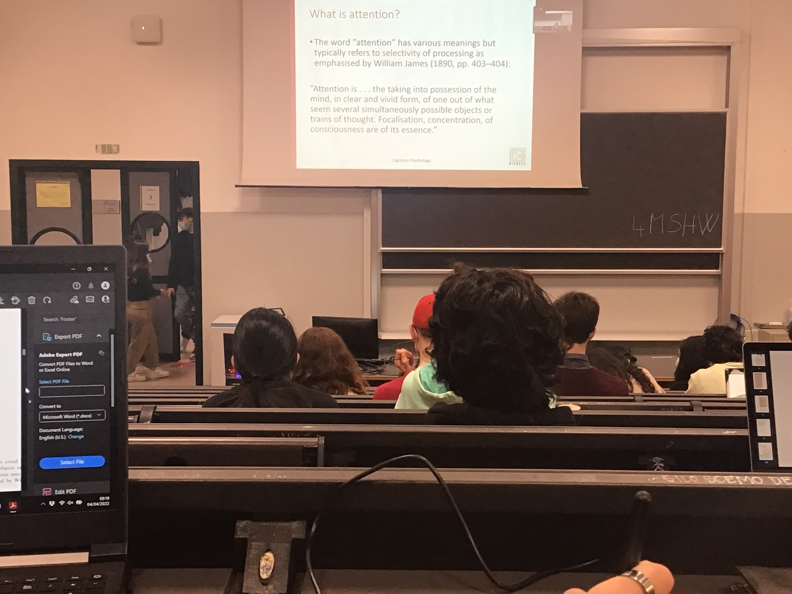

Attention is interpret as a mechanism of the brain that select some type of information present in the environment

This aspect of attention was already underlined at the end of 1800

There are some important distinction

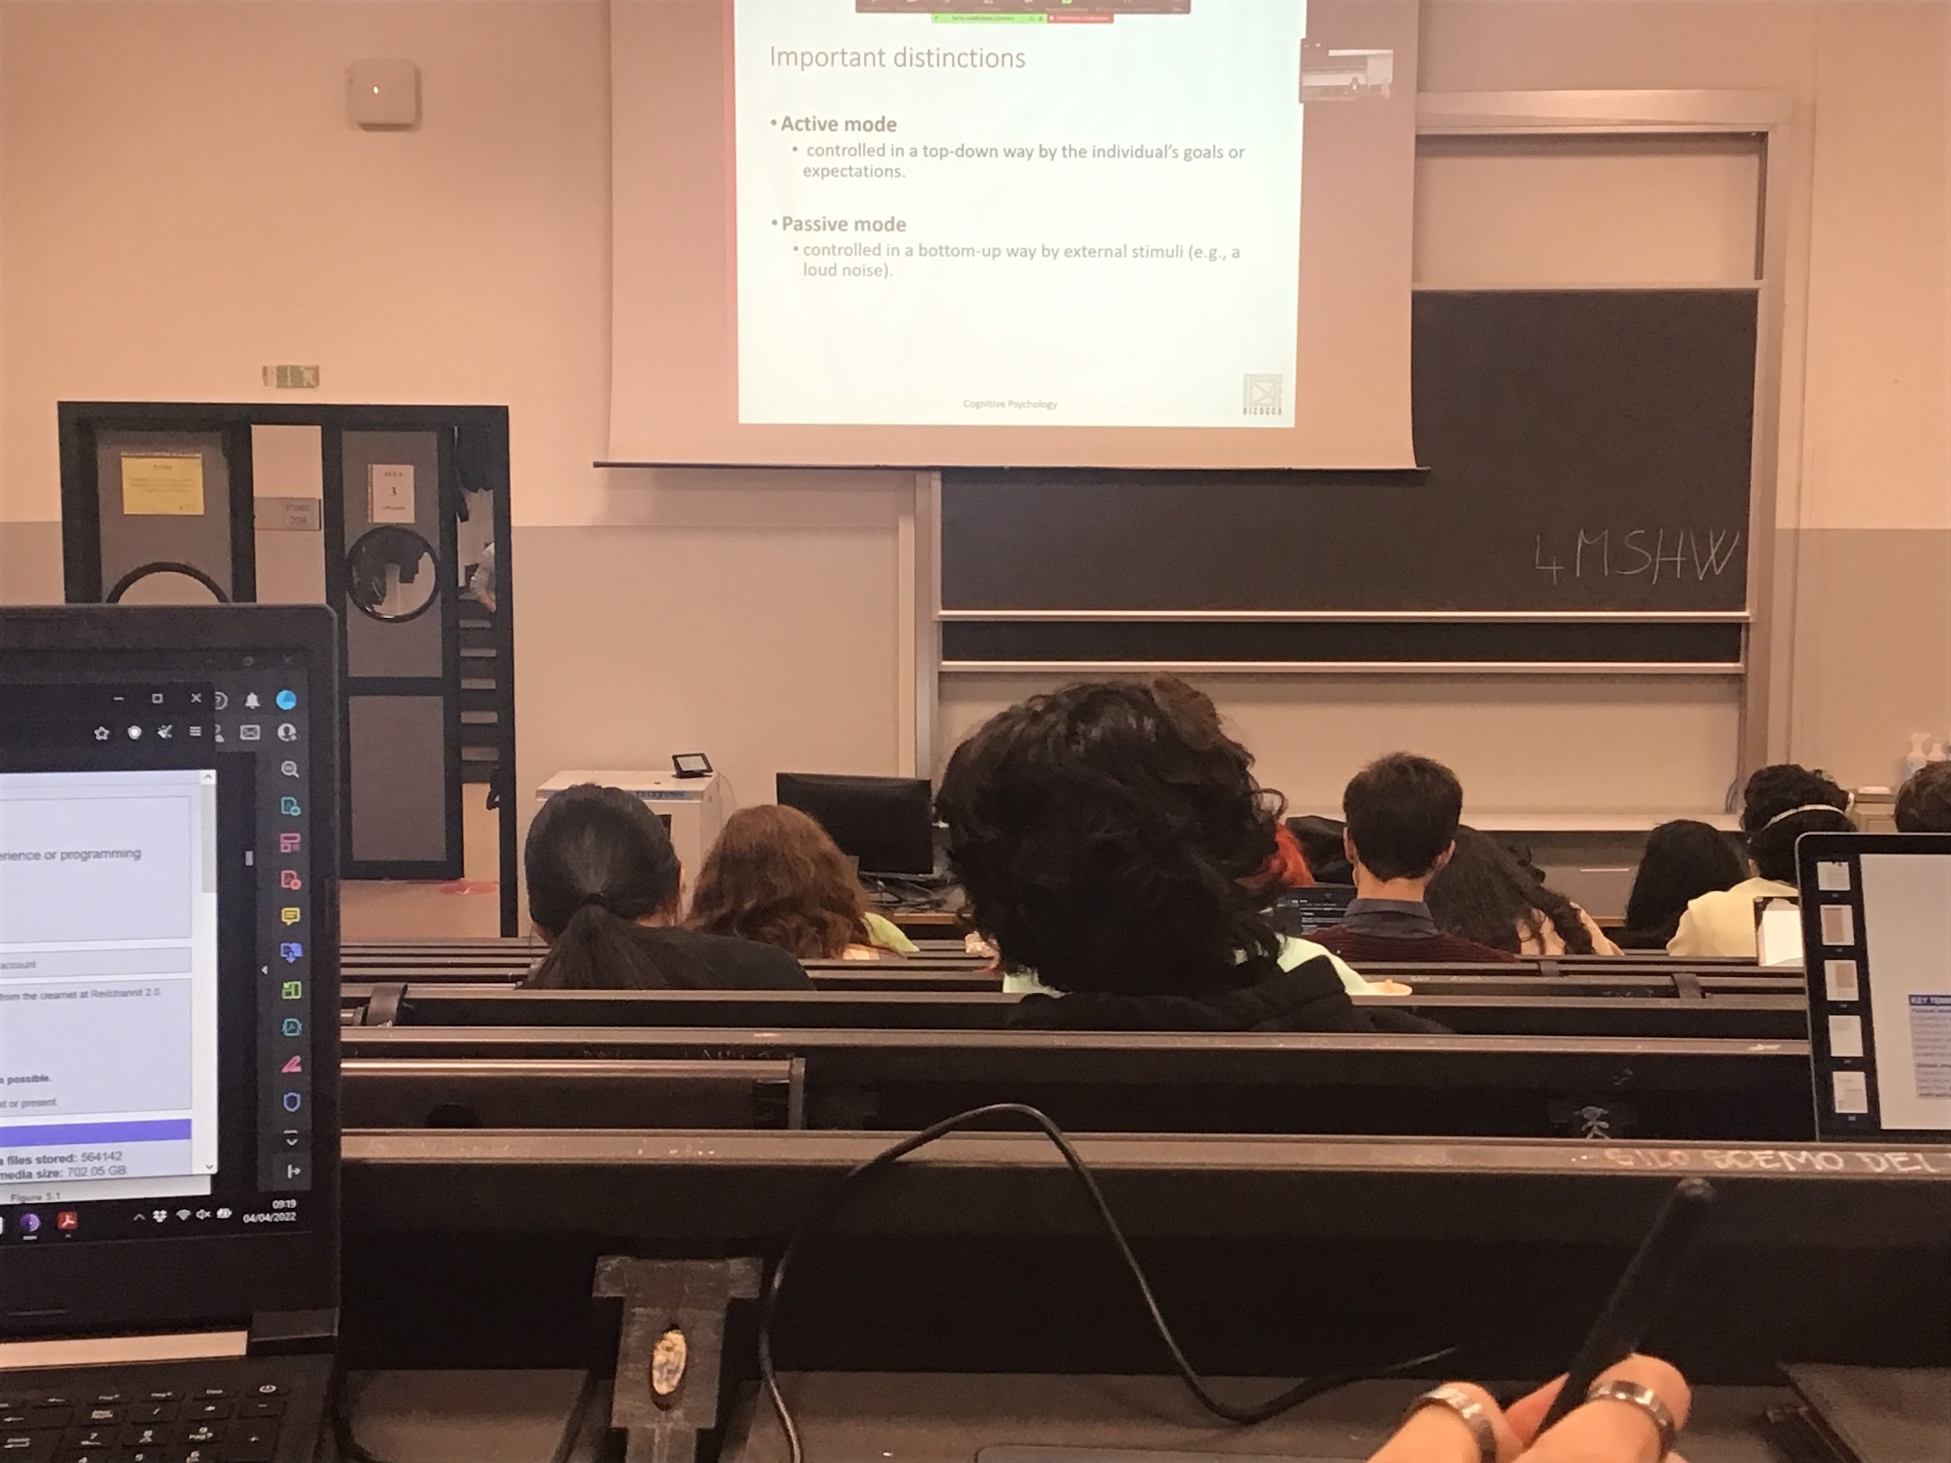

Active and passive mode

* **active mode**: the person decides where he what’s to attend to. Conscious decision, depends on your goals and expectations
* **passive mode**: attention is attracted automatically by the environment around, ear a loud noise, see a strange movement… direct your gaze to that position

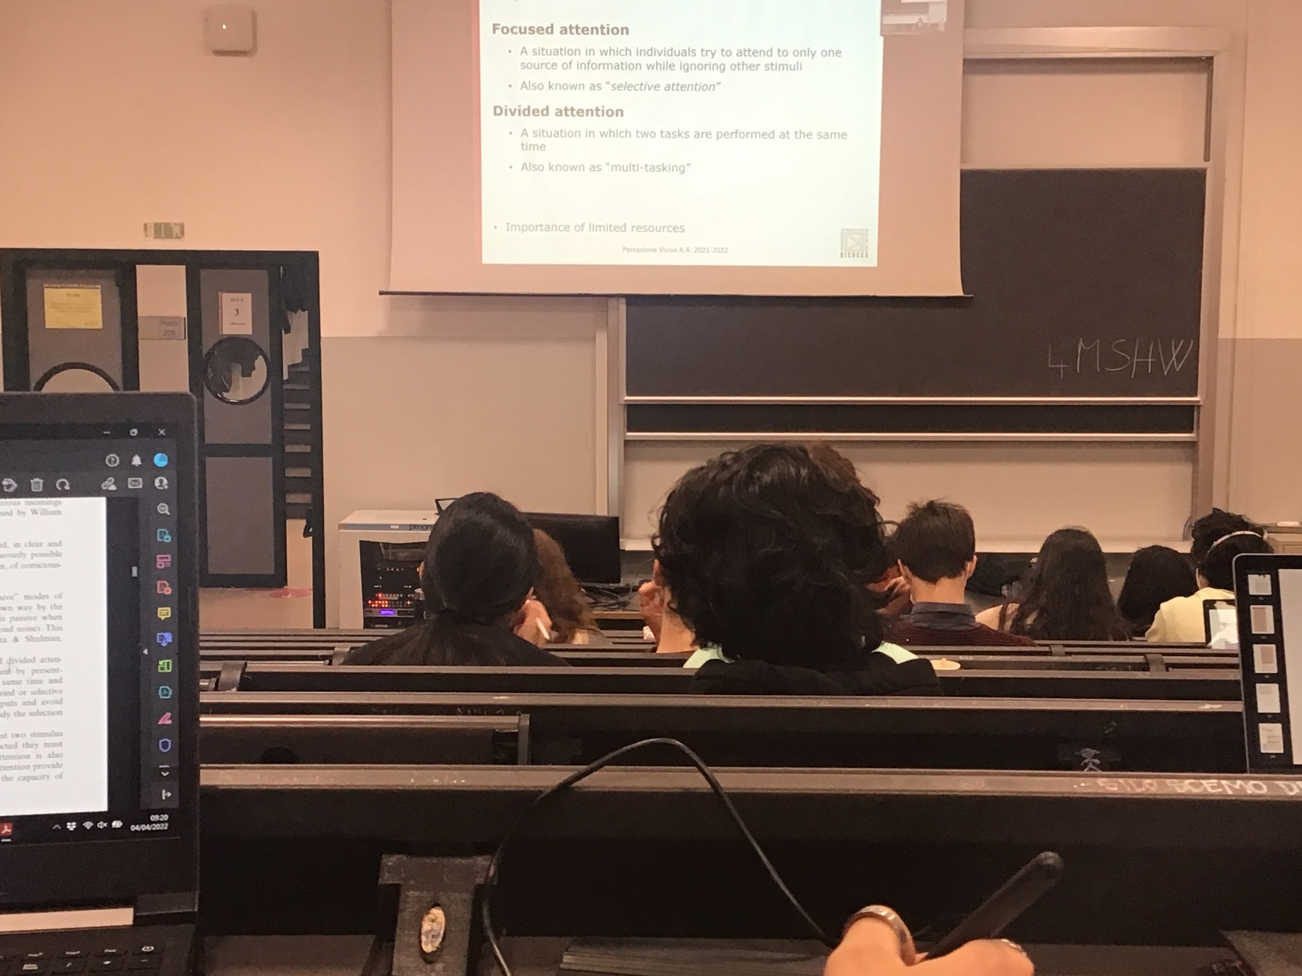

Another distinction:

* **Divided attention**: ability to do multiple things at the same time, multitasking
* **Focused attention**: concentration of all our resources in one specific part of the scene (or internal attention on one specific thought)

The brain even if it has a huge computation power does not have enough power to code and create representation of everything at every single moment, we have to choose on what to work on, the limited resources are optimally uses if you concentrate them on what you care about in this moment

Coding the colour of the room does not matter if I want to decided if a person changed his haircut

There are many things that we can do at the same time with the image in front of me but the brain have to choose what to work on in a given moment

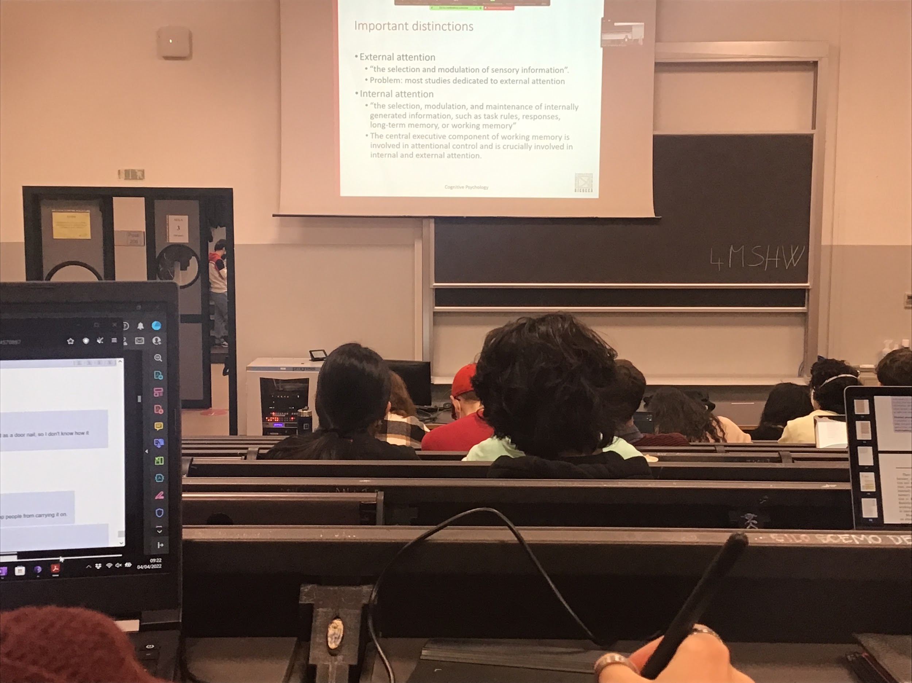

* **external attention**: paying attention to some kind of part of the environment, other people, sound…
* **Internal attention**: paying attention to some thoughts or our feeling and emotions

Most research has been done in external attention

Vision most studies human sense, because is the one we dedicate most resources to

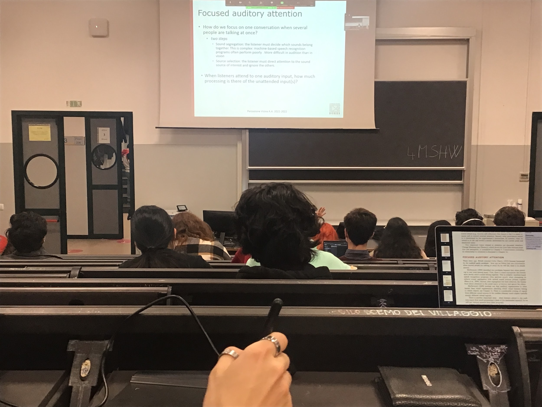

Auditory attention first attento studies

Huge difference between sound and vision:

* **sound** that arrives in our ears is a **overlapping mixture of all the sounds** created by the different objects in our environment.
* If there are two peoples in front of me I have **two difference areas of the visual system** that are stimulated I can segregate them partially

The sound of two people talking to me the sound that arrives is a complex overlap, is a speech sound (and background) that contains all the informations

If you are talking while others people are talking there is a continuous stream of sound waves that contains overlapping situation

**Sound segregation**: This complex sound wave has to be decoded and **different streams should be isolated**. This task can be do under some conditions relatively easily is very difficult for artificial intelligence

Once we have segregated the different streams we have to decide which to attend to. I have to discriminate the different speech streams and **select the one that I am interested in**

In some cases vision can help us, we can read the lips

Attention: how do we select and what happen both to the relevant and unattended stimuli

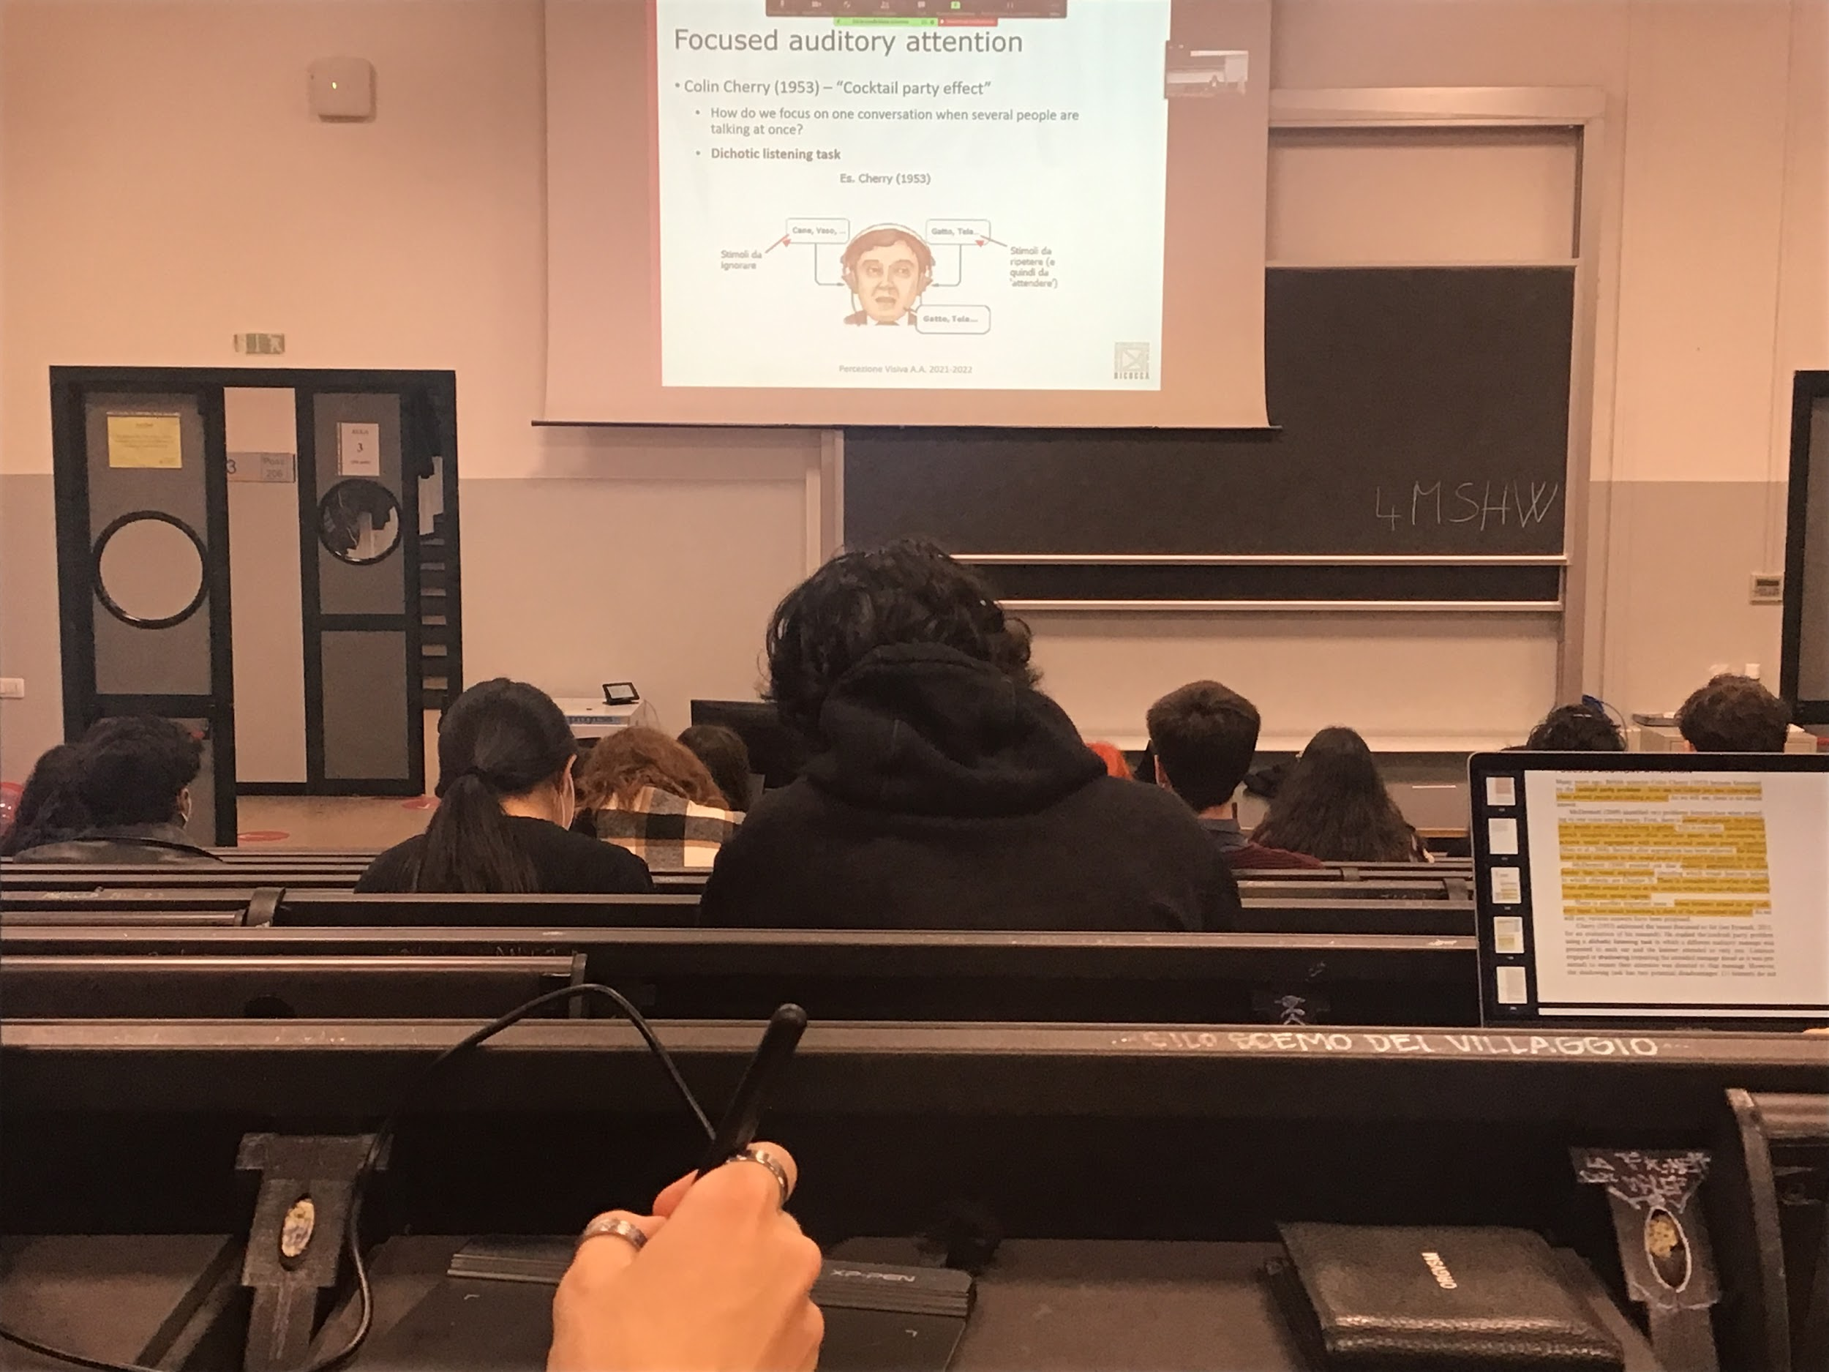

Cherry introduce the concept of focused auditory attention

**Cherry Experiment**:

When I am presenting to a person two speech streams overlapped and they are presented in the two ears at the same time the ability of the listen to decoded the two streams is difficult

**Dichotic listening task**: the two streams are presented **separately**. Different words in two streams, ask to repeat the words ear in the left ear

This task is called shadowing, shadow one of the two channels

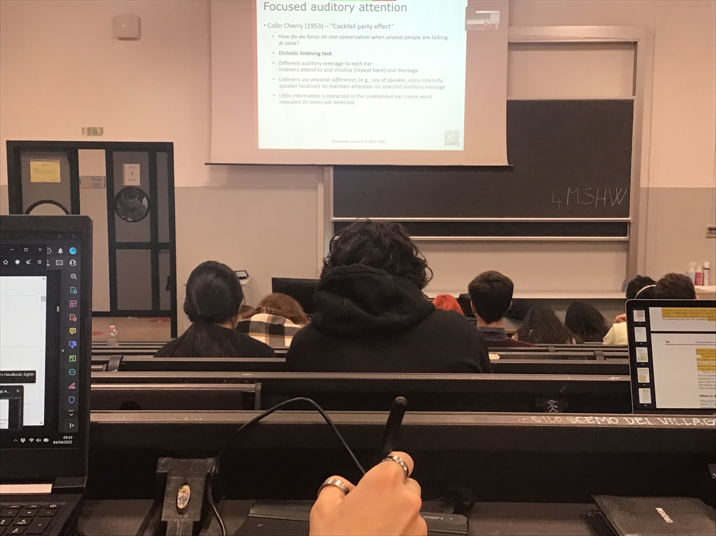

He show that listeners uses physical difference to discriminate between the two streams, for them is **relatively easy to discriminate when there is a physical difference** (one ear or another ear) another difference might be a male and a female voice you can discriminate them easily, also if one is loud and the other is not

There are some physical characteristic of the soundwave that helps you discriminate the two streams

If the two voices are of the same person can be more complicated

If there is a physical difference we can discriminate, we can process and relaborate the information coming in the ear

The other ear, **practically in the other ear there is no elaboration**, in the experiment on the left people have two shadows on the right the voice was repeating the same word multiple times, at the end, after the person shadow the words on the left he didn’t know what was in the other ear

Even the repetition of the same word people don’t know if asked what ear in the other ear

Attention can select if there a physical difference, and the relevant message is process and coded, the irrelevant message is blocked, **no elaboration in the brain about what happen in the other ear**, as if I stop at the beginning and the information is not processed

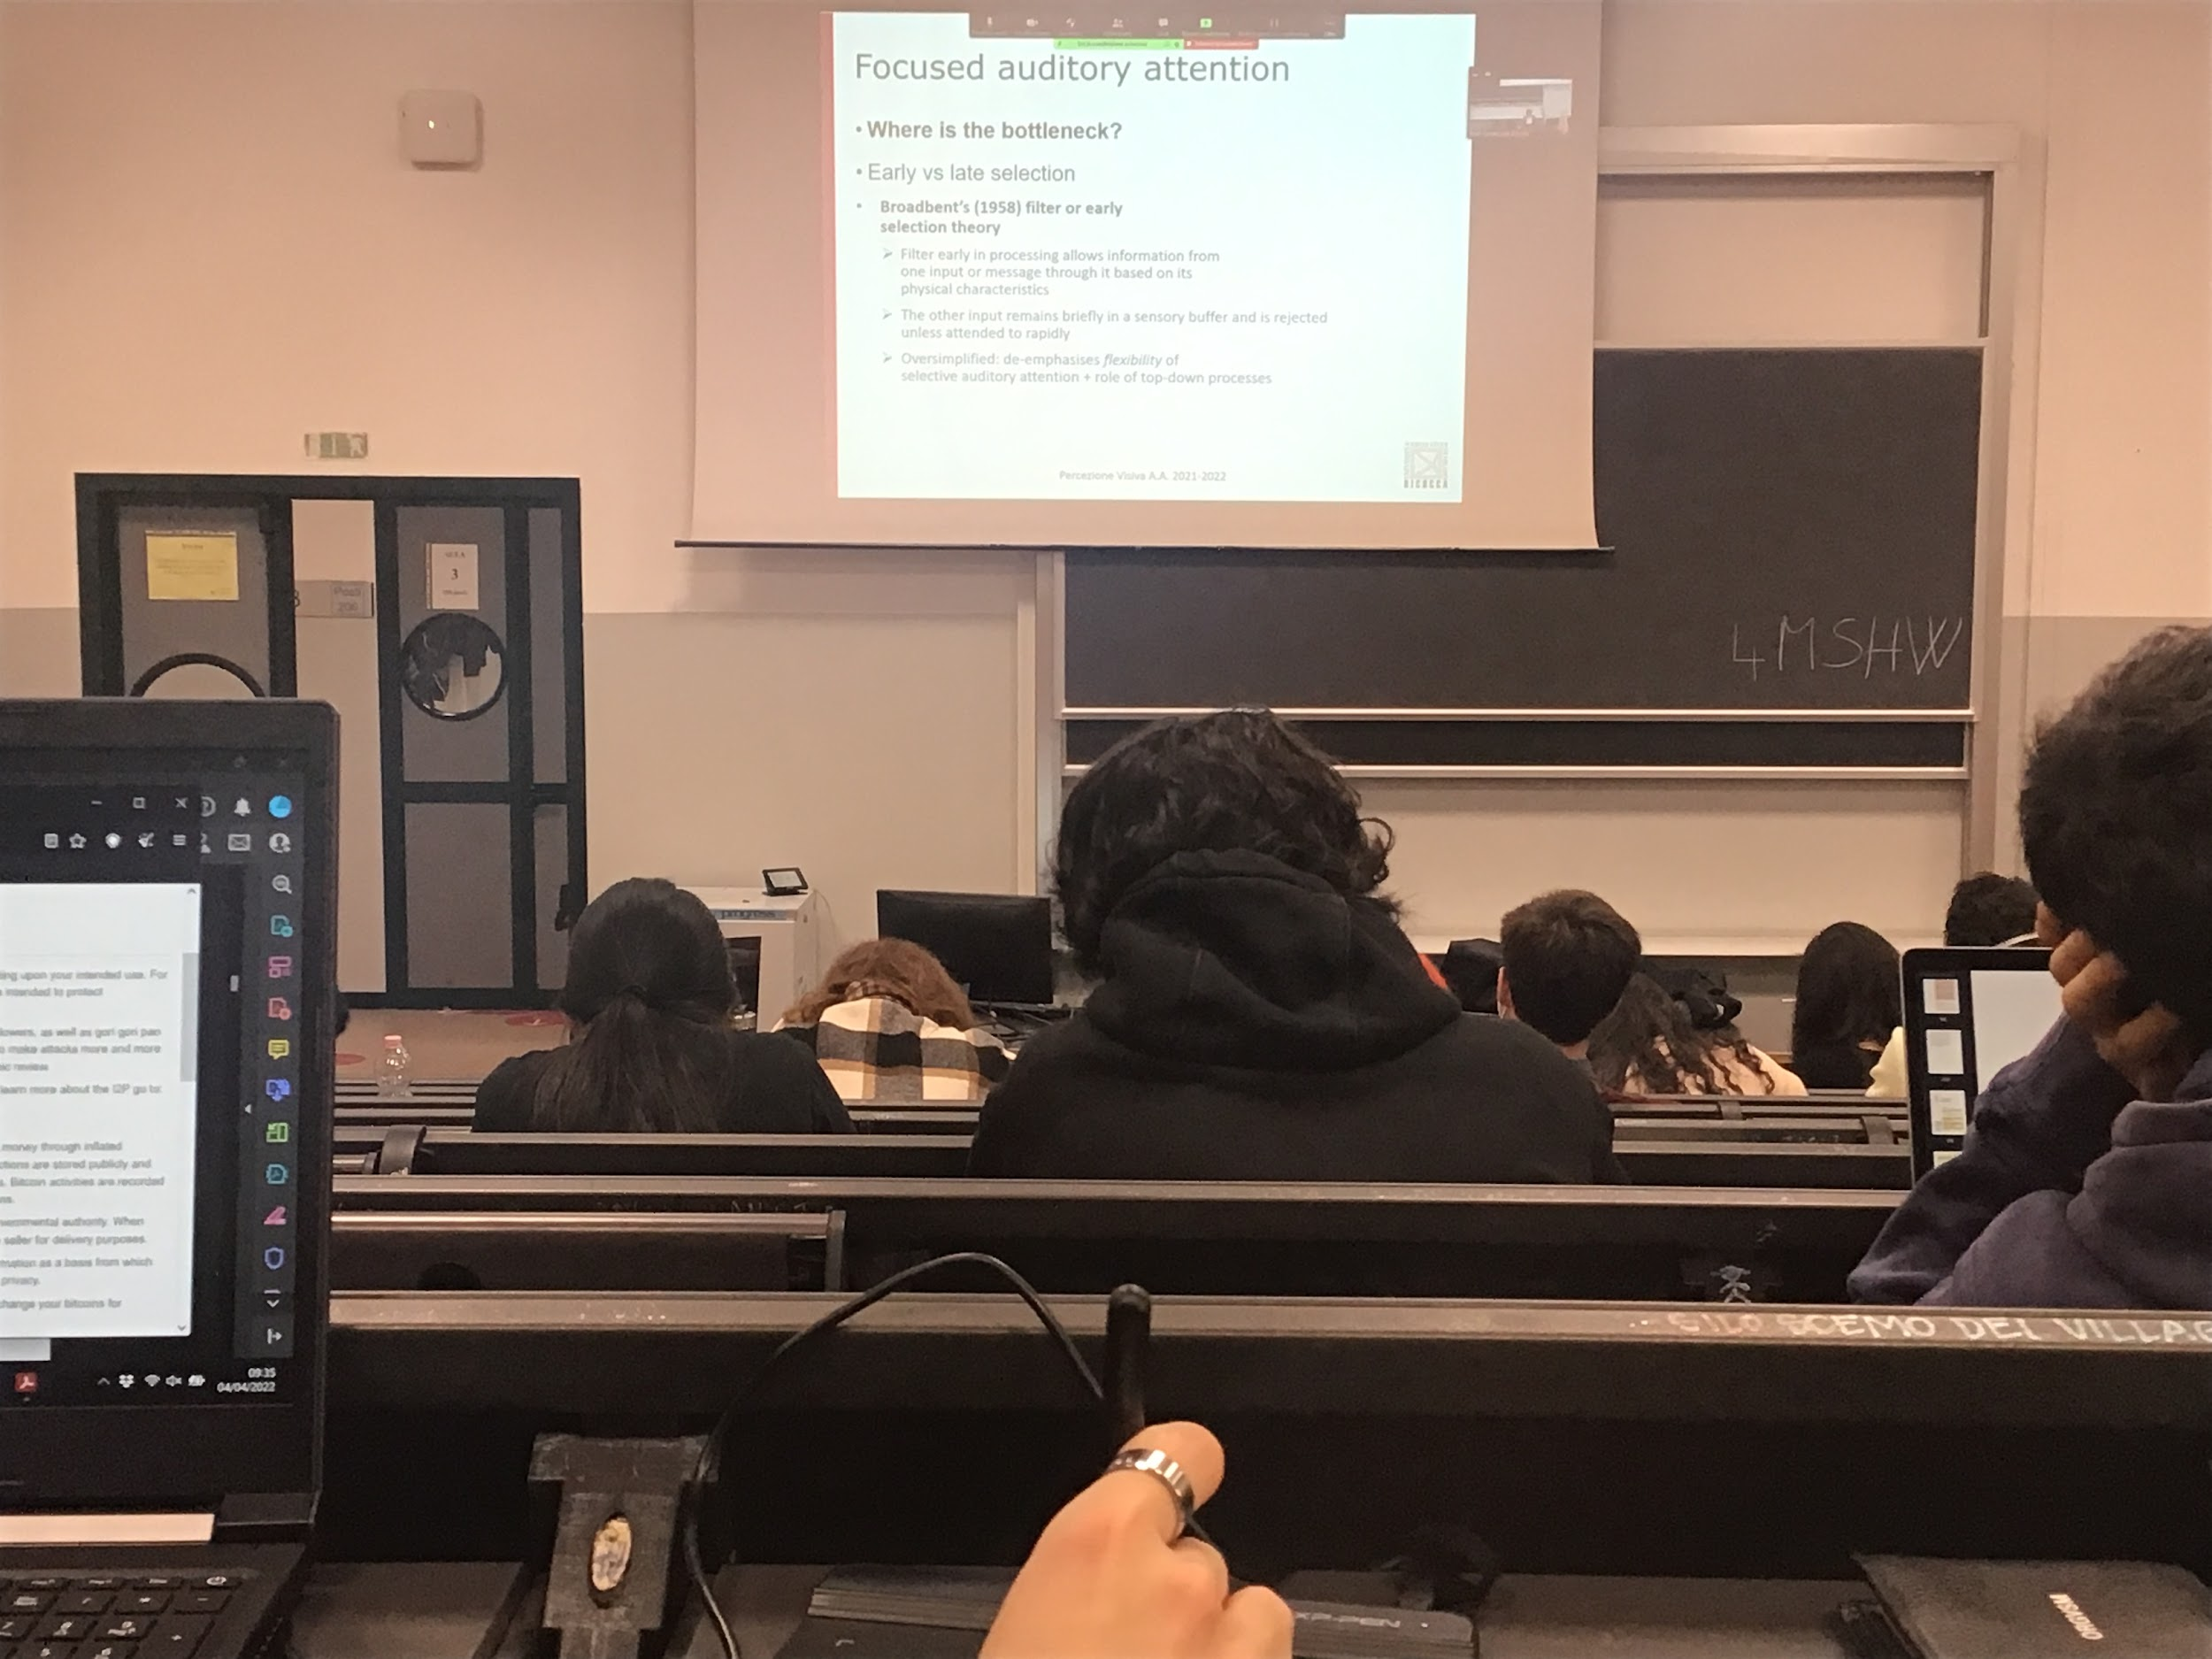

There is a bottleneck: **attention selects as if it has to go through a small passage**, what passage through is processed up to the end and influences your behaviour, the rest is not elaborate or processed.

Question: where is the bottleneck? Is it at the beginning? Late selection?

**Cherry idea**: the other information is not processes at all, don’t know anything about the other stream

**Broadbent early selection theory**: is a filter. You have two streams, there is a block in early at the beginning, attended information is processed through the end and influence perception, **unattended information is not process at all**, it enters the first stage but is no process

After a while find out that if you are in a bar you are talking and you ear your name, you turn around. It means that you have process that information, you didnt’t care what the others people were talking about

No idea of what they were talking about, if they said your name, it means that what was in my unattended stream was actually coded

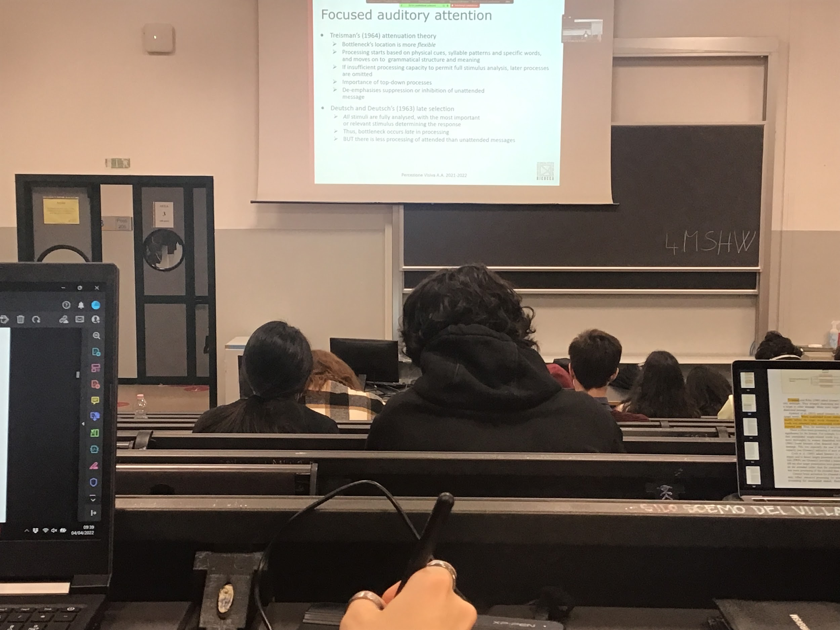

**Treisman**: there is an early filter, I do not process everything at the same level, but is it a **flexible filter**, depends on some type of information. The system elabratorates specific words, but if it is not important for me it is not processes anymore

There is some early processing and there is an influence on top-down processes

Every stimulus that come in from any of the two ears have a level of importance, given by the top-down processes

**My name is always important for me**

If I am talking about soccer I ear also the other people next to me if also they are talking about soccer, if instead they are talking about shopping I will not know what they are saying

There is a early elaboration that is done attuanting the information that we don’t care about and let trought informations about the other stream

Treisman theory was a modification of Bormann theory, still a selection, the difference is that **Bormann is a all-or-not filter, instead Treisman filter is flexible**

Triesmann and Deutsch and Deutsch realised that Bormann theory was to drastic

**Deutsch and Deutsch**: both the attended and unattend information is processed, the only thing that happens is when I am to answer I base my answer only from the information coming from the attended stream

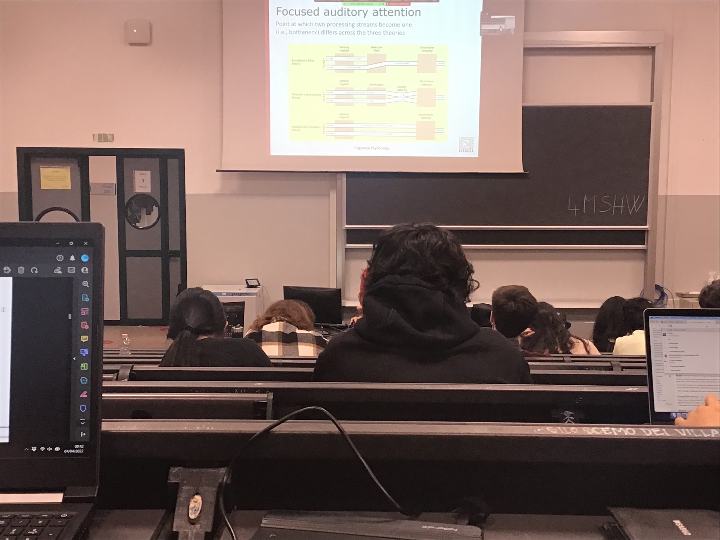

Sensory register: the information arrived and it is coded in the lower level areas, the information arrives from all the stream

What changes is in the successive steps

* **Broadbent**: two streams come in, we select right away after the sensory register, we block the attended ear, passes troughs the filter, and goes to short-term memory, area in which we reason and make decision
* **Treisman**: instead of the selective filter we have an attenuator, the information from the attended ear passes trought, also the information form the other ear but what is considered important pass truth. The information is mixed and then go to short term memory, everything is processes in short term the information is selected
* **Deutsch and Deutsch**: everything is processes and goes to the short time memory and there you reason and select on which of the to streams you will given an answer

Bormann theory: is out of discussion, is incorrect because it is too drastic

The others two are more supported, but don’t have a lot of top-down influences

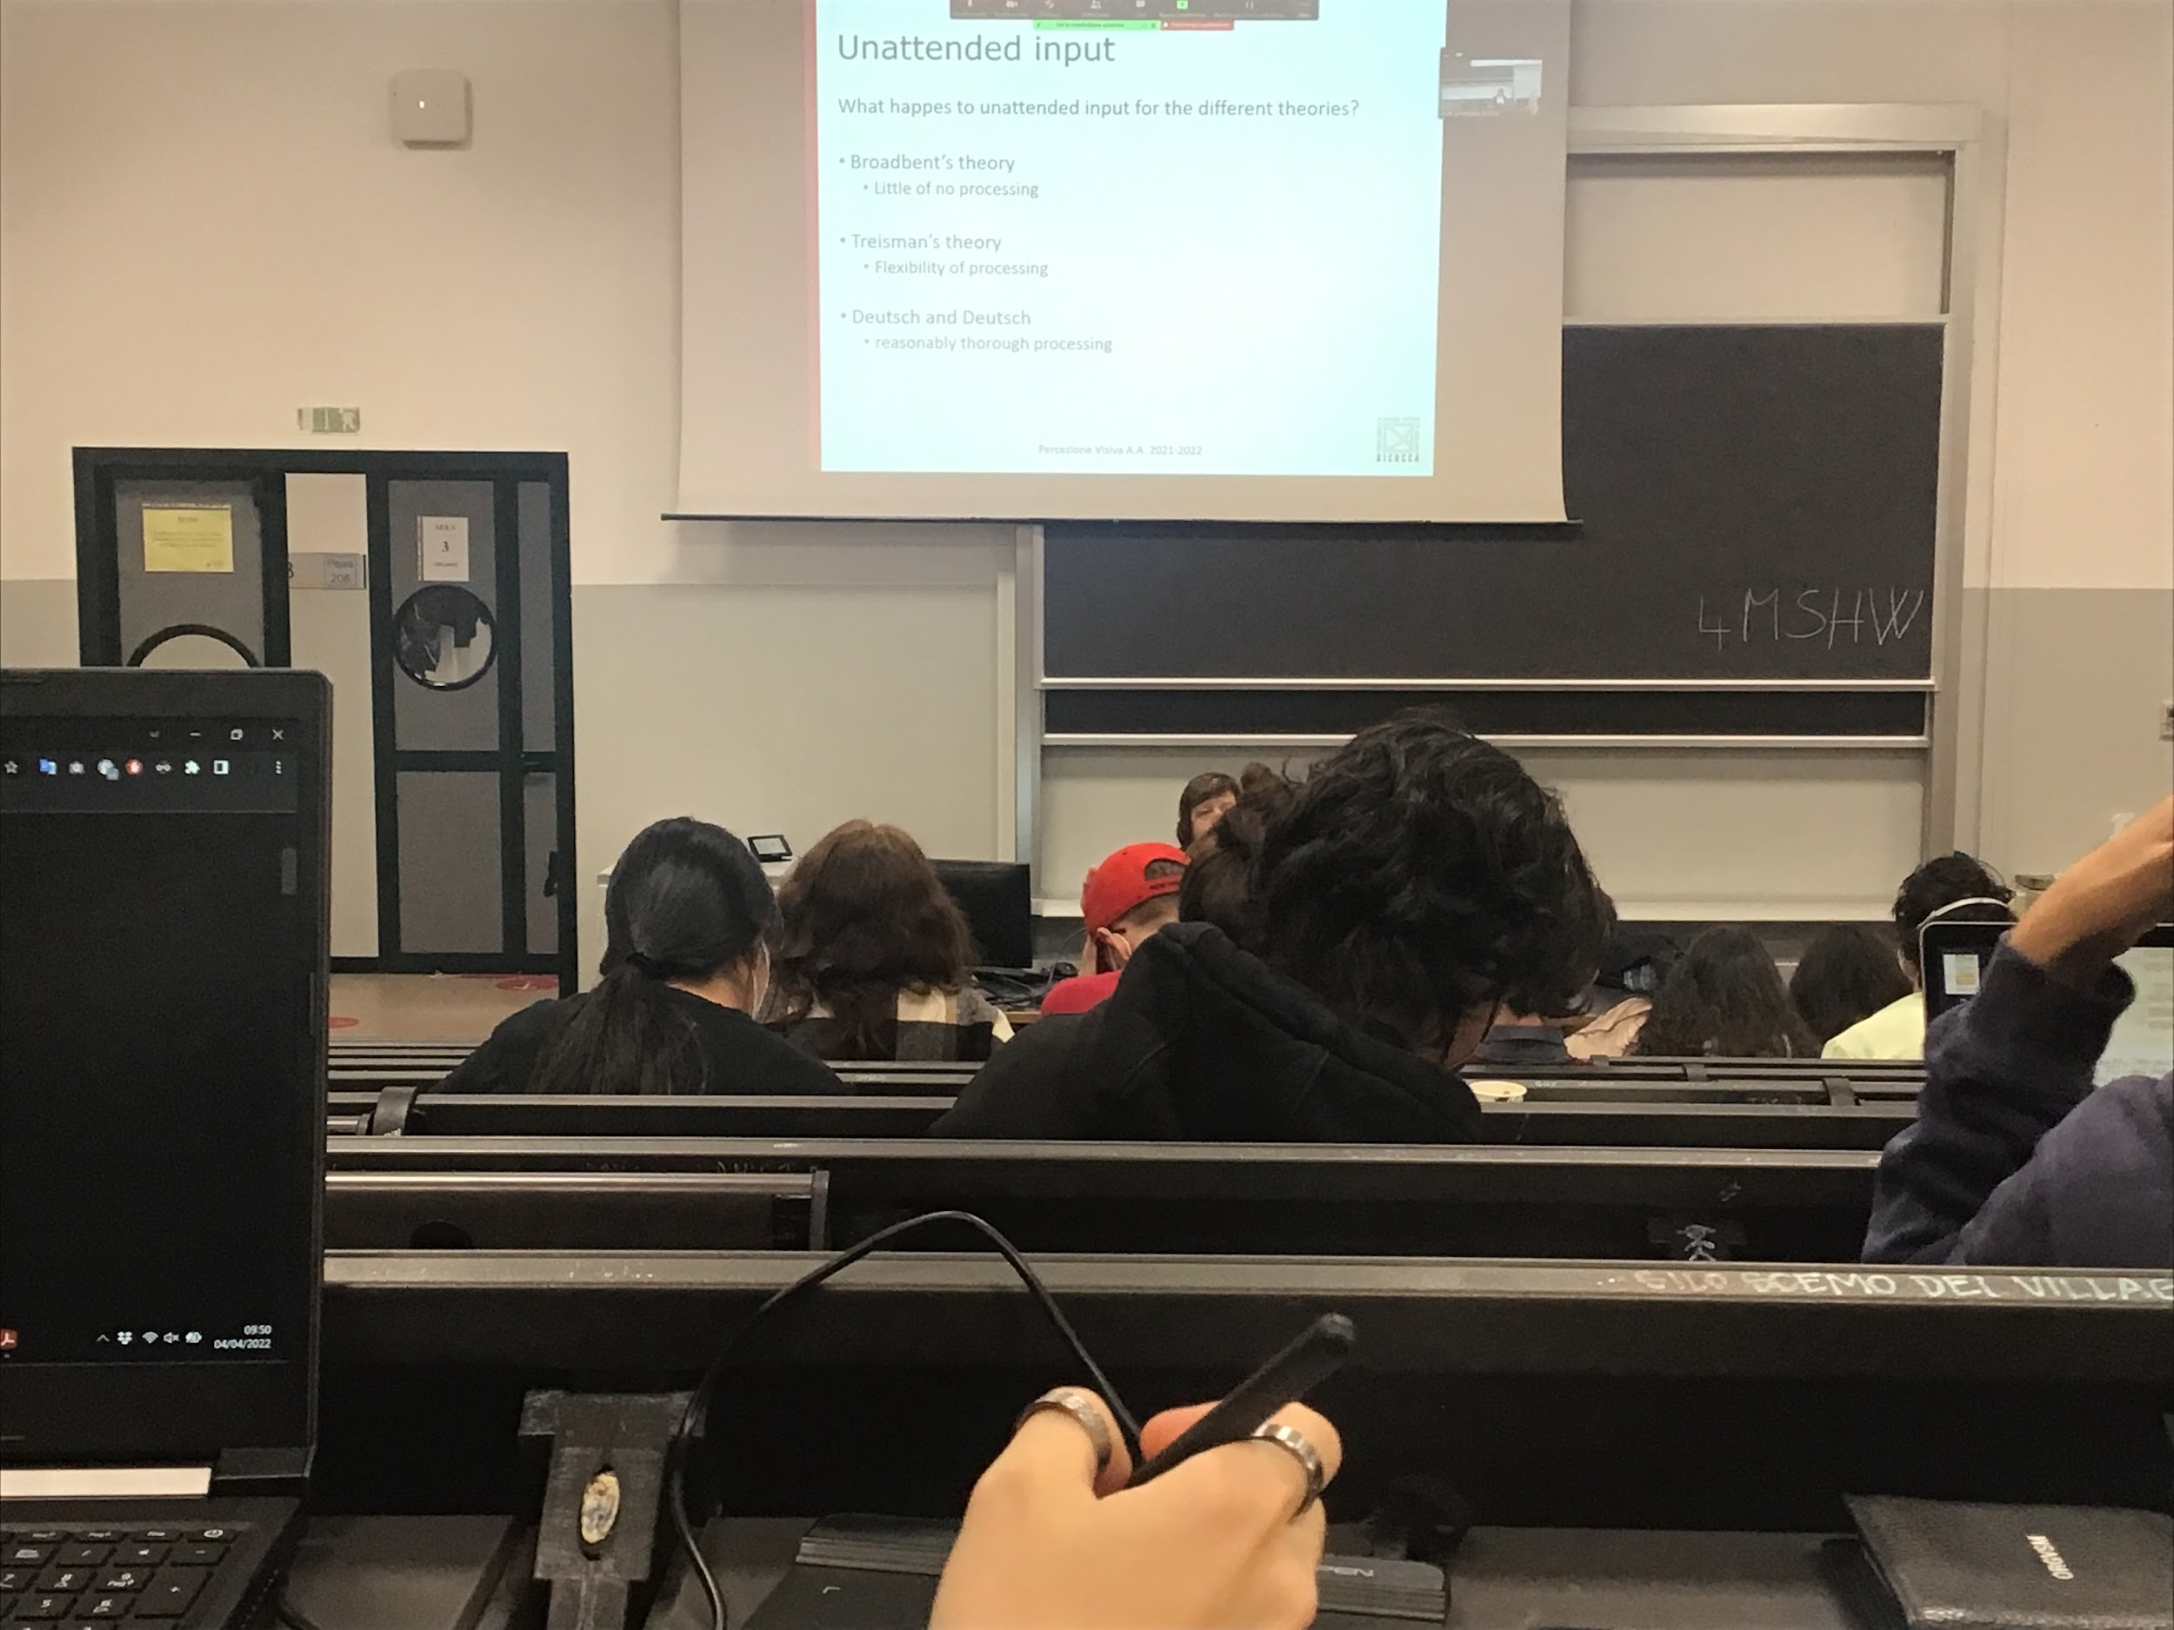

What happens to the unattend input?

* **Broadbent**: little or no processing
* **Treisman**: there is flexibility, depends on what is your task right now, and what is important for you in general
* **Deutsch and Deutsch**: almost complete processing of the information

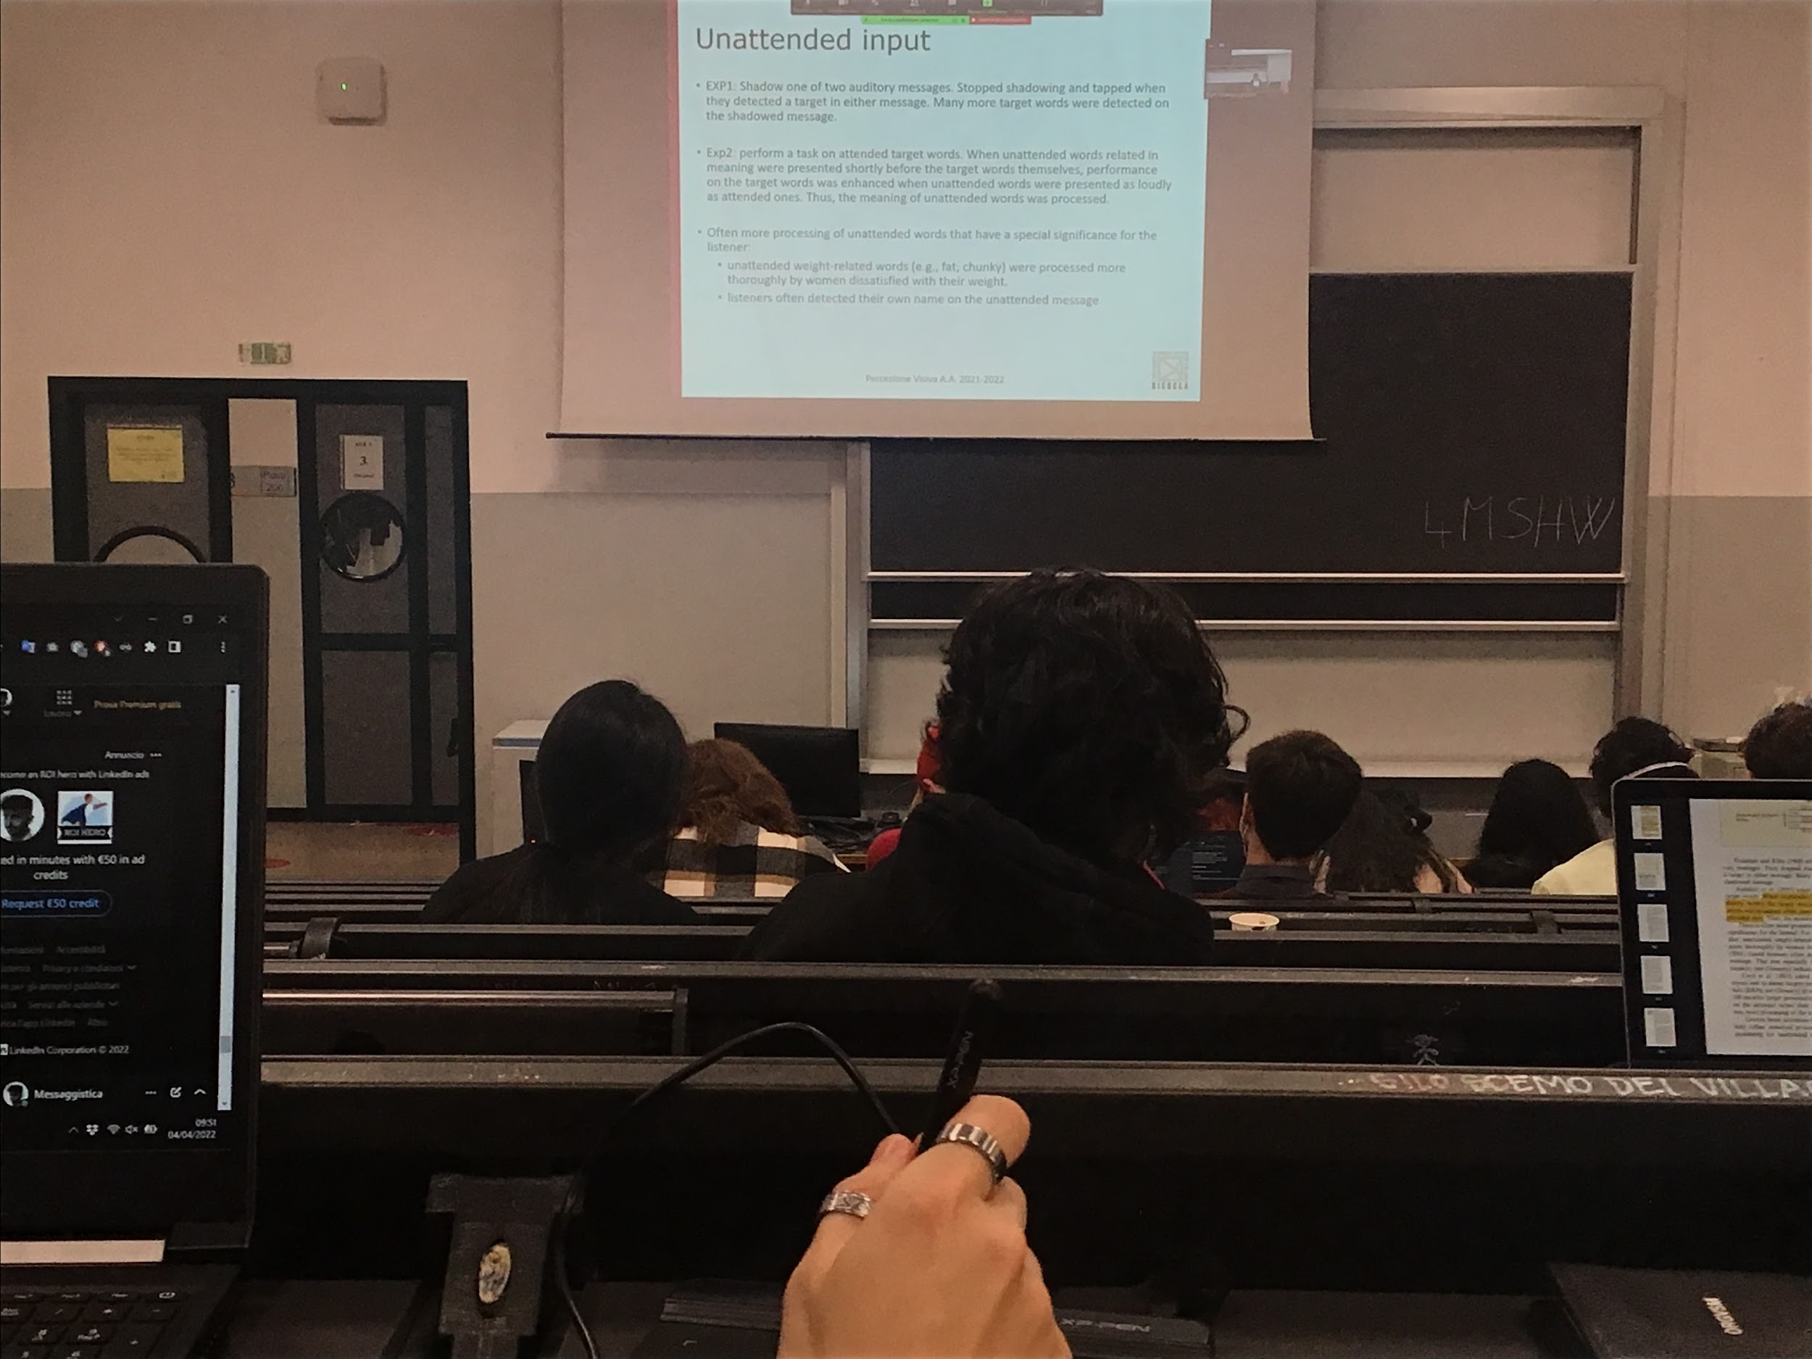

**Treisman experiment**:

Two different audivory message, and need to shadow the other one, and have to look for a specific word and when they ear it they have to press a bottom and stop shouting

What was shown: more target where detectect in the shadowed message, but they still found some targets in the other message.

There is a preferential processeing on the shadow message but still process in the other, this is against Broadbent theory: he would have excluded the fact that people would report this word in the other message

Ex2: report some words, find a specific word, even in the unattended stream there are words that are related to the one that we have to detect we change our performance

**The meaning of the unattended word influence your performance in the attend stream**

If you ear two streams, you have to report a word in the left ear but there are word similar in the right ear, that changes how good you respond. The data show that **unattend input is elaborated**

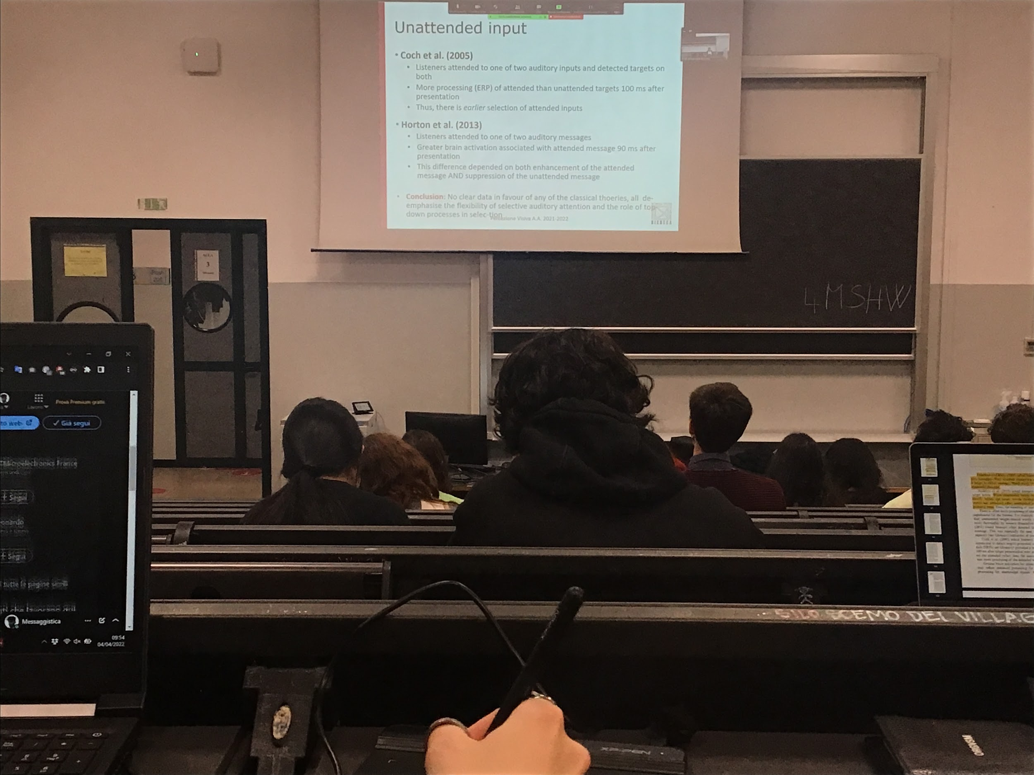

**Coch** asked people to listen to two inputs and to detect targets in both input but they have two shadows one of the two. One attend stream and one unattend stream. Shows that there is more activity on the target of the attended stream, there is some kind of early selection

Idea supported also by another experiment: if you attend one of the two stream there is larger attivation in the attend message earlier

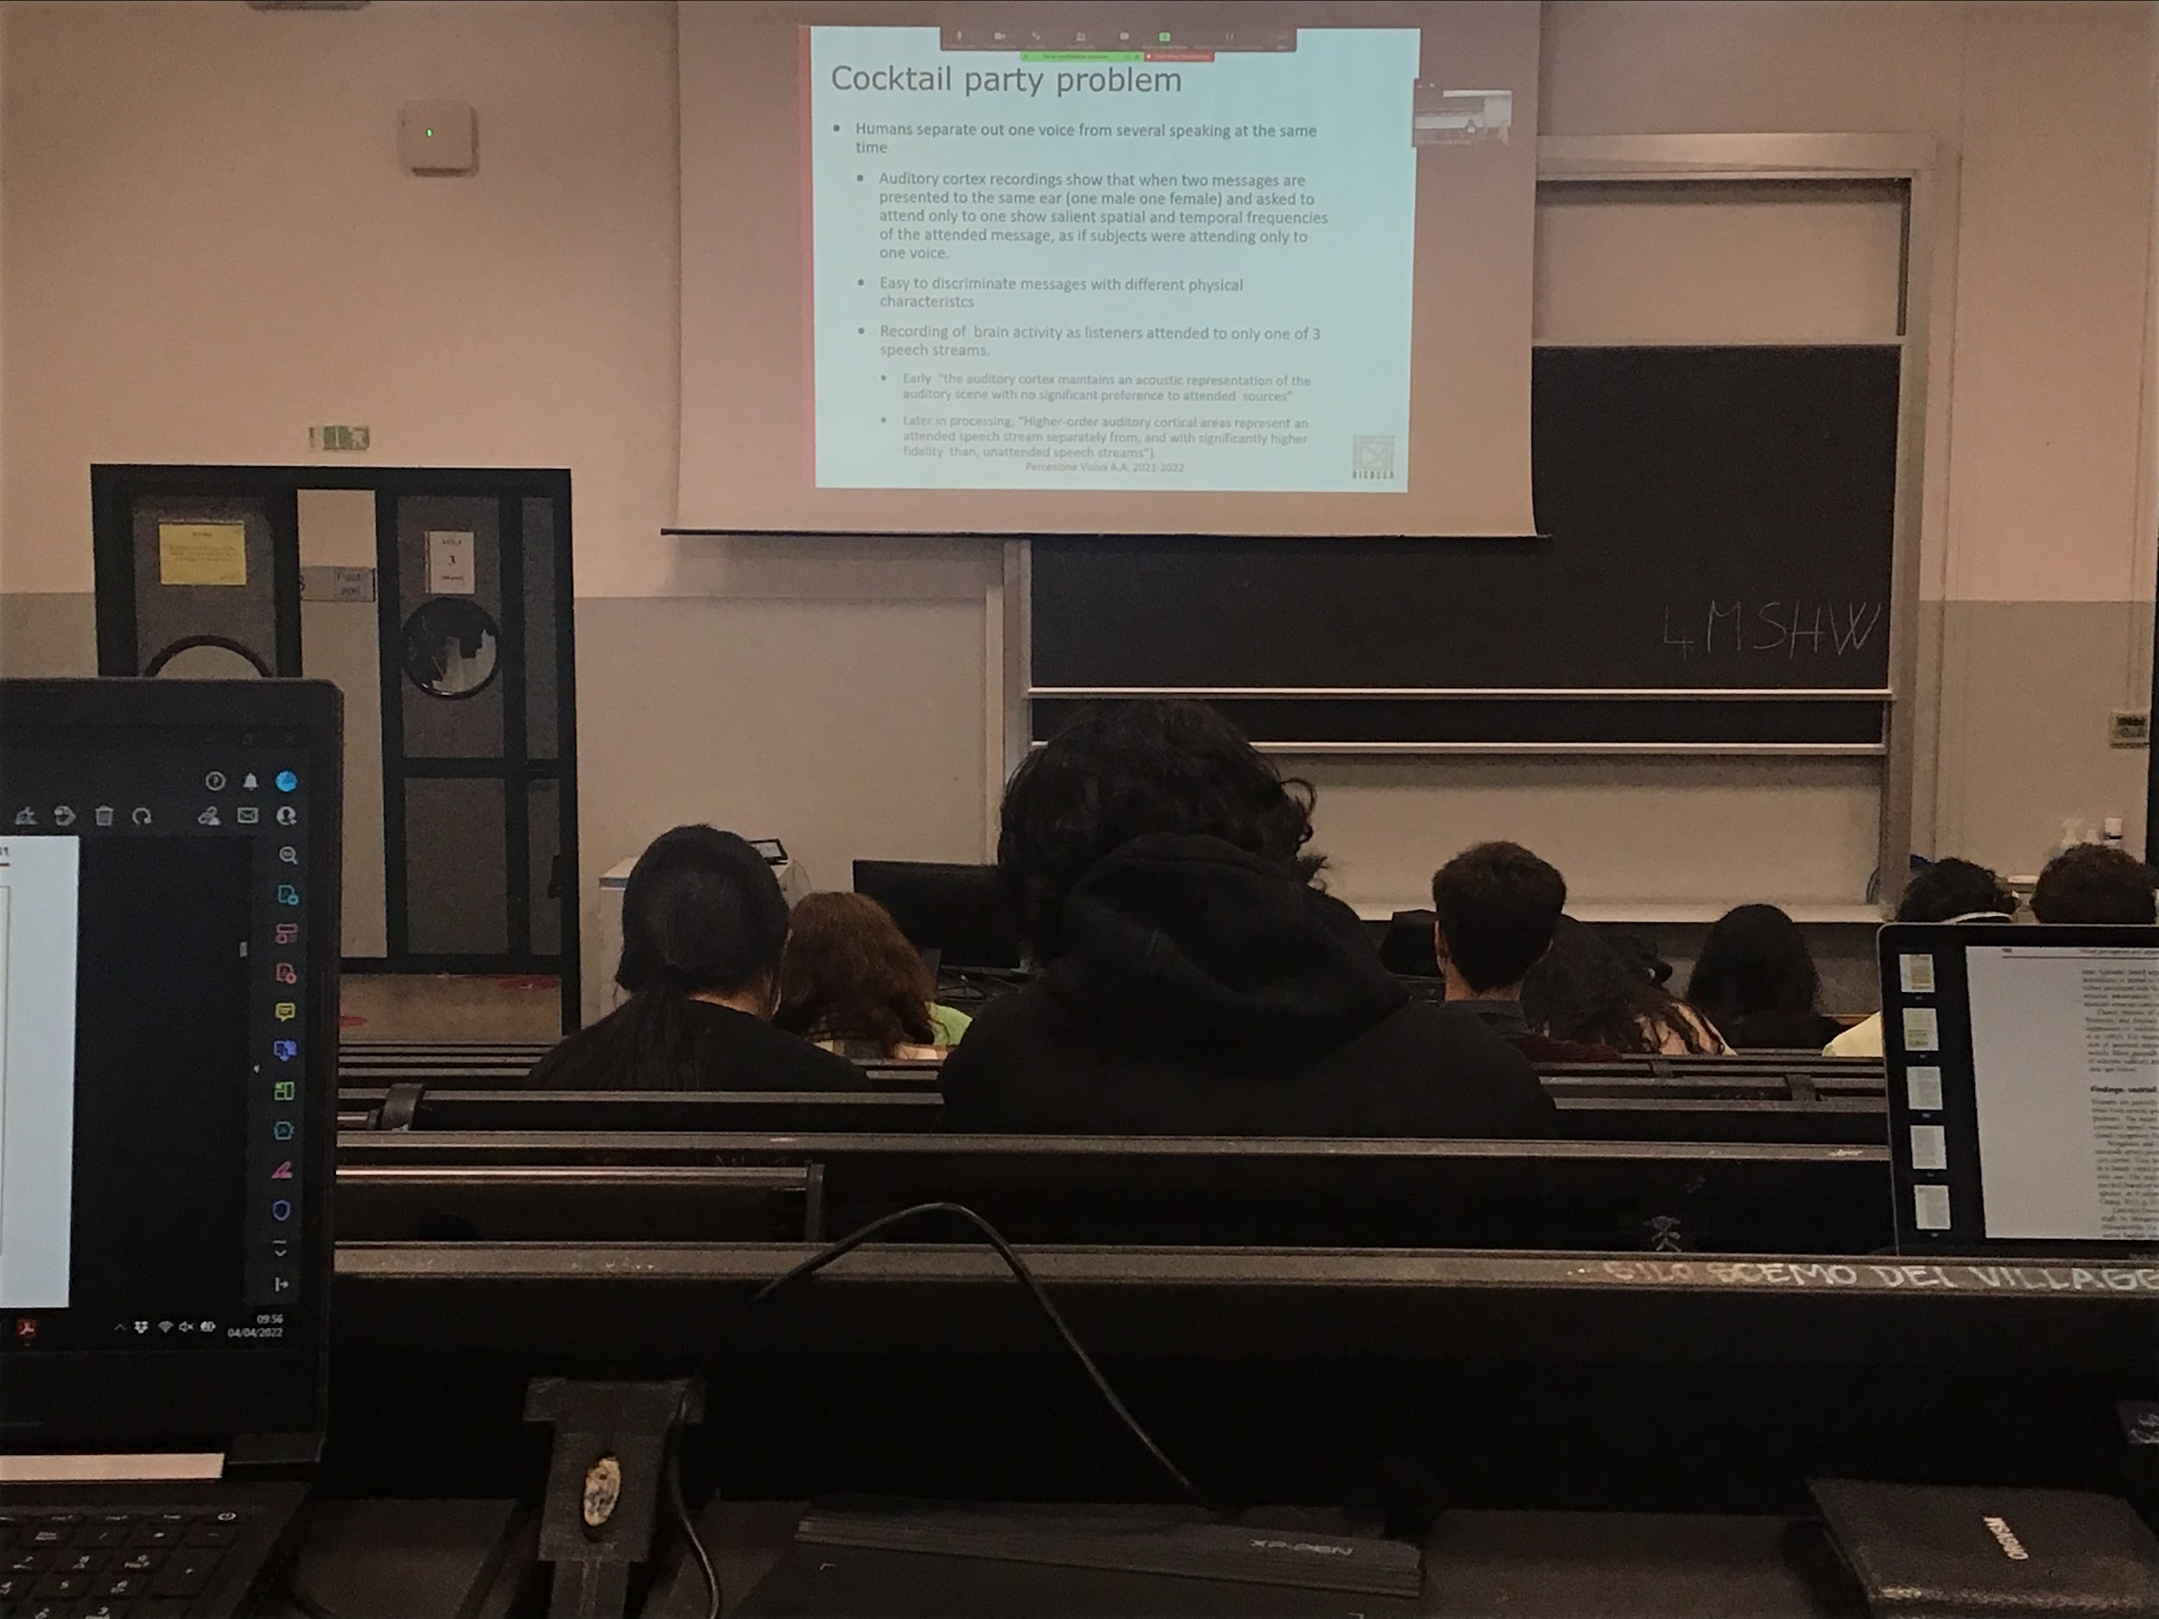

Cocktail party: How good are we at selecting?

**We can definitely select**, usually we are in a situation where more than one person is speaking

We can show this ability to select one of the two voices, we can discriminate physically between two voices.

The activity reflects one of the two voices, we are able to select

The see that at the very early inauditory cortex there is no selection, everything is coded but in the next passage the stream is selected and you elaborate only one information

There is a lot of data that shows that we are able to select and we put most of our resources in the attend message

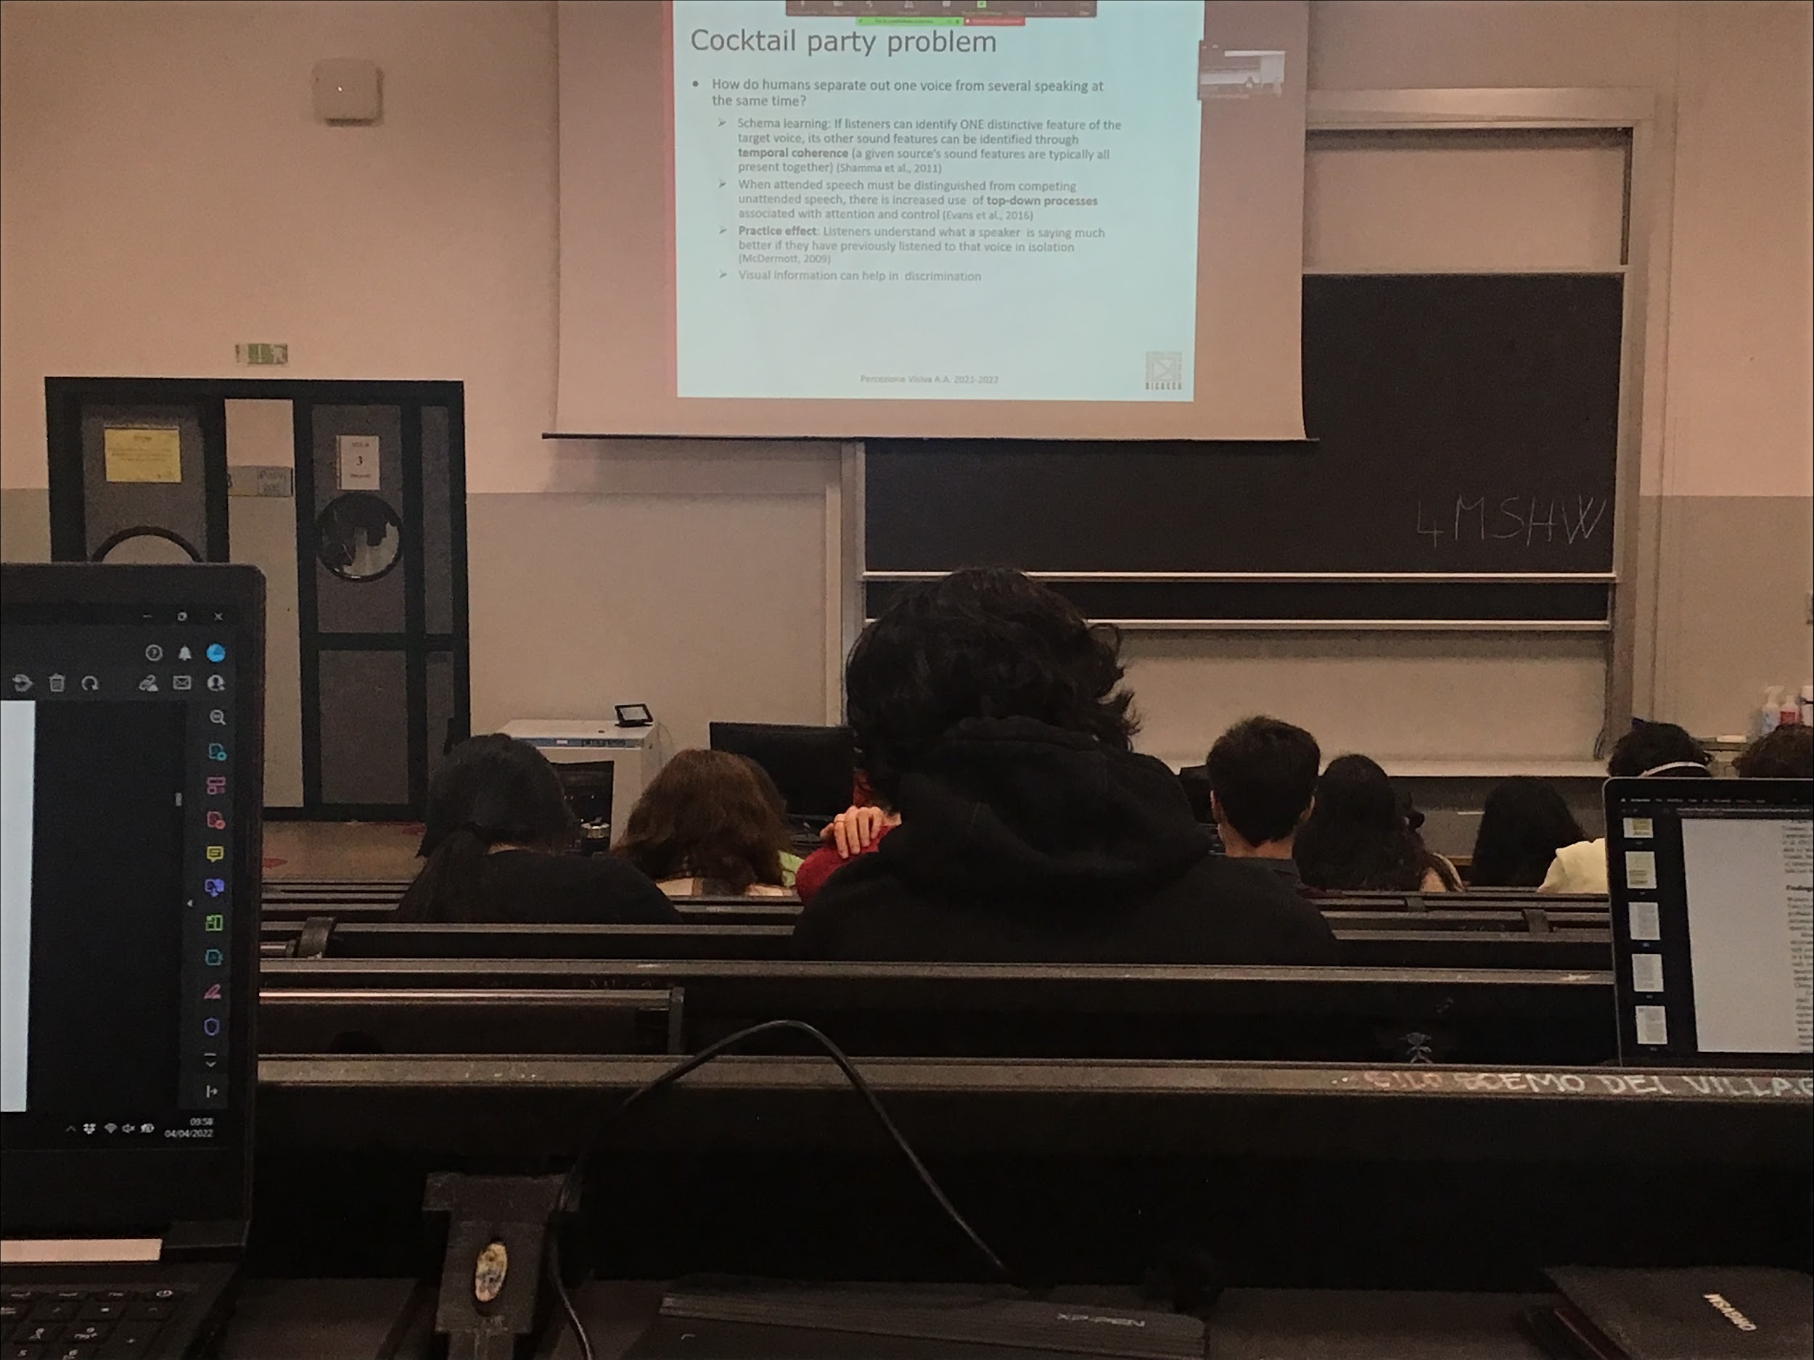

Focusing on temporal coherence: the human voices have different physical characteristics that distinguish one voice from the other, we use multiple representation, if I can find one feature that discriminate the two voices that using that specific feature as a fixed point I can find everything that changes in synchroning with that

This ability to discriminate voices is shown also by the practice effect. Once you have listen to a voice in isolation you brain creates a schema that represents the different characteristic of that voice and then we can ear that voices in multiples audio much better

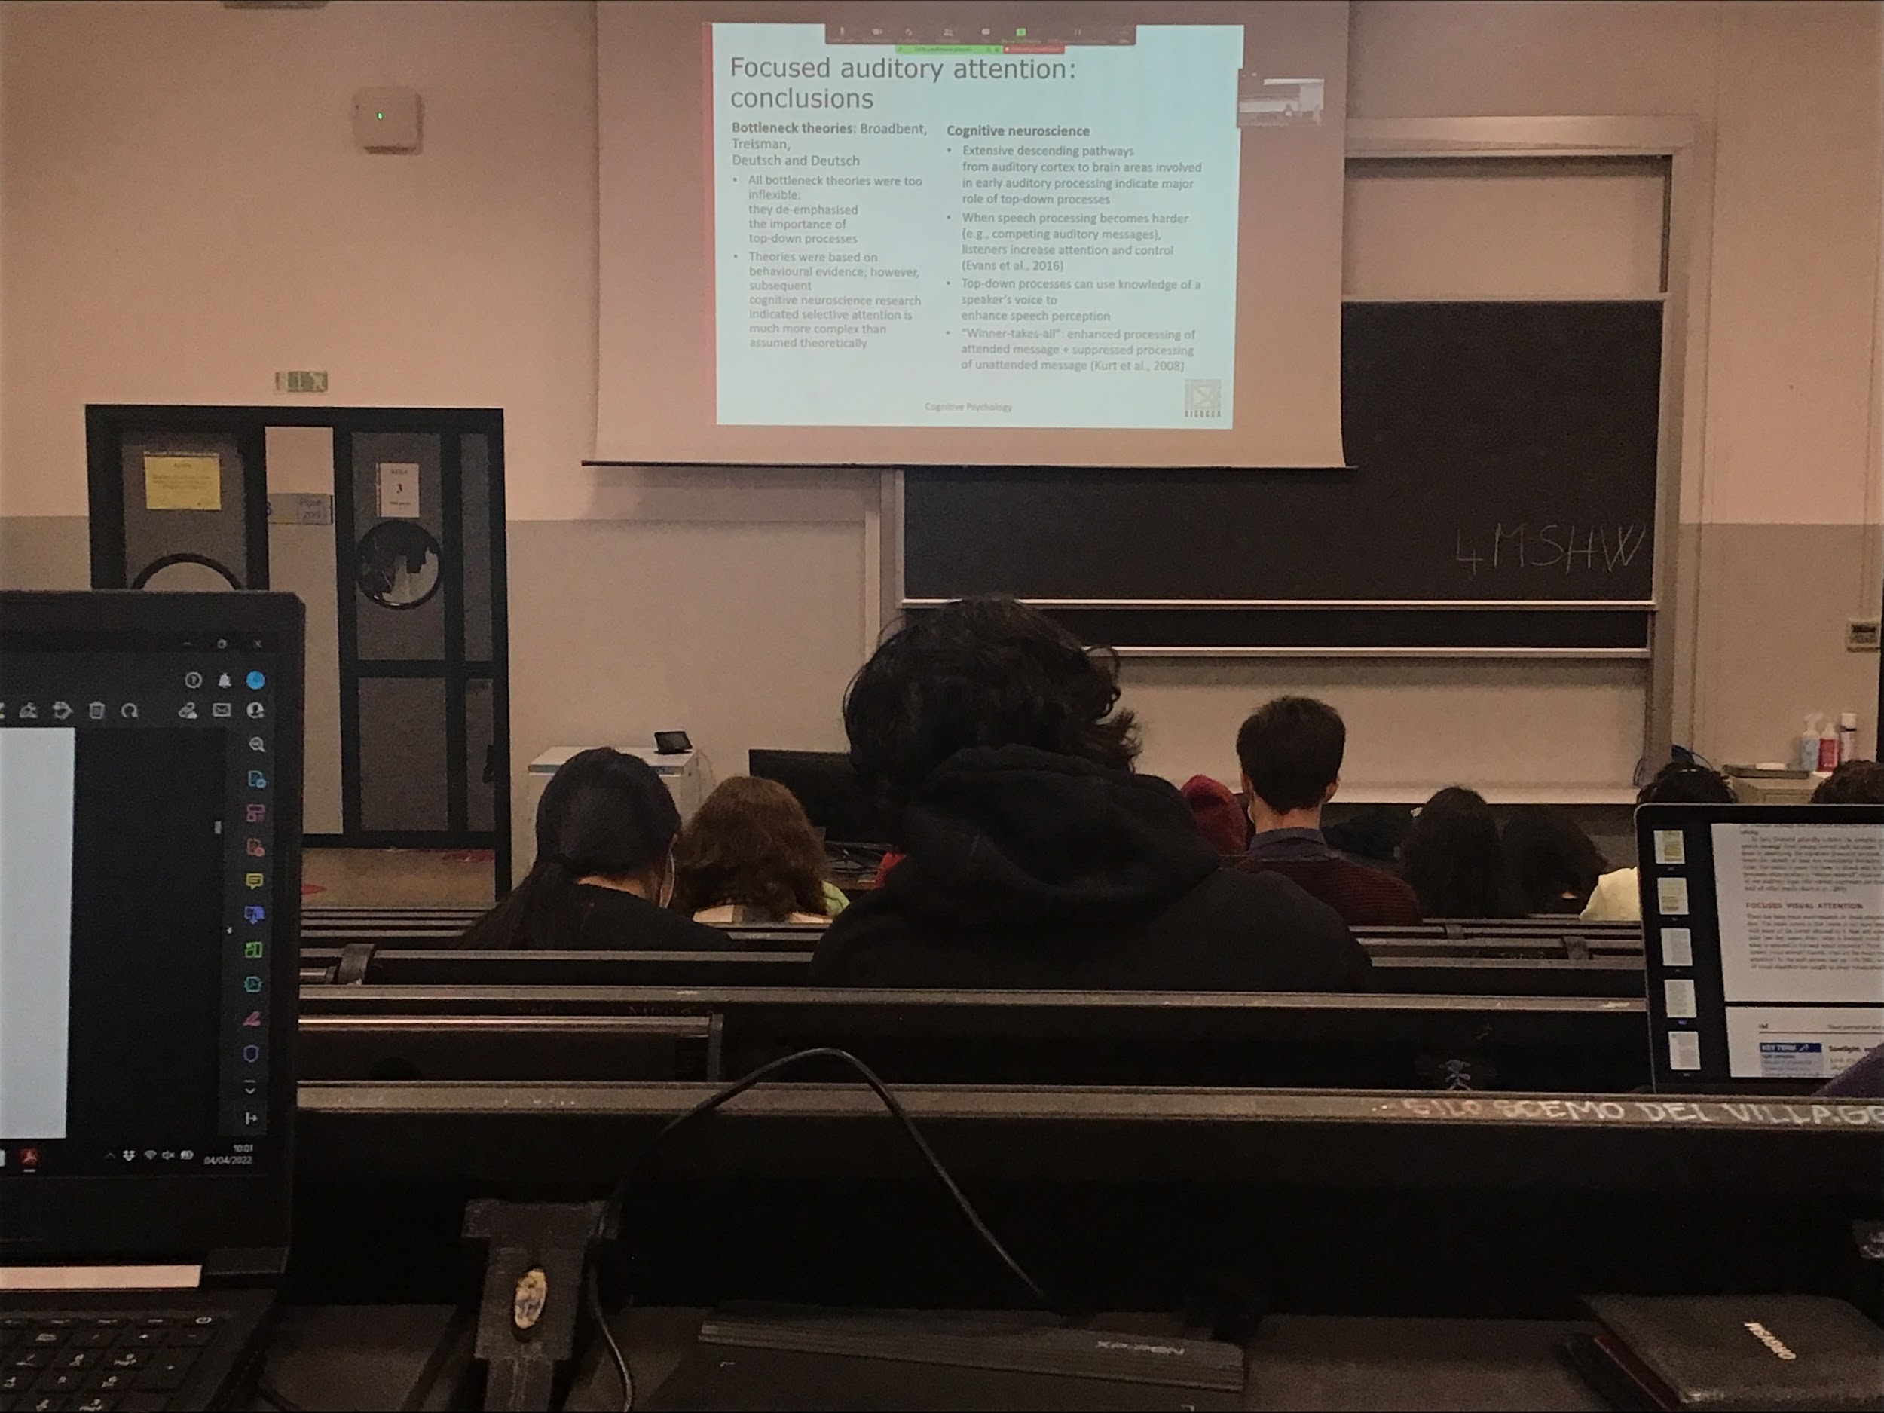

There are 3 bottle neck theories

* Broadbent theory is too limited
* Treisman and deutsch and deutsch are too inflexible, they de-infatize the top-down process

Cognitive neuroscience show that there is a lot of top-down process that the theories do not explain

**Visual attention**

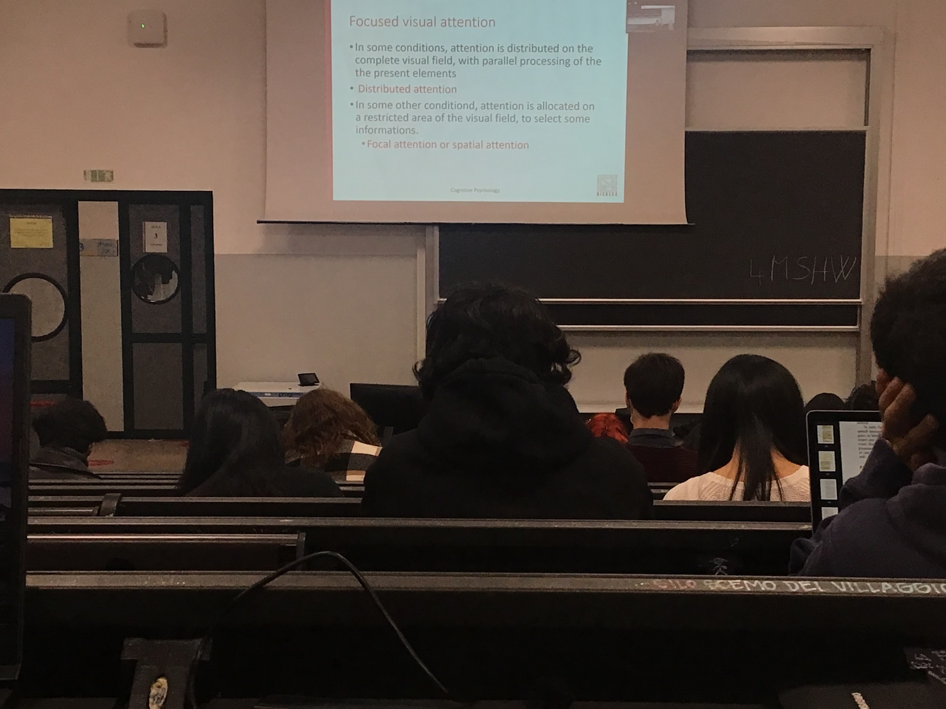

**Disturbed attention**: we are paying attention to whatever happens in our visual field, don’t know what to expect, so we don’t select some kind of informations

**Focus visual attention**: we focus our attention in one spatial position

Many times focus visual attention is called spatial attention. Concentrate our resources on one specific part of the visual field

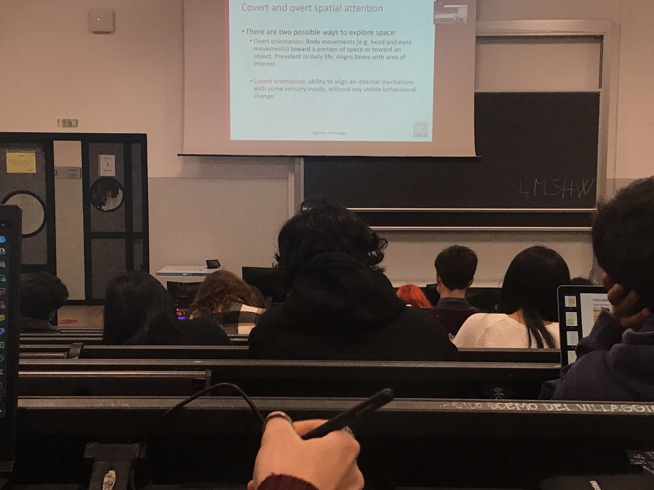

Two different ways to focus our attention spatially we can orient our overly or covertly

* **Overtly**: the way we do usually, we move our body to bring the part of the visual field that we are interested in into the analyses. Move our gase so that it falls in one specific area. We know that with the central part of the visual field we analyse data much more in details, moving our eyes in a given positions means that I can process the informations there at higher detail
* **Covert orientation**: I can still put my gaze in any position any paying attention to **move my attentional window to a position that is different from the central gaze**. We can pay attention in one position of the visual field **without actually moving our eyes there**, without any visible behavioural change, I do not see where people are paying attention to

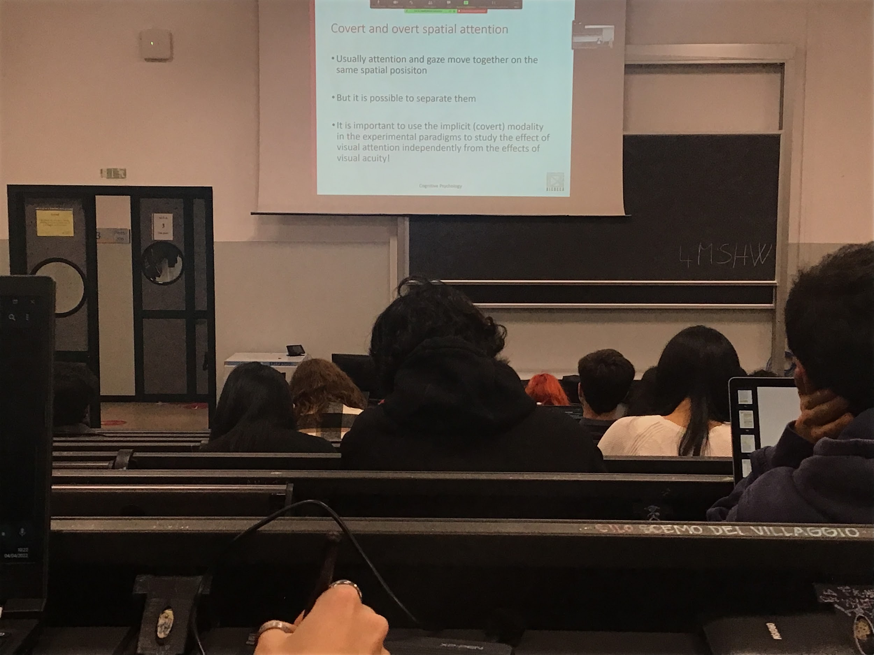

Usually attention and gaze move together at the same spatial position, but is possible to separate them

When we want to study attention we have to use most of the times cover attention, otherwise we mix perception and attention and we can not understand if effect is attention or if effect is perception

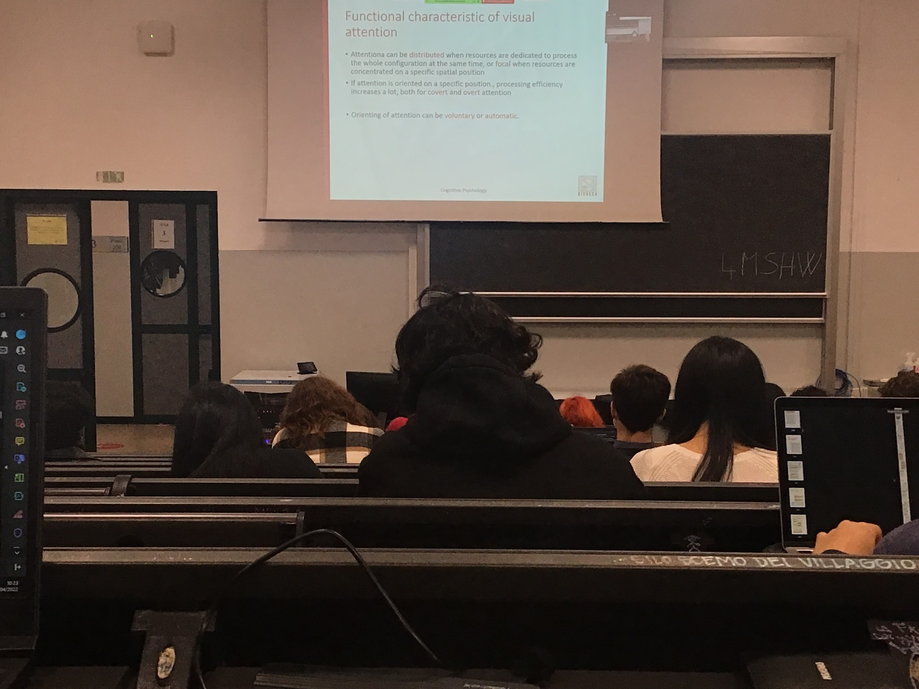

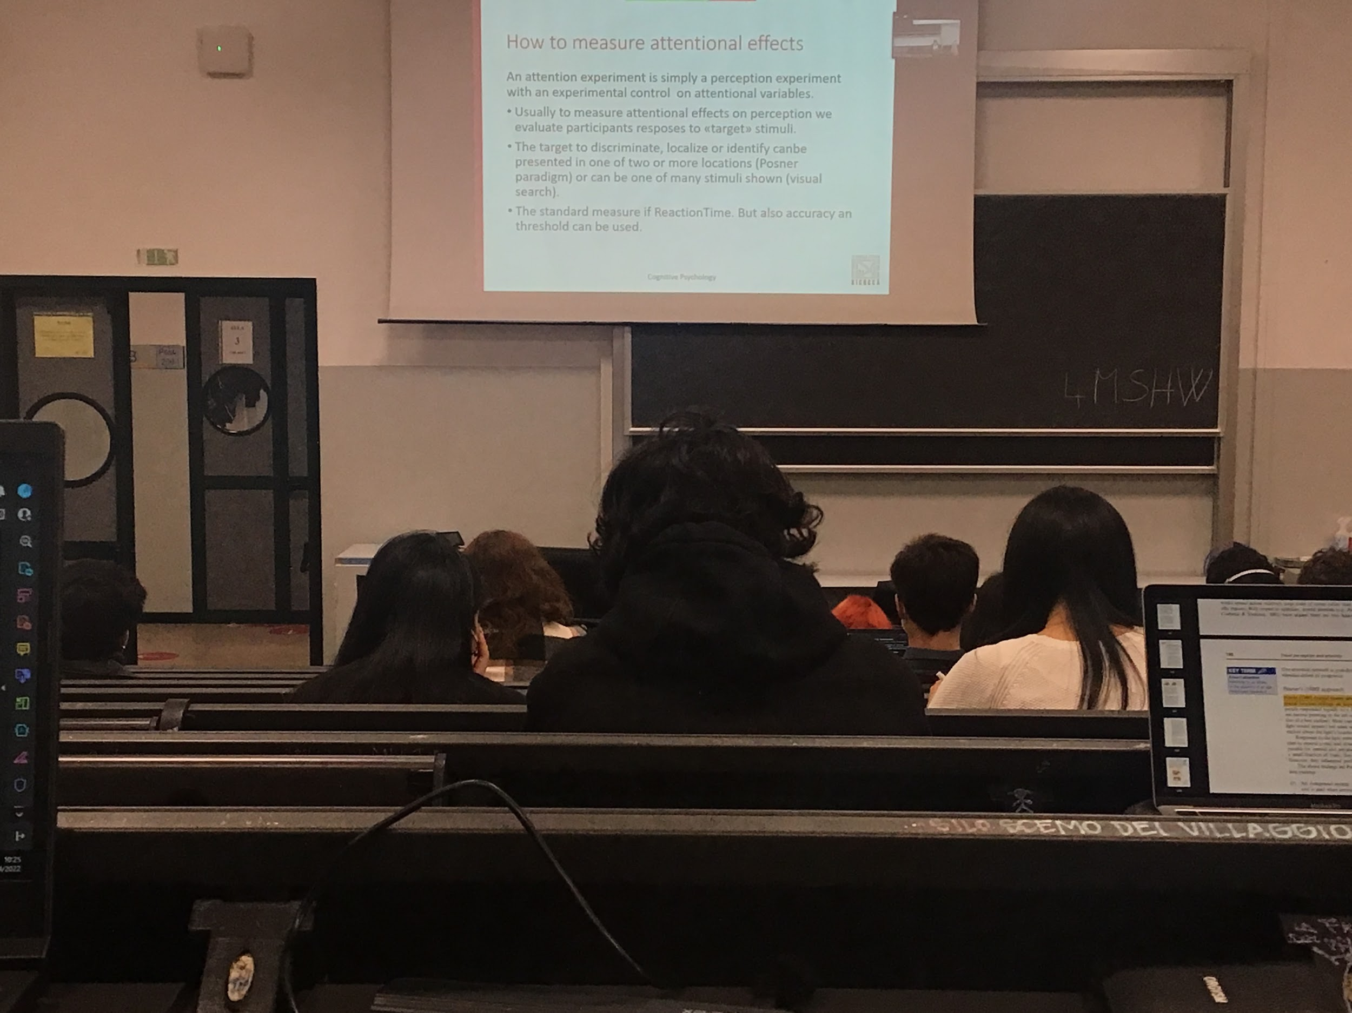

**Focusing attention means that we put the majority of all the resources available processing that part of the space**, if I put more resources in a part means that my processing can go faster

Sometimes a loud noise, a flashing light, attract our attention, but most of the times we decide where to put our attention

To study attention we have to find a way to test it, very difficult

To test attention we have to show that when you put attention in one specific space you put more resources in that space and therefore you are fare in detecting that respons

To study attention we have to compare two situations. Is a perceptual task *tell me the red stimuli appear* but I must have two different condition

* when your attention is forced in the space where the object is going to appear, should have more resources, you should response fast
* The identical stimuli by your attention is somewhere else, little resources, you can give me the right answer but it will take longer

The standard measures was reaction time: how fast you are to response. Now we also use accuracy (the task is so complicated that you make mistake) or we can use threshold measurement (how much information I must give you before you are able to respond to me)

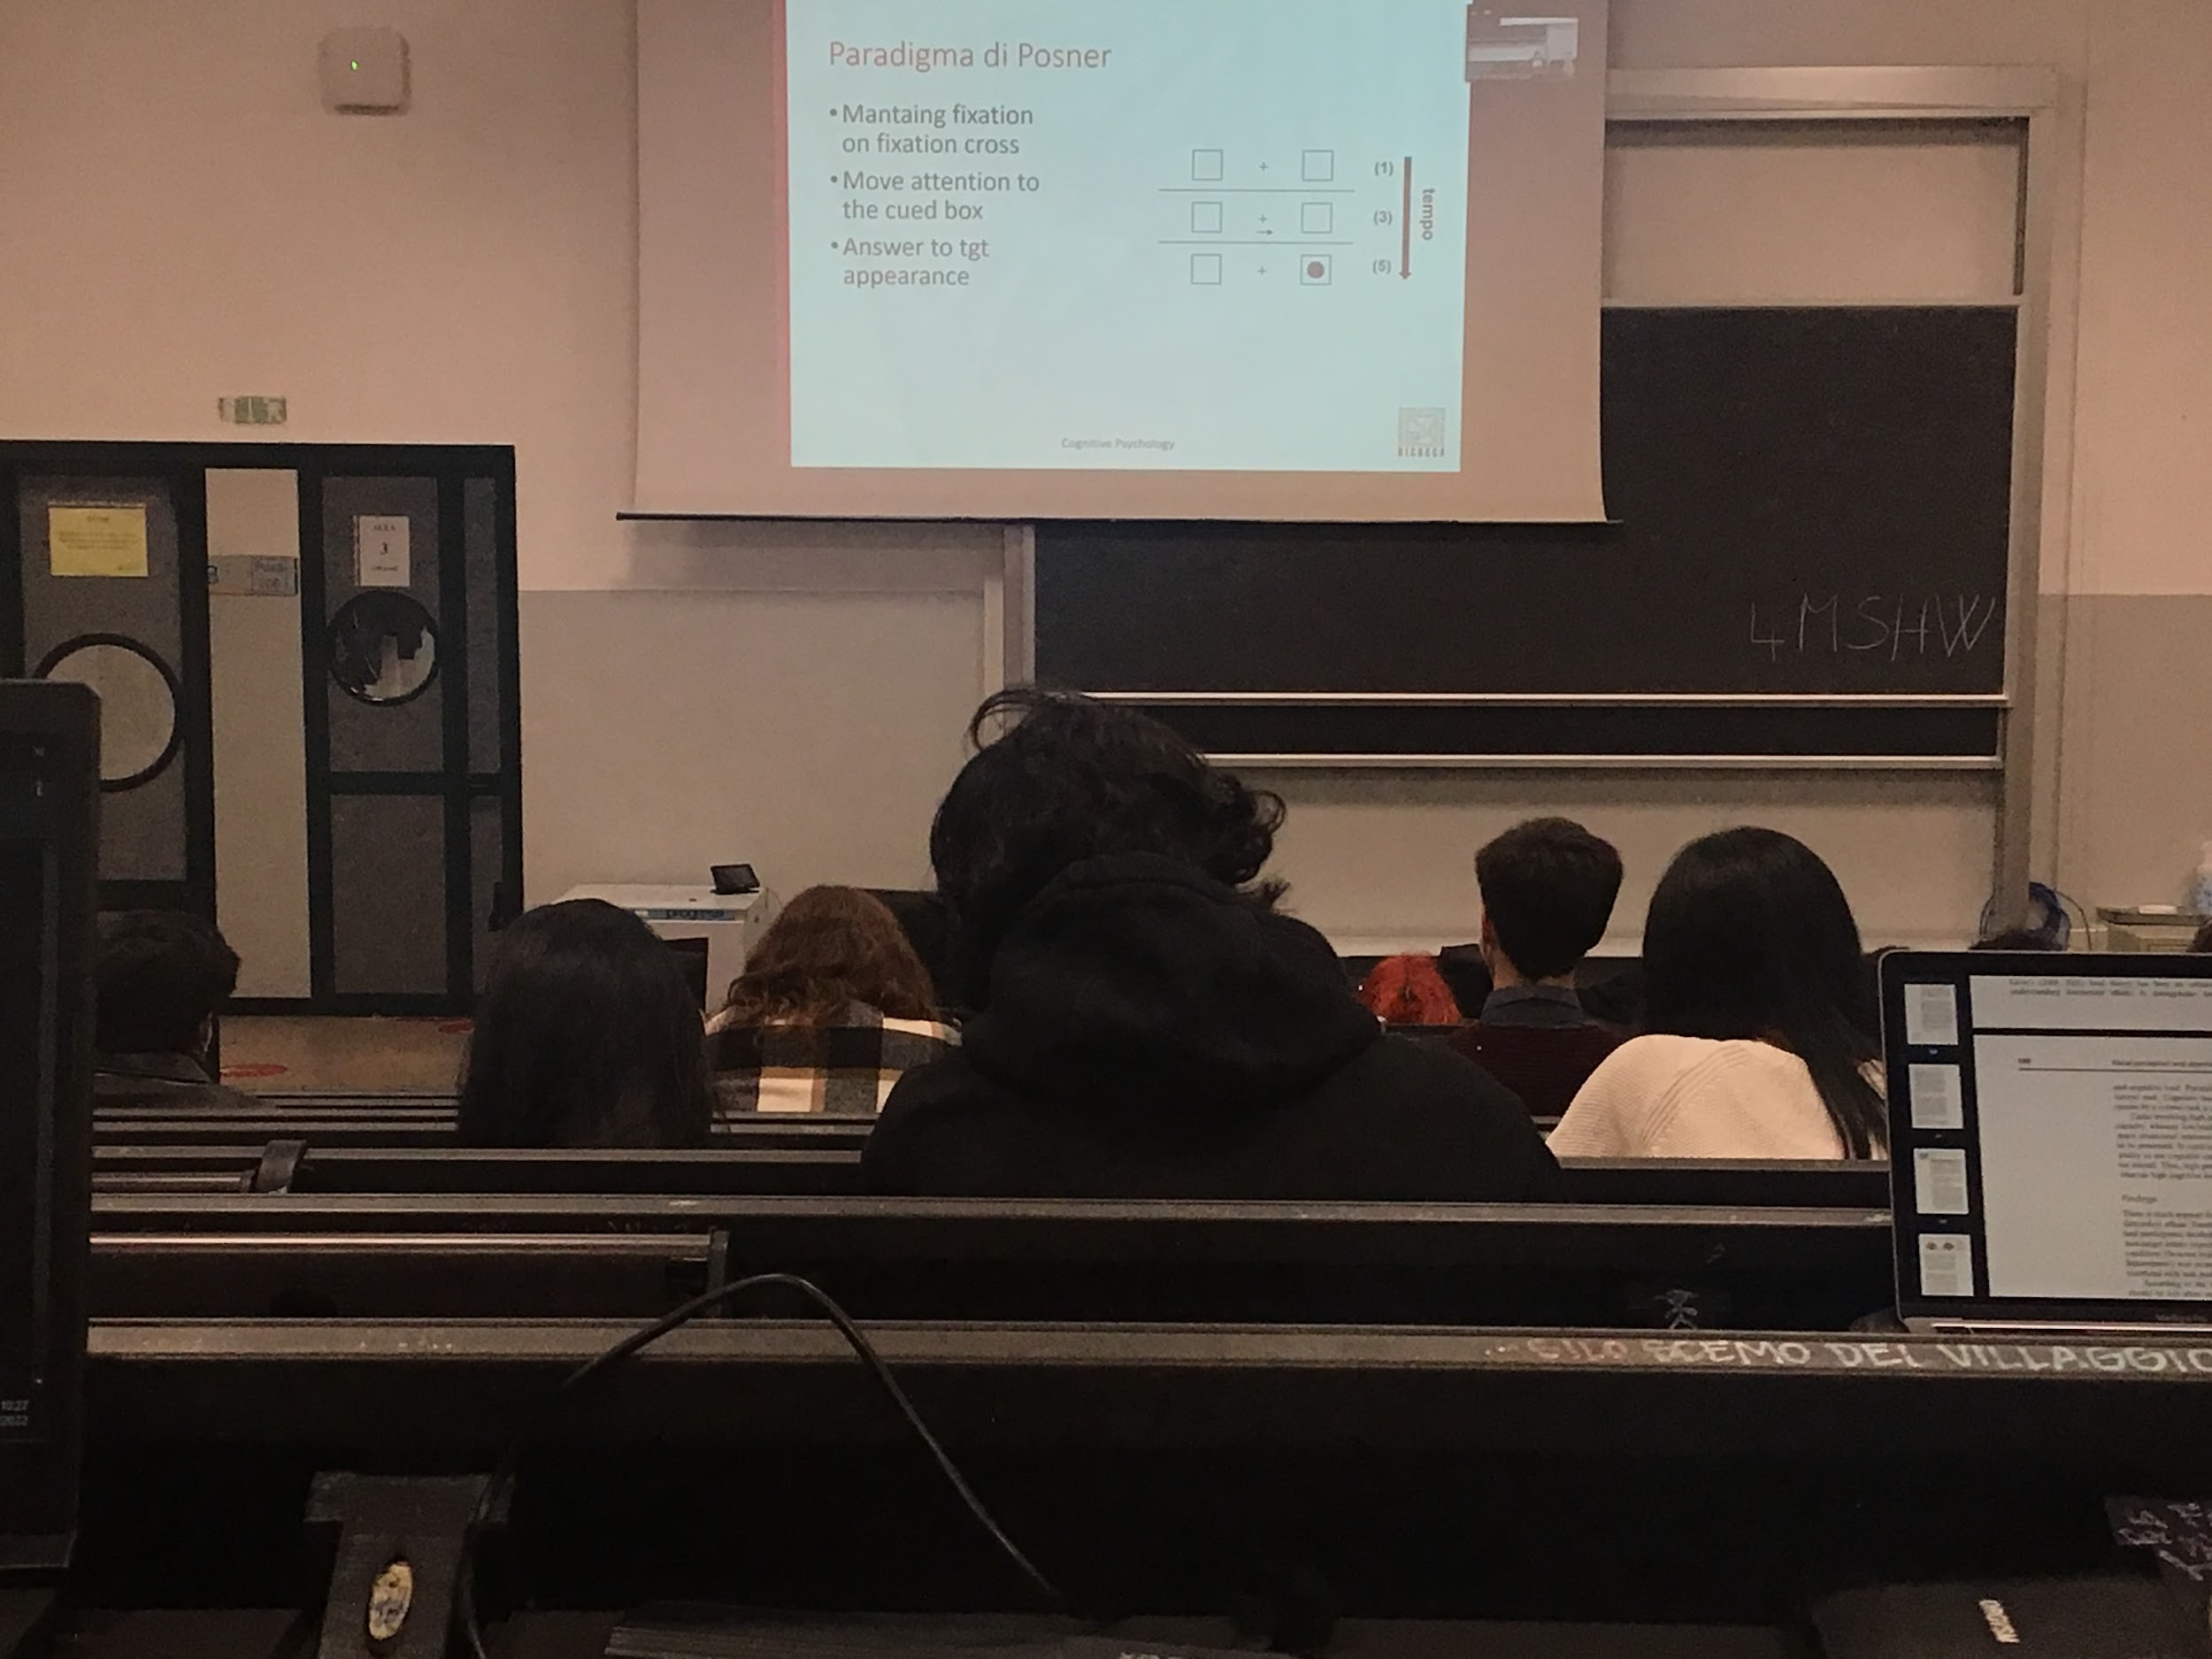

**Posher paradigm**:

At a certain point you're facing a screen focus on the screen there is a cross (+) in the center (called fixation point) and there are two squares on the two sides. The task of the participant is to stay with the gaze in the fiction point for all the time of the trial. Eye tracking are checking that you don’t move your eyes.

After a certain point an arrow → appears. It is called the ***cue*** tells to move your attention to the square.

The arrow disappear and after a while one target can (or can not) appear in the square

We have to press a bottom when the target appear

Measure the reaction time

* **valid condition**: when the arrow point the direction where the target appears
* **Invalid condition**: when the arrow point the direction opposite where the target appears
* **Neutral condition**: the arrow appears with both heads ↔

For this task to work we are testing voluntary attention because you have for the task to work to look at the arrow and interpret the arrow and decide to move your attention at the direction of the arrow

Since it is voluntary **I need to have the neutral condition (↔) to test what is your reaction time when you distribute your attention**. To compare your results I have to compare the to when you don’t know where to look

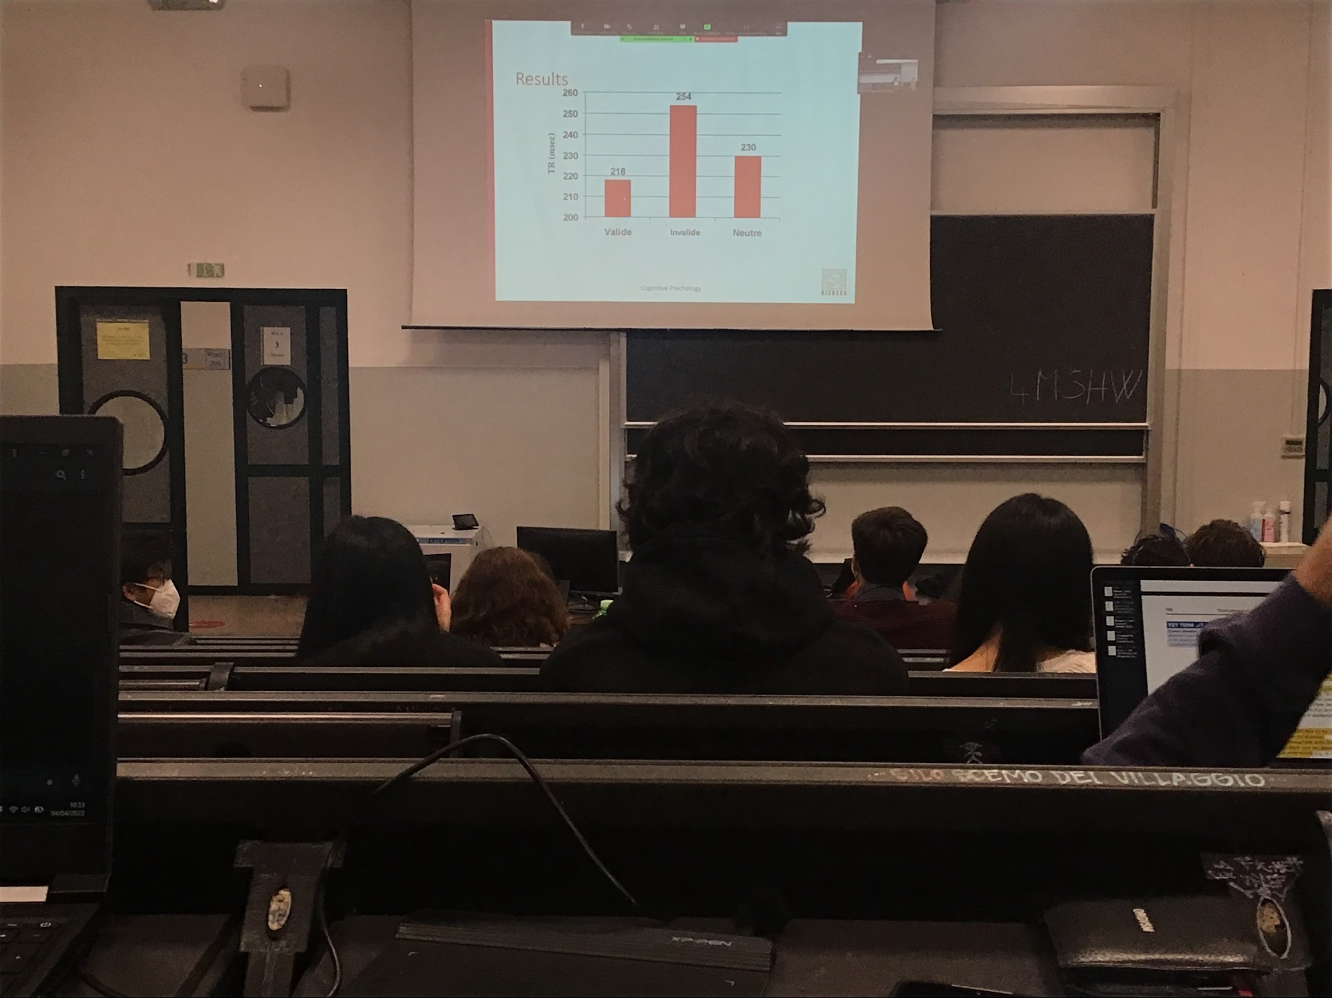

Reaction time is very short, 230ms when you don’t know where to put your attention

When you **put attention to the correct side**, you move your resources to elaborate on that position, you have **faster reaction time**.

**The difference between valide and neutre results in the Posner paradigm show that attention exists**. Because there is a difference in reaction time. Increase time when the target is invalid, you have your resources on the right and the target appear on the left

If people were not looking to the cross it would be that one area is in the cover, I would have unbalance coding in one area. If you focus in the center both the areas have the same result and perception behaves identical in the two situations, all the differences that I find are only due to attentional resources dedicated to a specific position

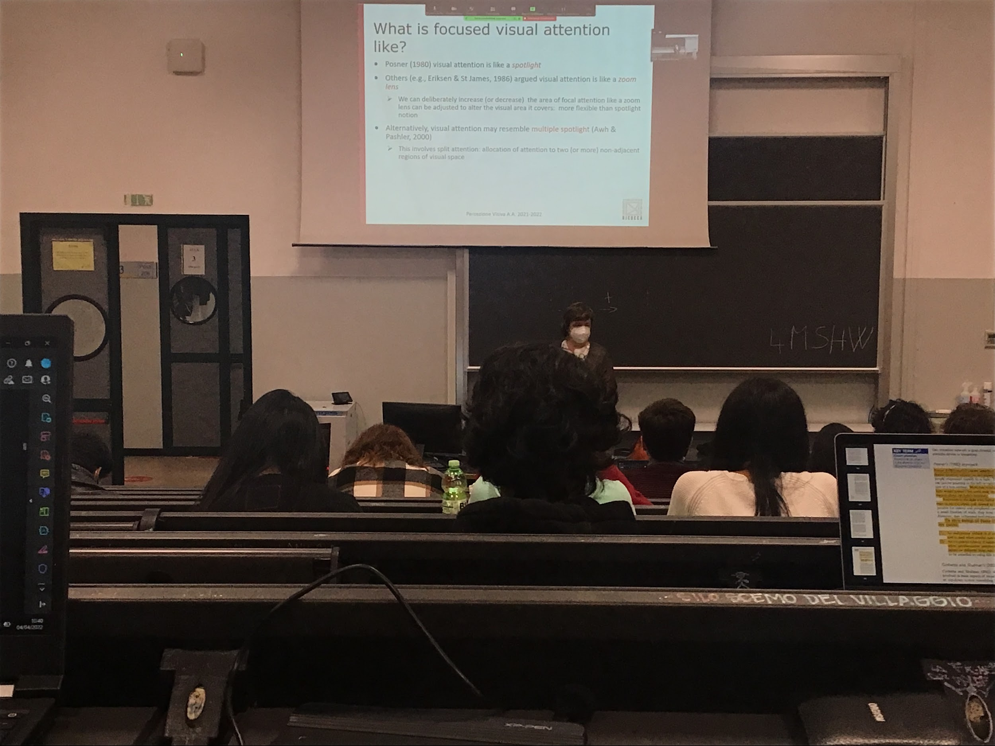

**Attention is like a spotlight**, you are in a dark room, you put a light in a position and you increase information there and the information is coded better, you increase the information coming from that area

The small is the area I zoom on the most resources I dedicate to that area.

First proposal: I can not split in two positions, choose only one spatial area

New thesis: **We can have splitting attention**. I can move attention to both sides, considering at the same time only two areas, splitting attention, not covering entirely the visual field

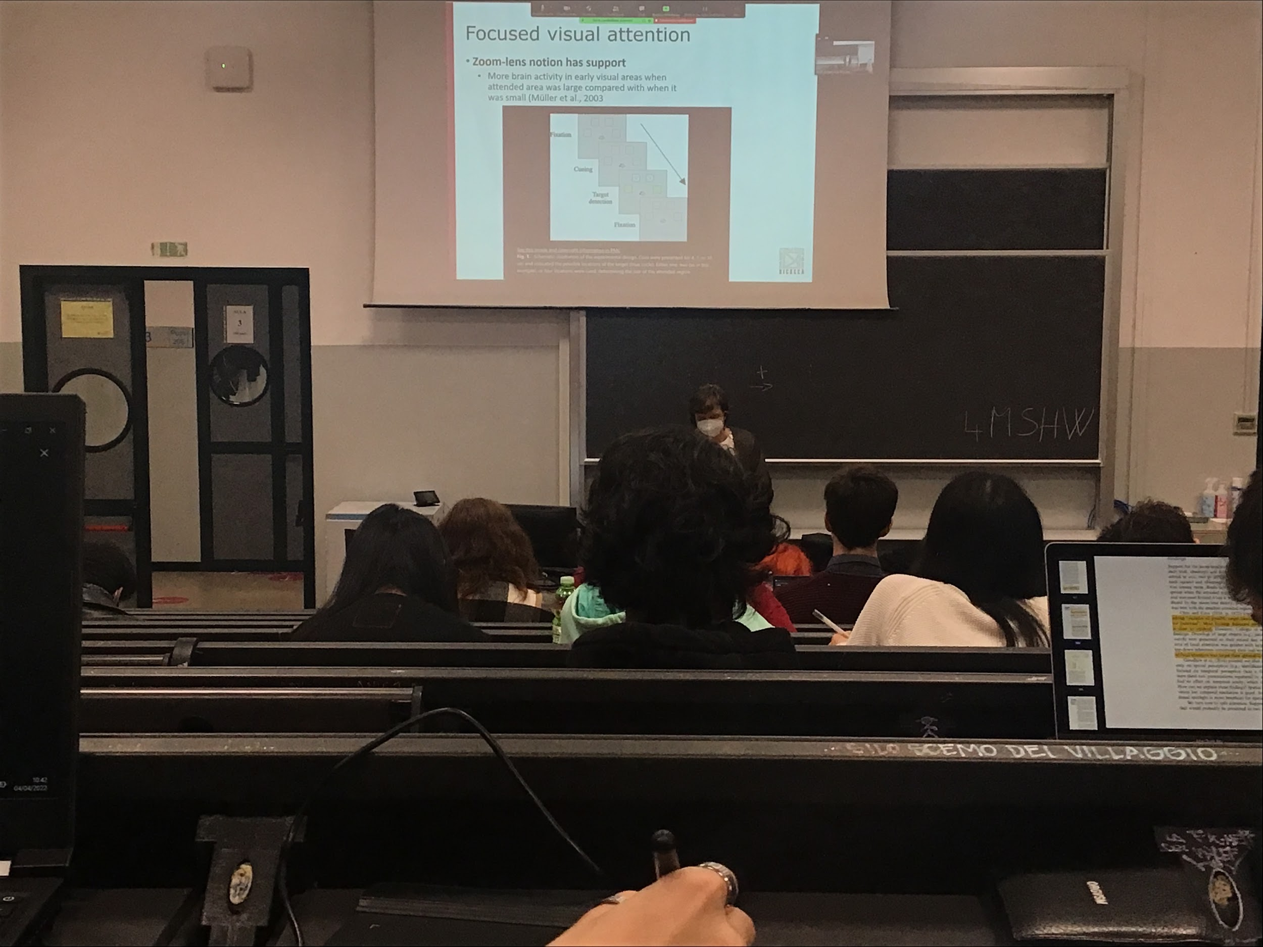

**Müller experiment**:

Fixation spot and 4 possible placeholders, you colour from 1 to 4 in which of the possible placeholder the target stimulus can appear

Presentation of a stimulus in all the possible position, you have to tell if one of this 4 is the one you are interested in

Depending on how many square you colour, your attention a window can be small (concentrated on 1 stimulus, medium with two stimulus of large when you are lighting up all 4 colours)

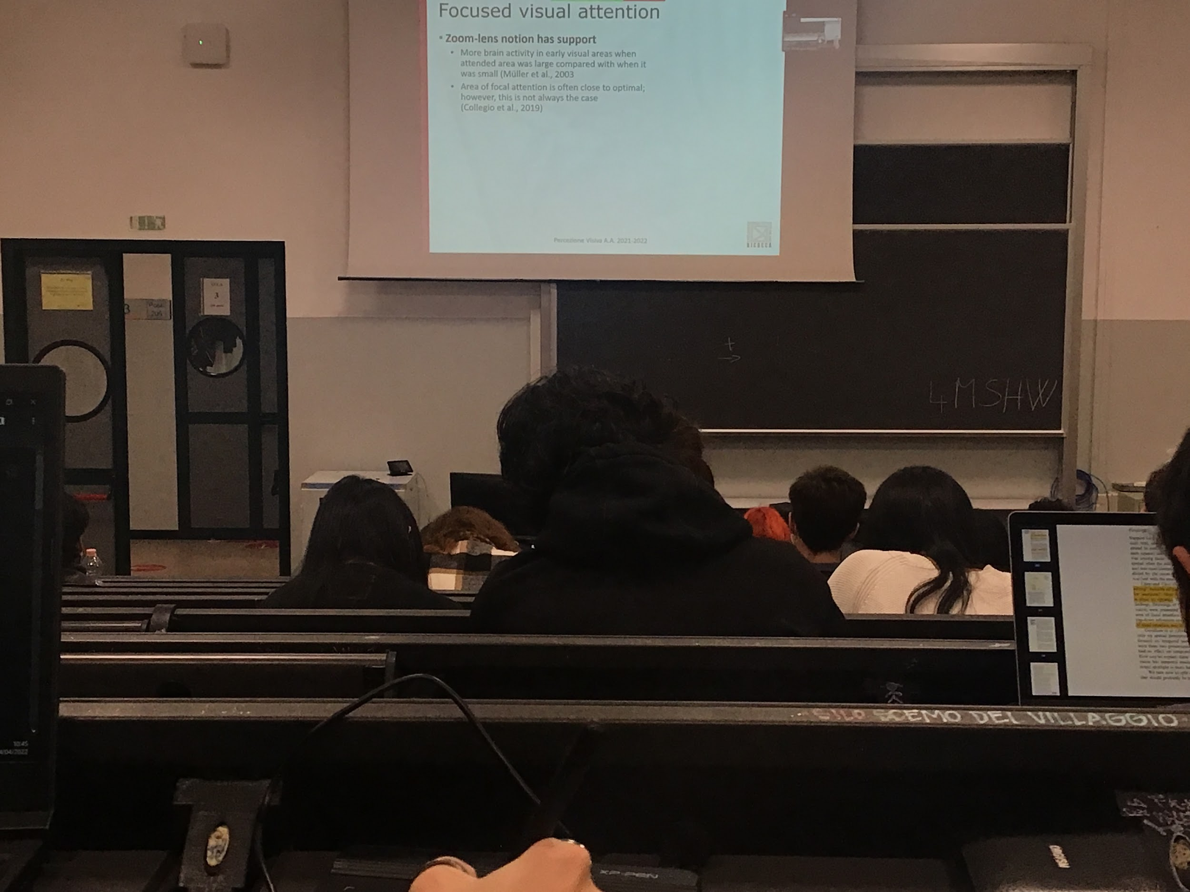

Show that there is more activity in the early visual area when the attended area was larger, when all 4 are colored you have more activity

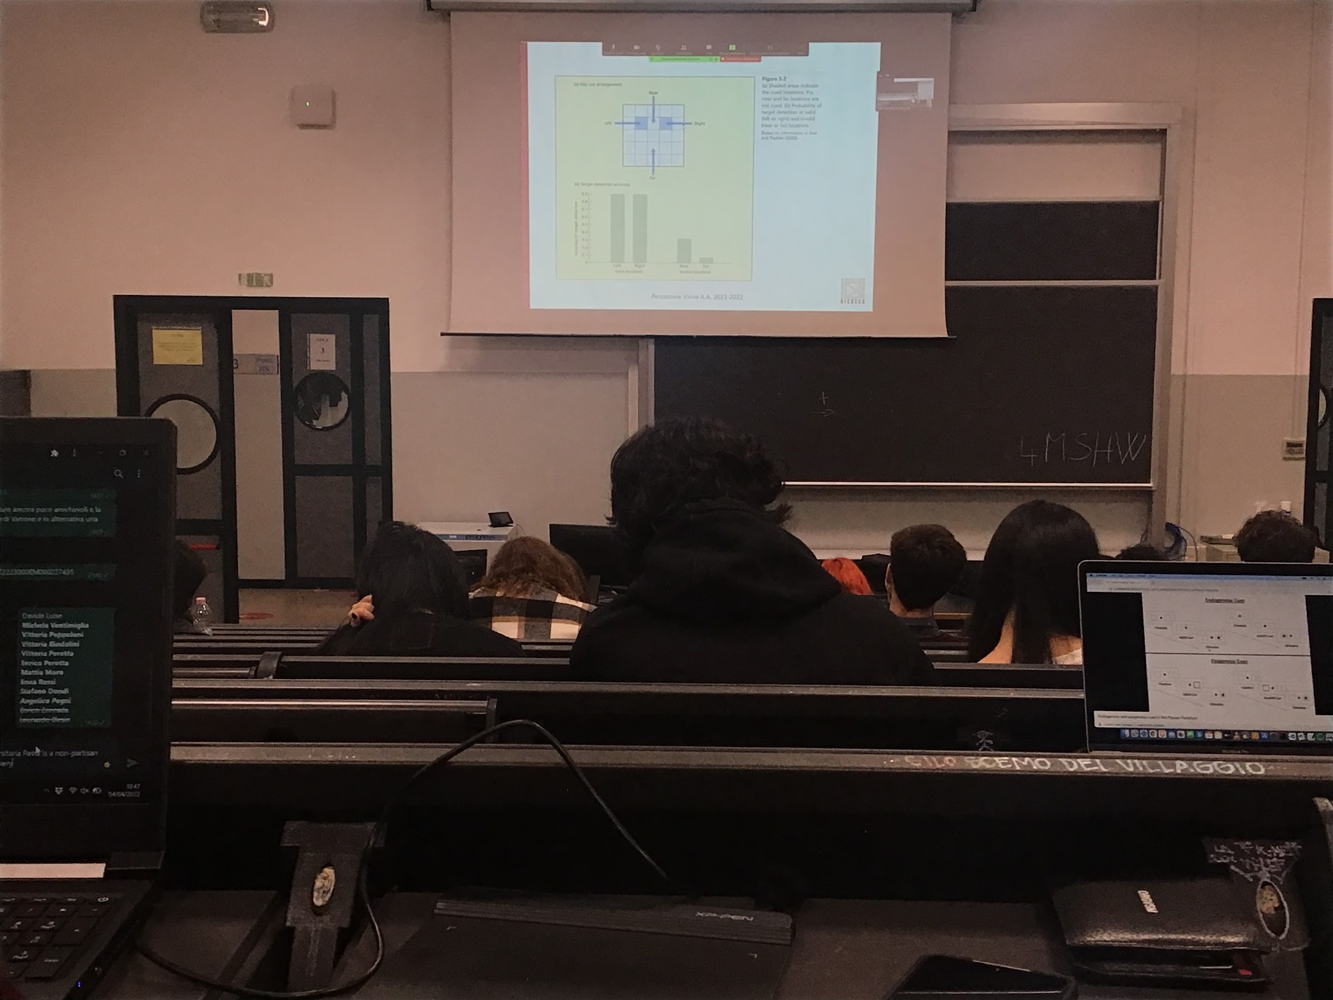

You have 4 possible position on a screen where a target can appear (at the points where the arrow is directed to)

The task is that cues appear (in the blue spot) and then it appears in one of the 4 position. If we cue the two blue position both of them at the same time and we make a target appear in the one of the other two we have a faster response

Invalid trial: cue the two blue one and the target appear in one of the two other position that are invalid

If the target appear in the box between the two cue Posnerr would say that you have a larger spotlight and so since the point is within the spotlight it should be fast

**You are slow if the target appear outside the spotlight**

Experiment show that there can be more than one window

Zoom lens idea: sensitive on the area I am focusing in

Postenrr: dosen’t matter how big it is

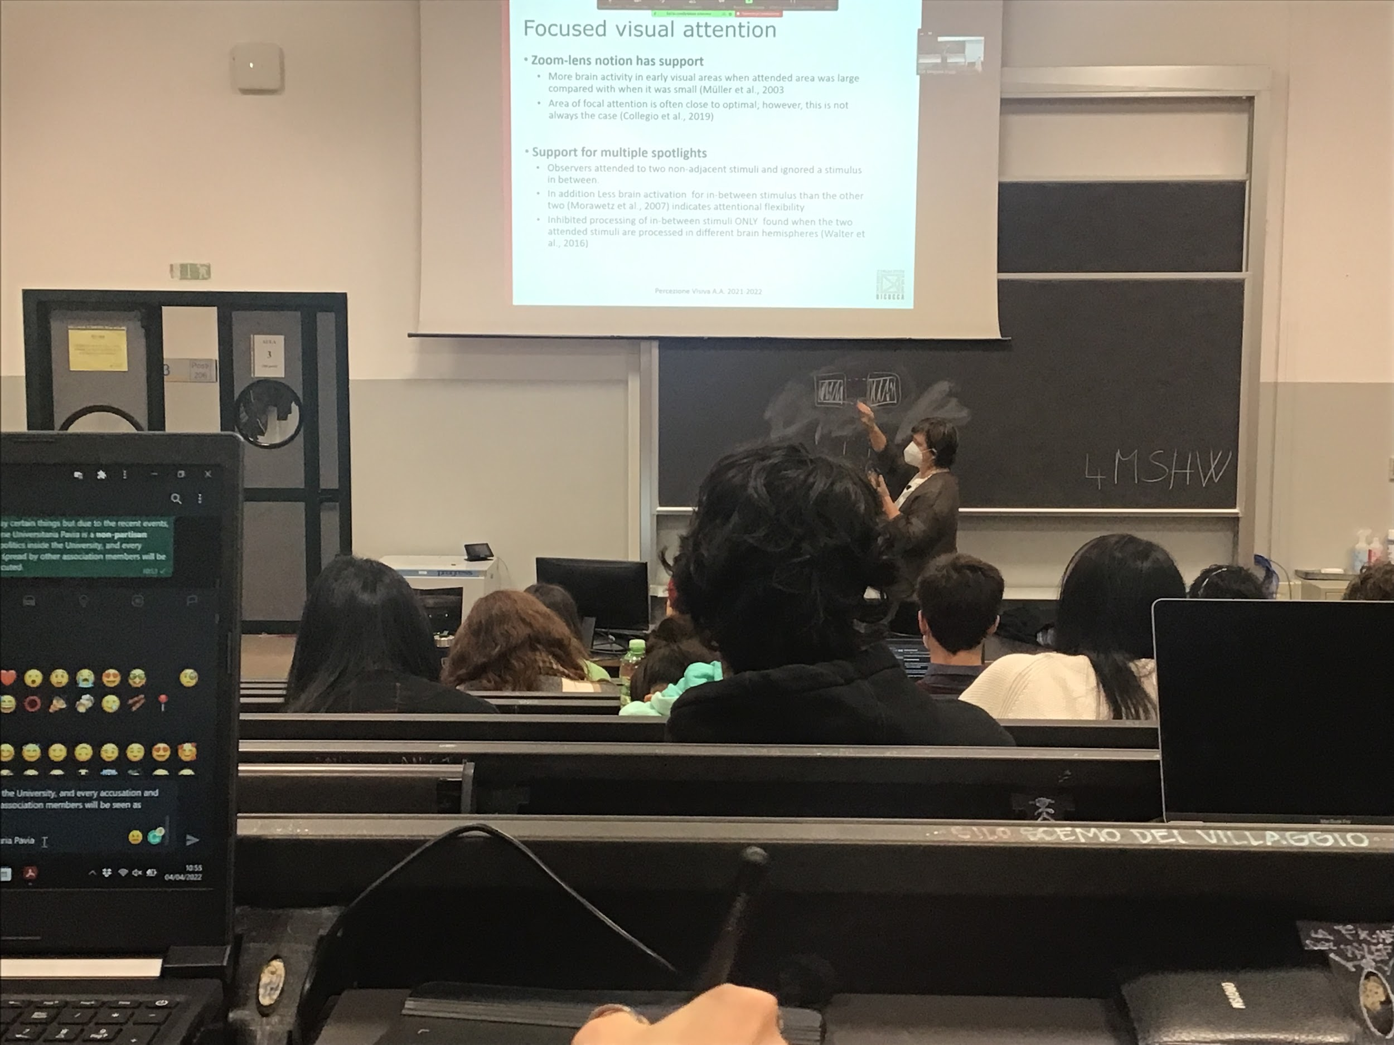

Split attention work only when the two stimuli are on the two different empisheres

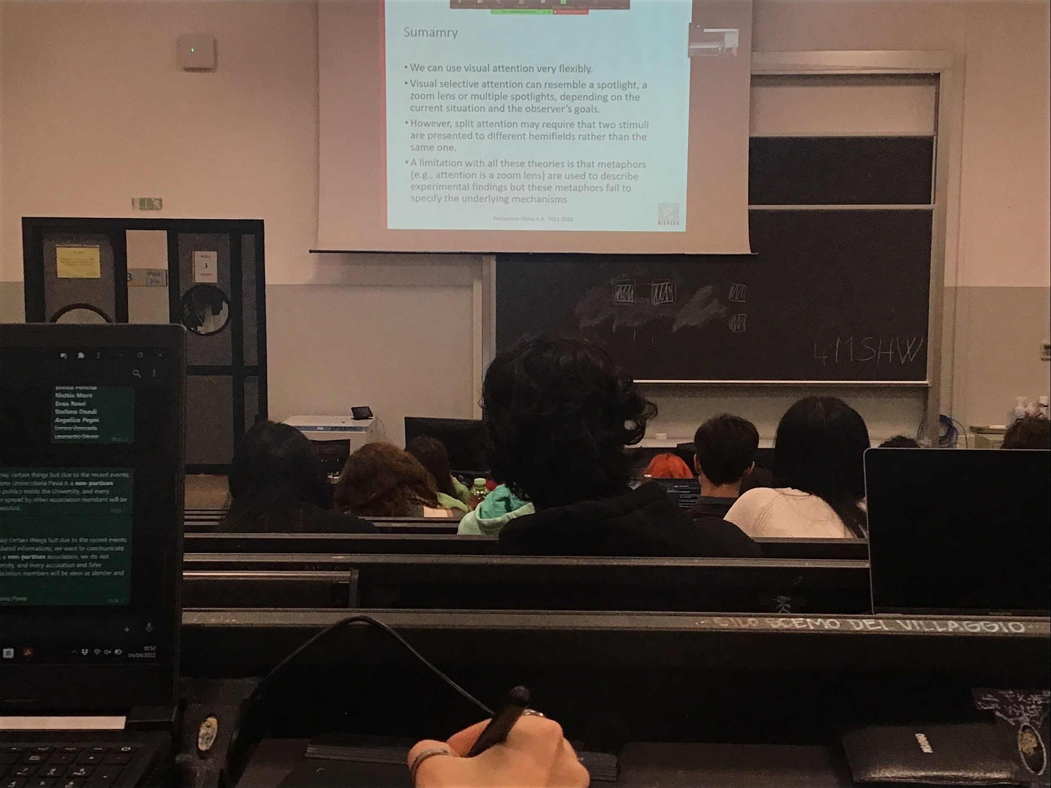

We can use attention in a flexible way

This theories can explain data but they are not real models, help to intepret what happens but do not specific what the underline mechanism are

**Audio 3**

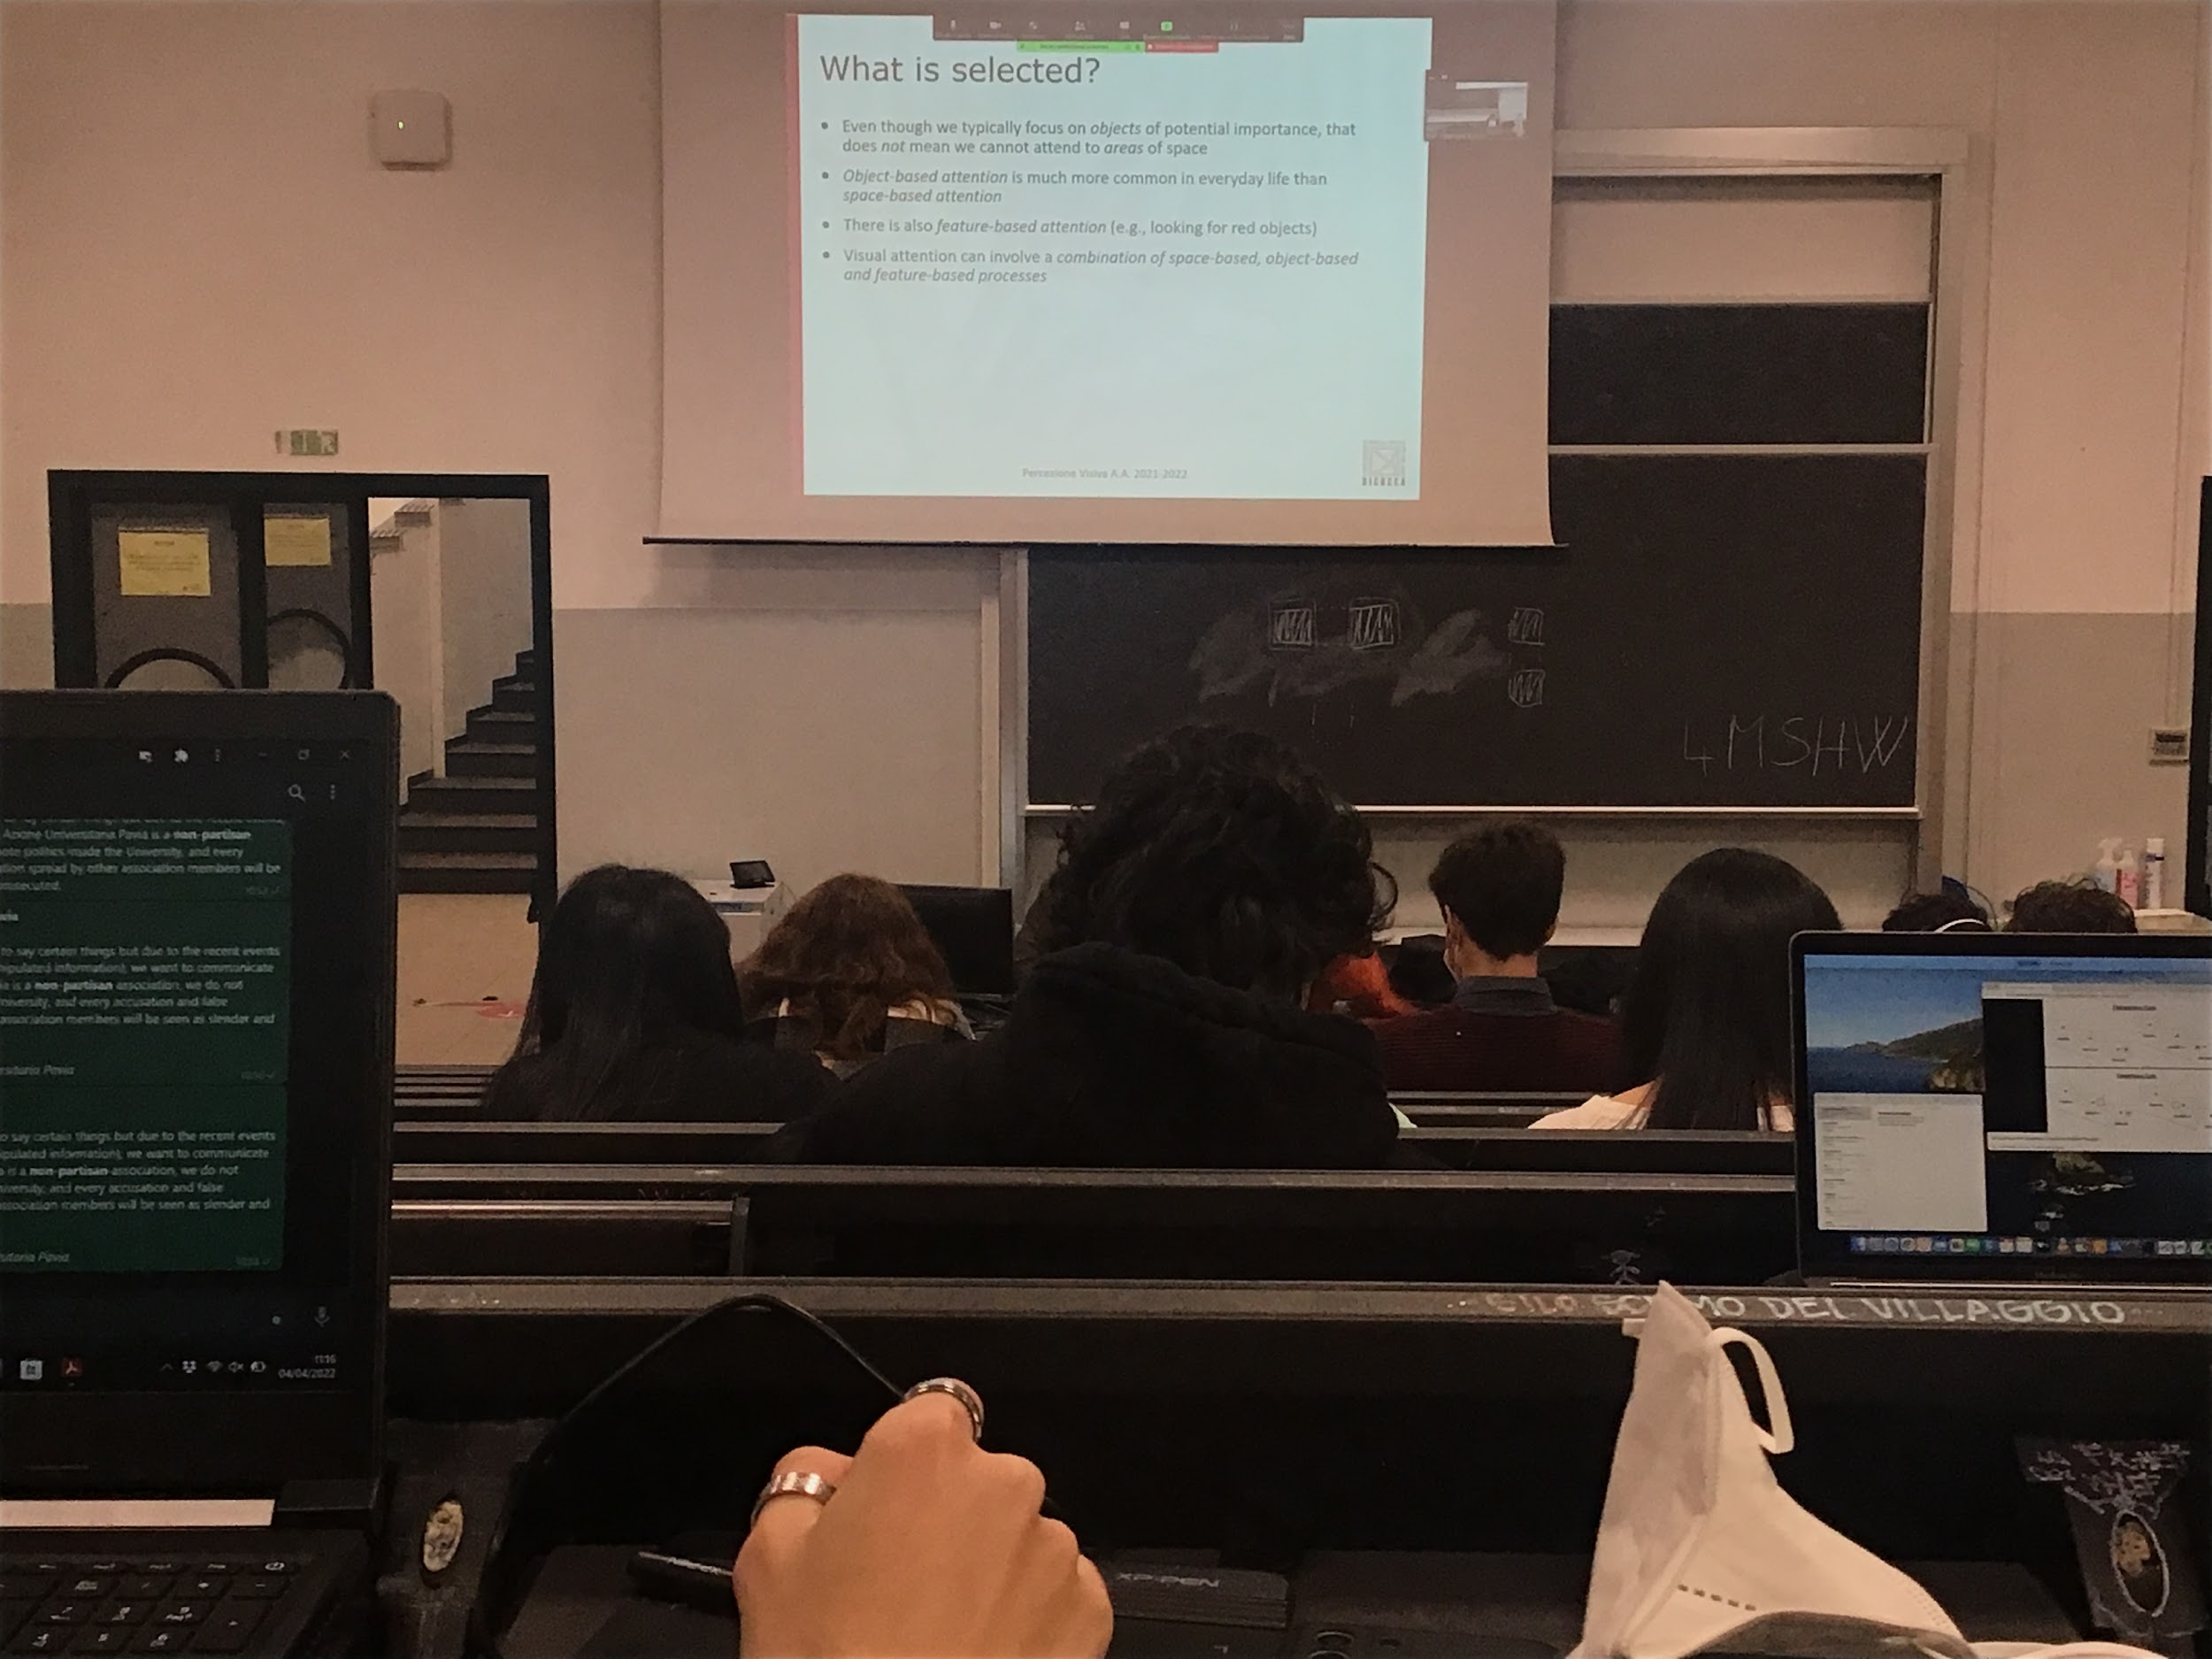

Debate if attention is spaitial (posnerr) or if the attention select obejcts and not space?

It is true that I can pay attention to the empty space

Feature base attention: can we select all the red obejcts in one type of scene?

In relity attention has all the aspect we focus on one or other type of attention depending on the ask

Experiments that tries to separate between object base and space based attention:

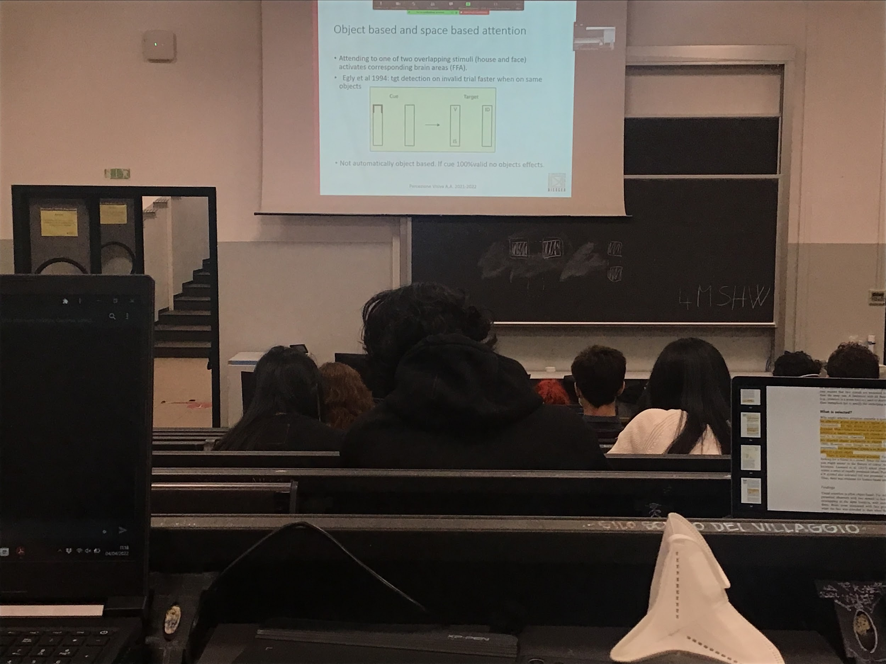

Experiment: put two objects in the same space overlapping, you see that even if you are looking at the same indetical stimulus if you pay attention to one or the other it activates different brain areas

Able to select one object out of two in the same identical space. There is data of object selection

Experiment in favour of the fact that there is object base selection:

Fixating in the center, appears two vertical bars and target can appear in one of the 4 corners

The cue is an object that appear before the target and the cue is the fact that one of the 4 corners light up, tells you that the stimulus will appear there with a high probability

* valid condition: stimulus actually appear in the lighted corner, we are much faster at detecting because our attention is there

Experiment show that we have object base attention is that if the stimulus appear in the two other position they have the same identical distance

Actually we are faster to respons when the object is on the same object

When the invalid target is on the same object you are faster than when the invalid target is in another object that is at the same distance. There is object base representation, not always automatic, we do it according to what the task is

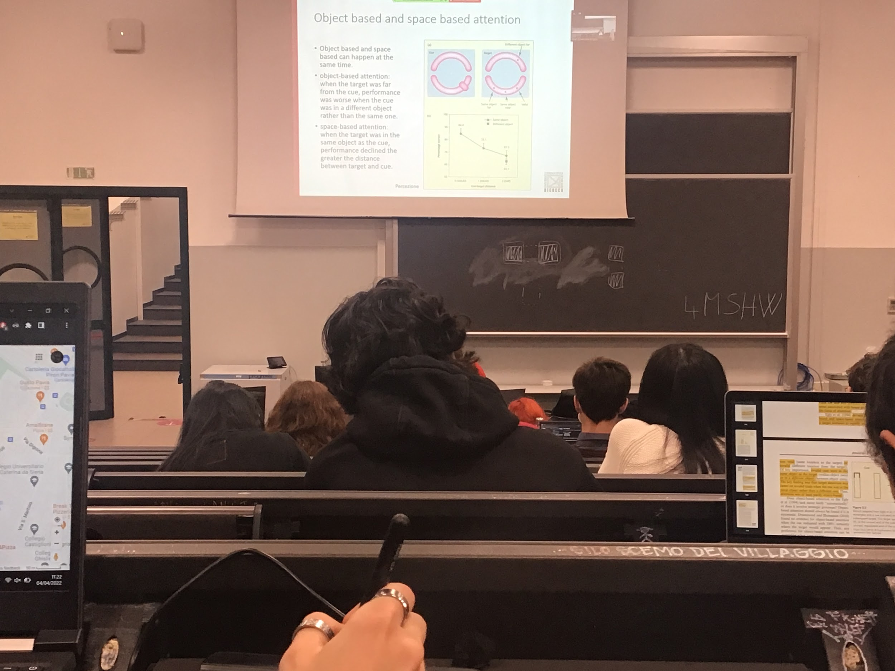

Experiment that show a difference between object base and space base attention:

Targets can appear in one of the 6 position and there is a cue, the cue is in one of the two parts

And we can show that object attention and space base attention happens at the same time

**On the different objects at the same distance I am faster when the target is on the same object**

There is both object base and spatial base attention, they coexist. On the same object I am faster when the invalid target is close to the cue and on the different object at the same distance I am faster when it is on the other object

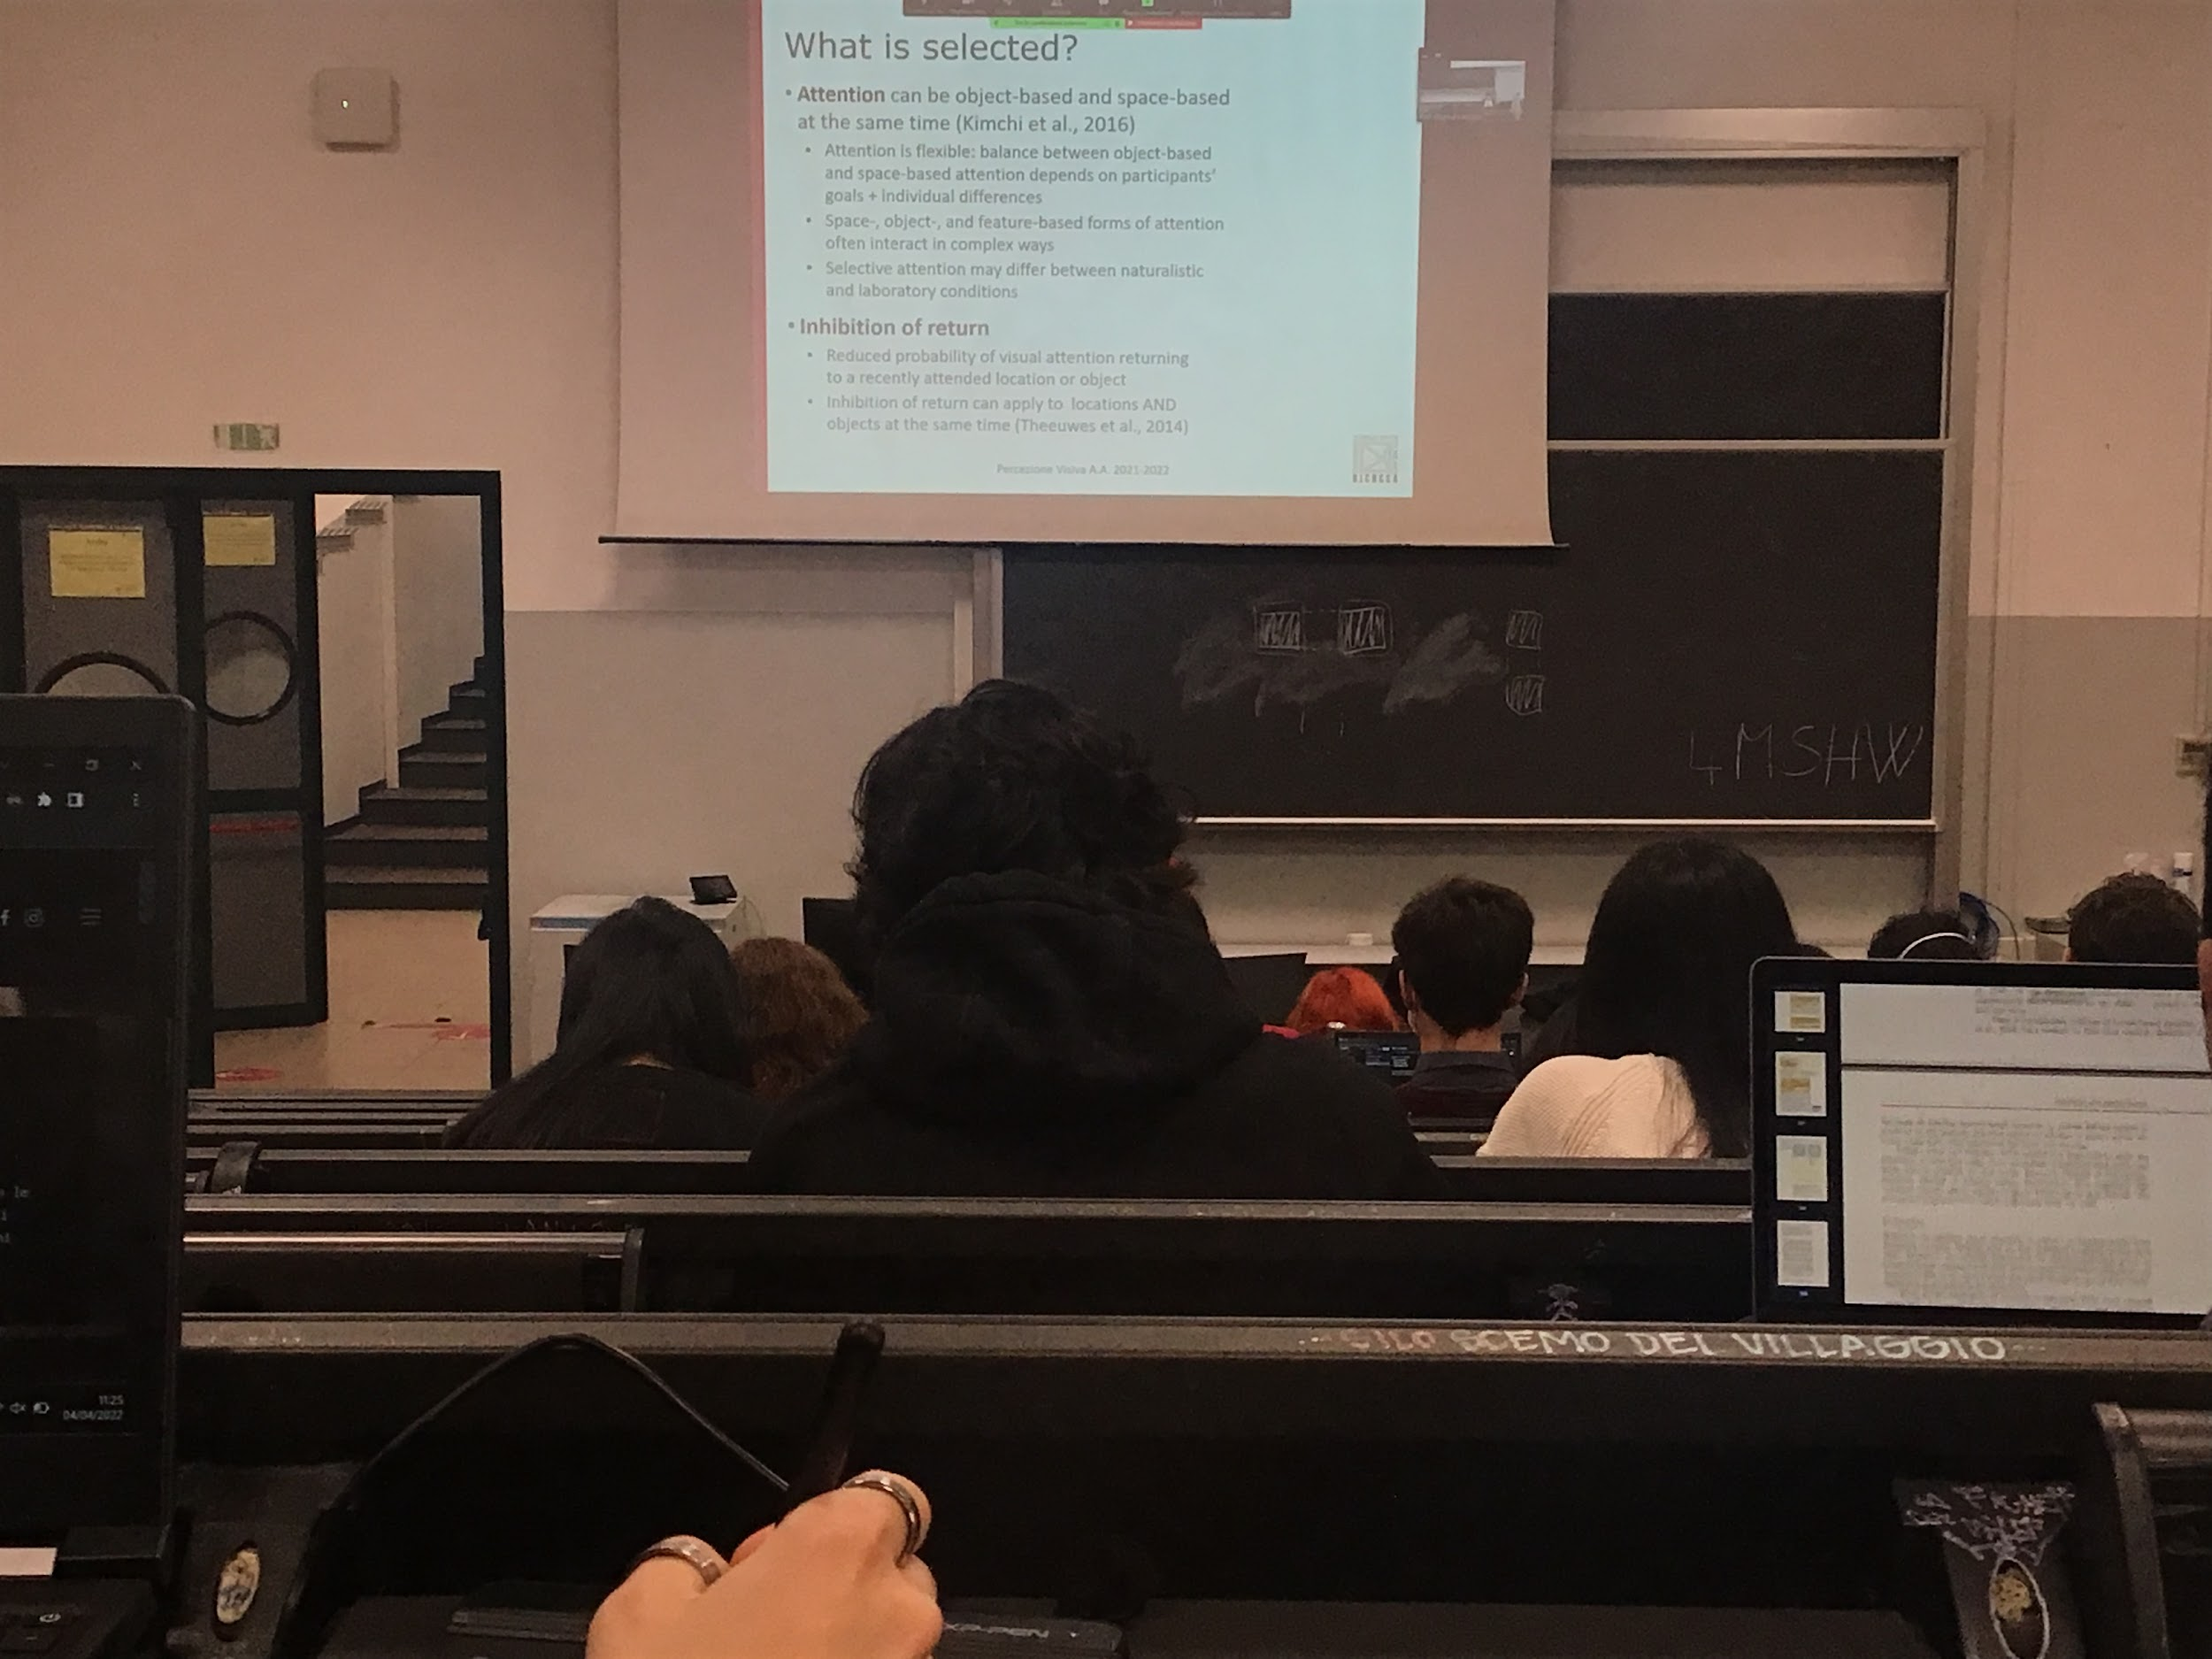

Attention can be object base and space base at the same time and it is flexible, it depends on your goals and on individual differences

These 3 types of attention interfere and interact

There is another important aspect of attention. Attention move the attentional window in a position that is interesting for us. If you are queuing a position and nothing happen there if I am attracted there (loud noise…) but nothing happen the system **inhibits** that space

**Inibite**: I was attracted there but nothing interested happen, I am not going back there if another think try to attract me.

If there is a blinking light but if I decide there is nothing interesting I stop going there, avoiding to go back to a spatial or object position where we decided there is nothing interesting

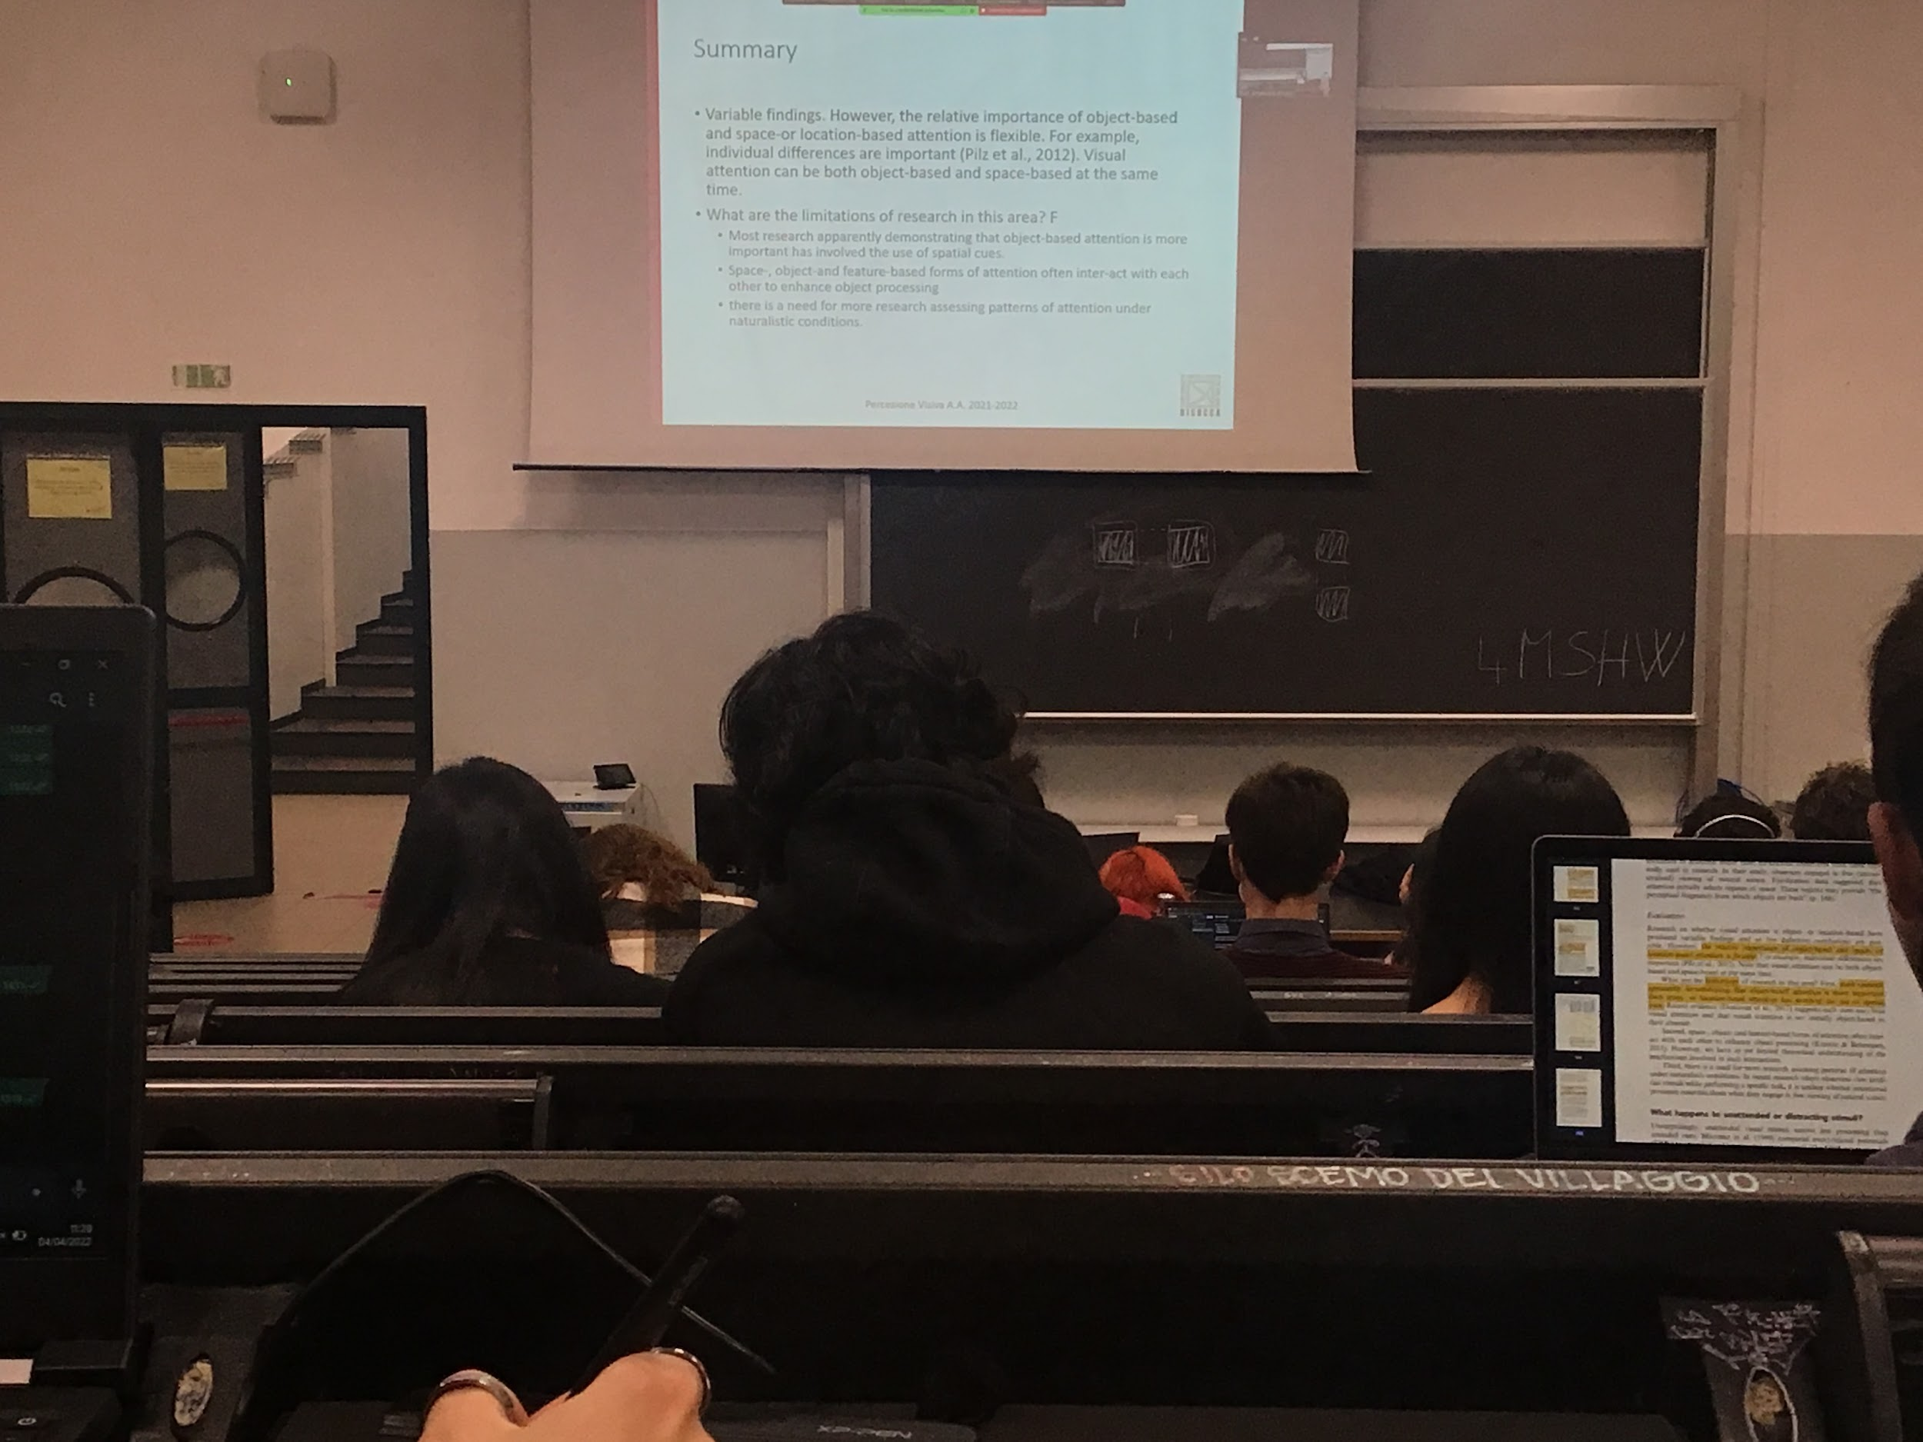

3 types of attention that interacts that we use dependly of what is our task and for what is important for us in that moment.

Limitations: most of the times we use spatial cue to define to move the attention.

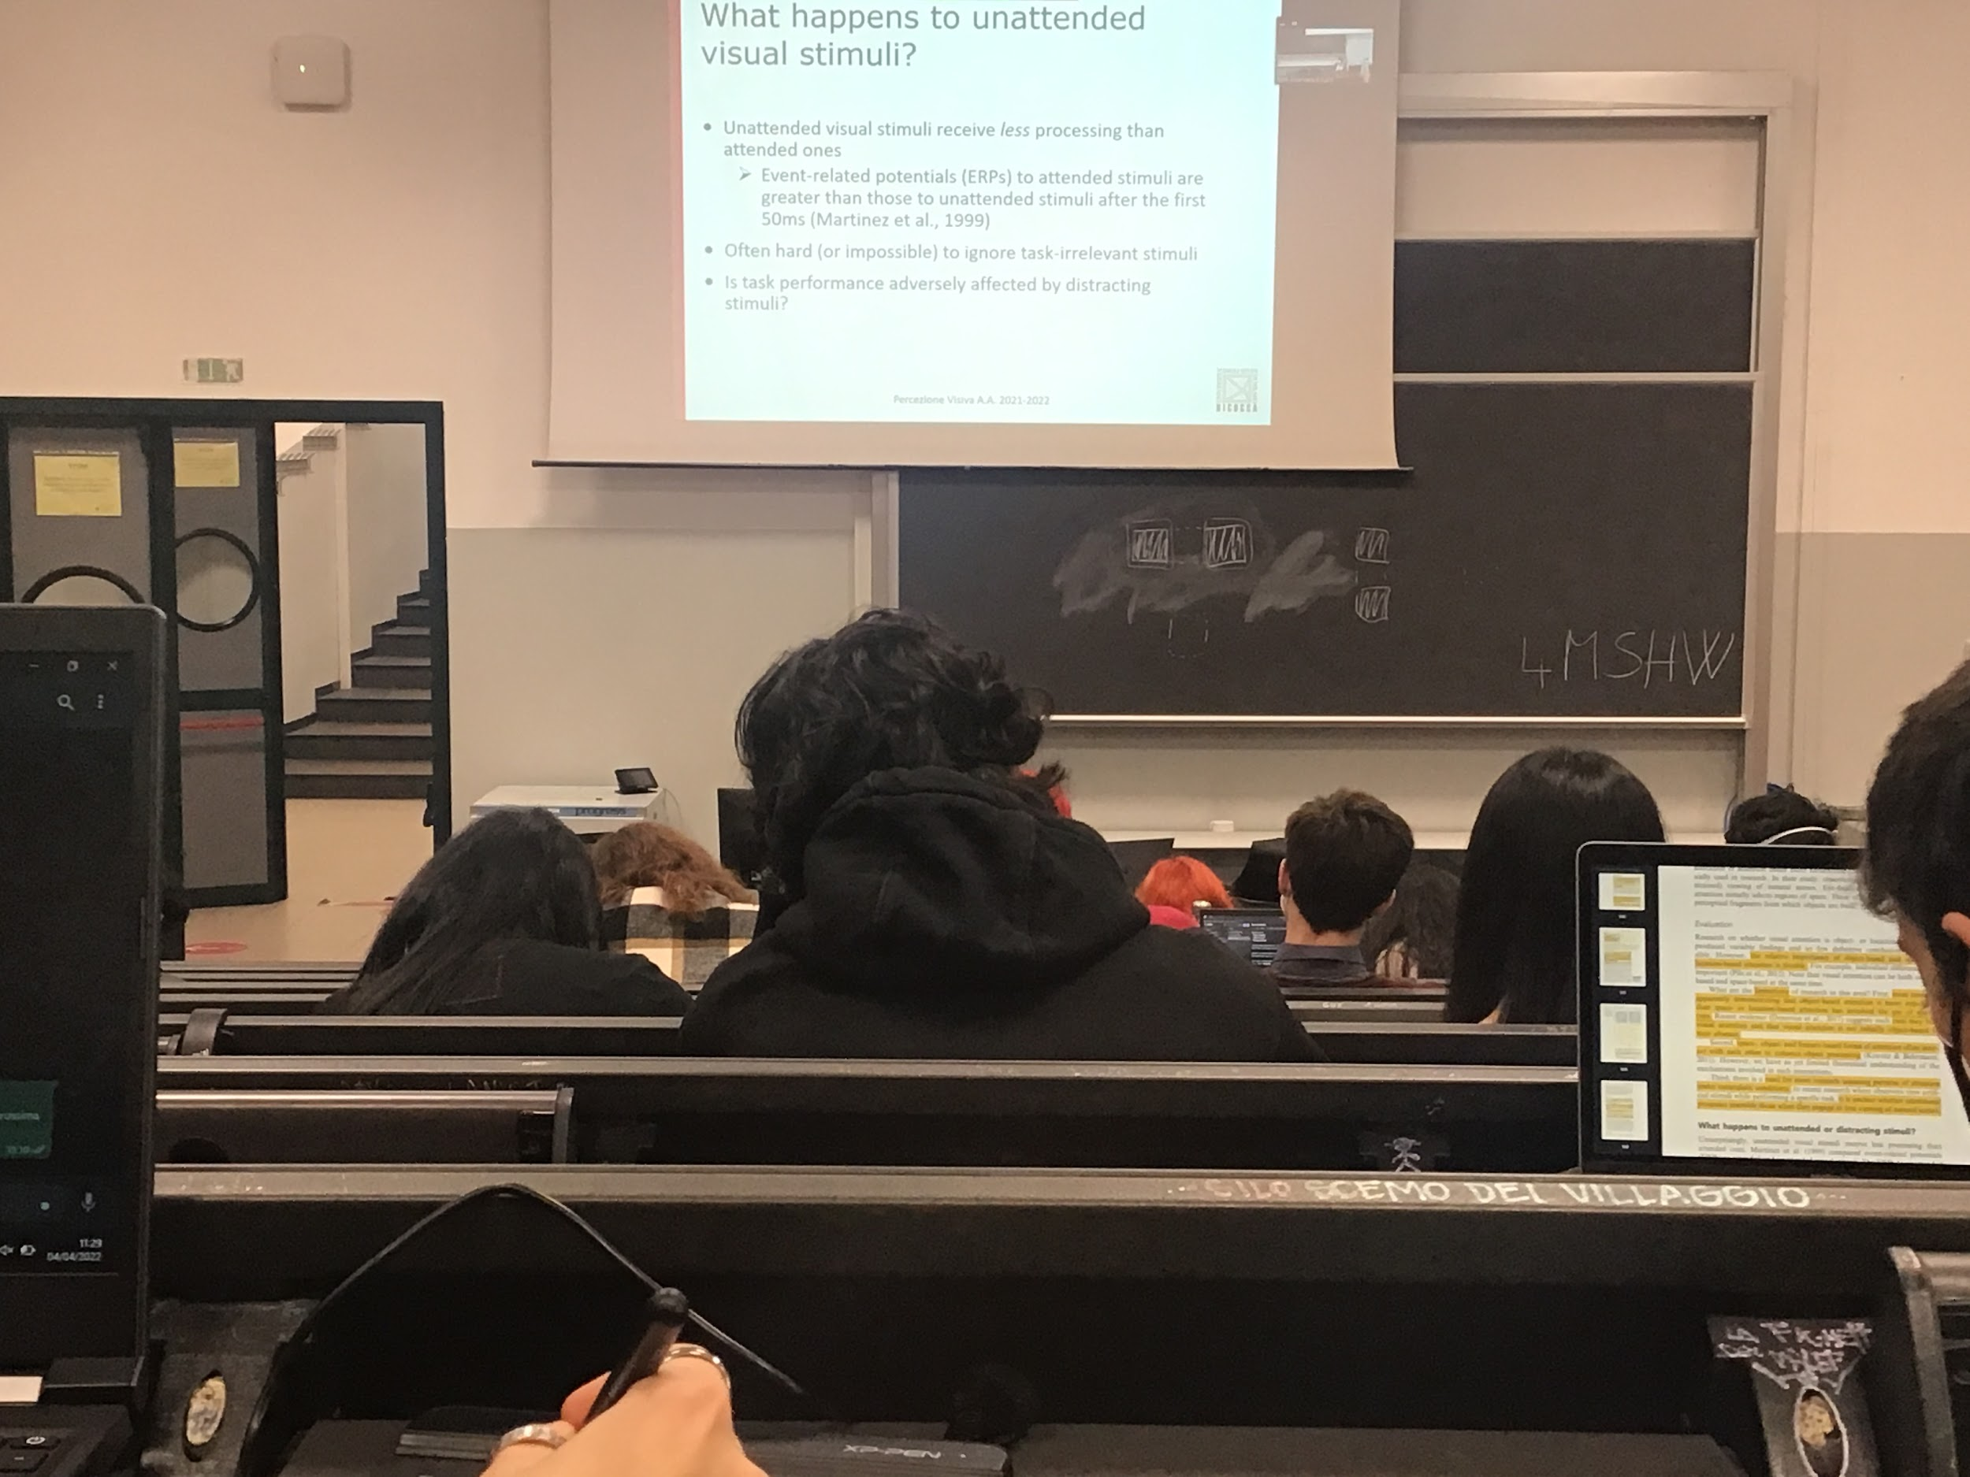

Unattended visual stimuli receive less resources, we don’t complete eliminate the informations but less resources dedicated to others parts

What we see is that in the first 15ms of computation the brain activity is more or less the same, all the early computation are done for all the stimulus. But after that there is definelty a difference between attended and unattend stimuli. We process much more the attended stimuli compared to the unattend stimuli

The unattended stimuli is coded is come way, even if it is very salient we will look to it even if we don’t want to. There are breakrules of informations

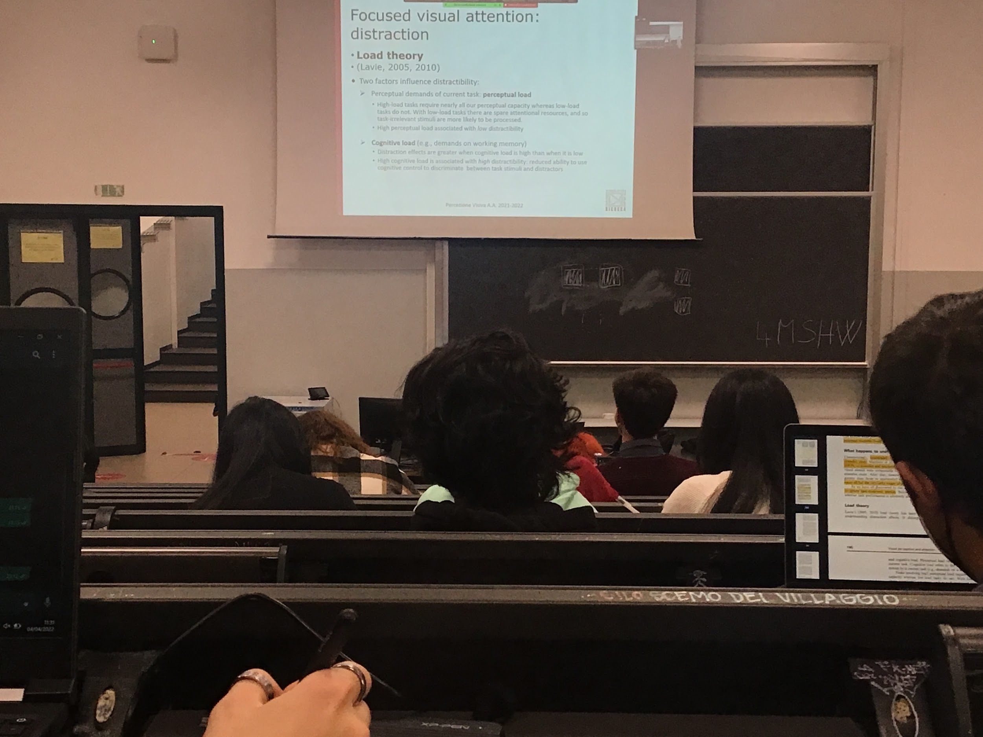

Load theory: theory that focus on how we deal with instructions and others informations that are not interesting for our task

We can be distracted by other stimuli, there are a lot of these stimuli, do the others objects present there create problems? We have to discriminate between two types of loads

The visual system have to make a representation of the object

Two different results according to Lavie, **when I have a high perceptual load task all my brain visual areas are computing the informations at maximum level**. I am not distracted by something else. If an image that I need to elaborate is very complicated all my resources have to be concentrated

Cognitive load: I am selecting what I am interested in

If I have to focus all my resources on deciding whether the object is correct or not then I cannot filter the distractors

I have to discriminate between perception and attention and the two different loads influences my perception

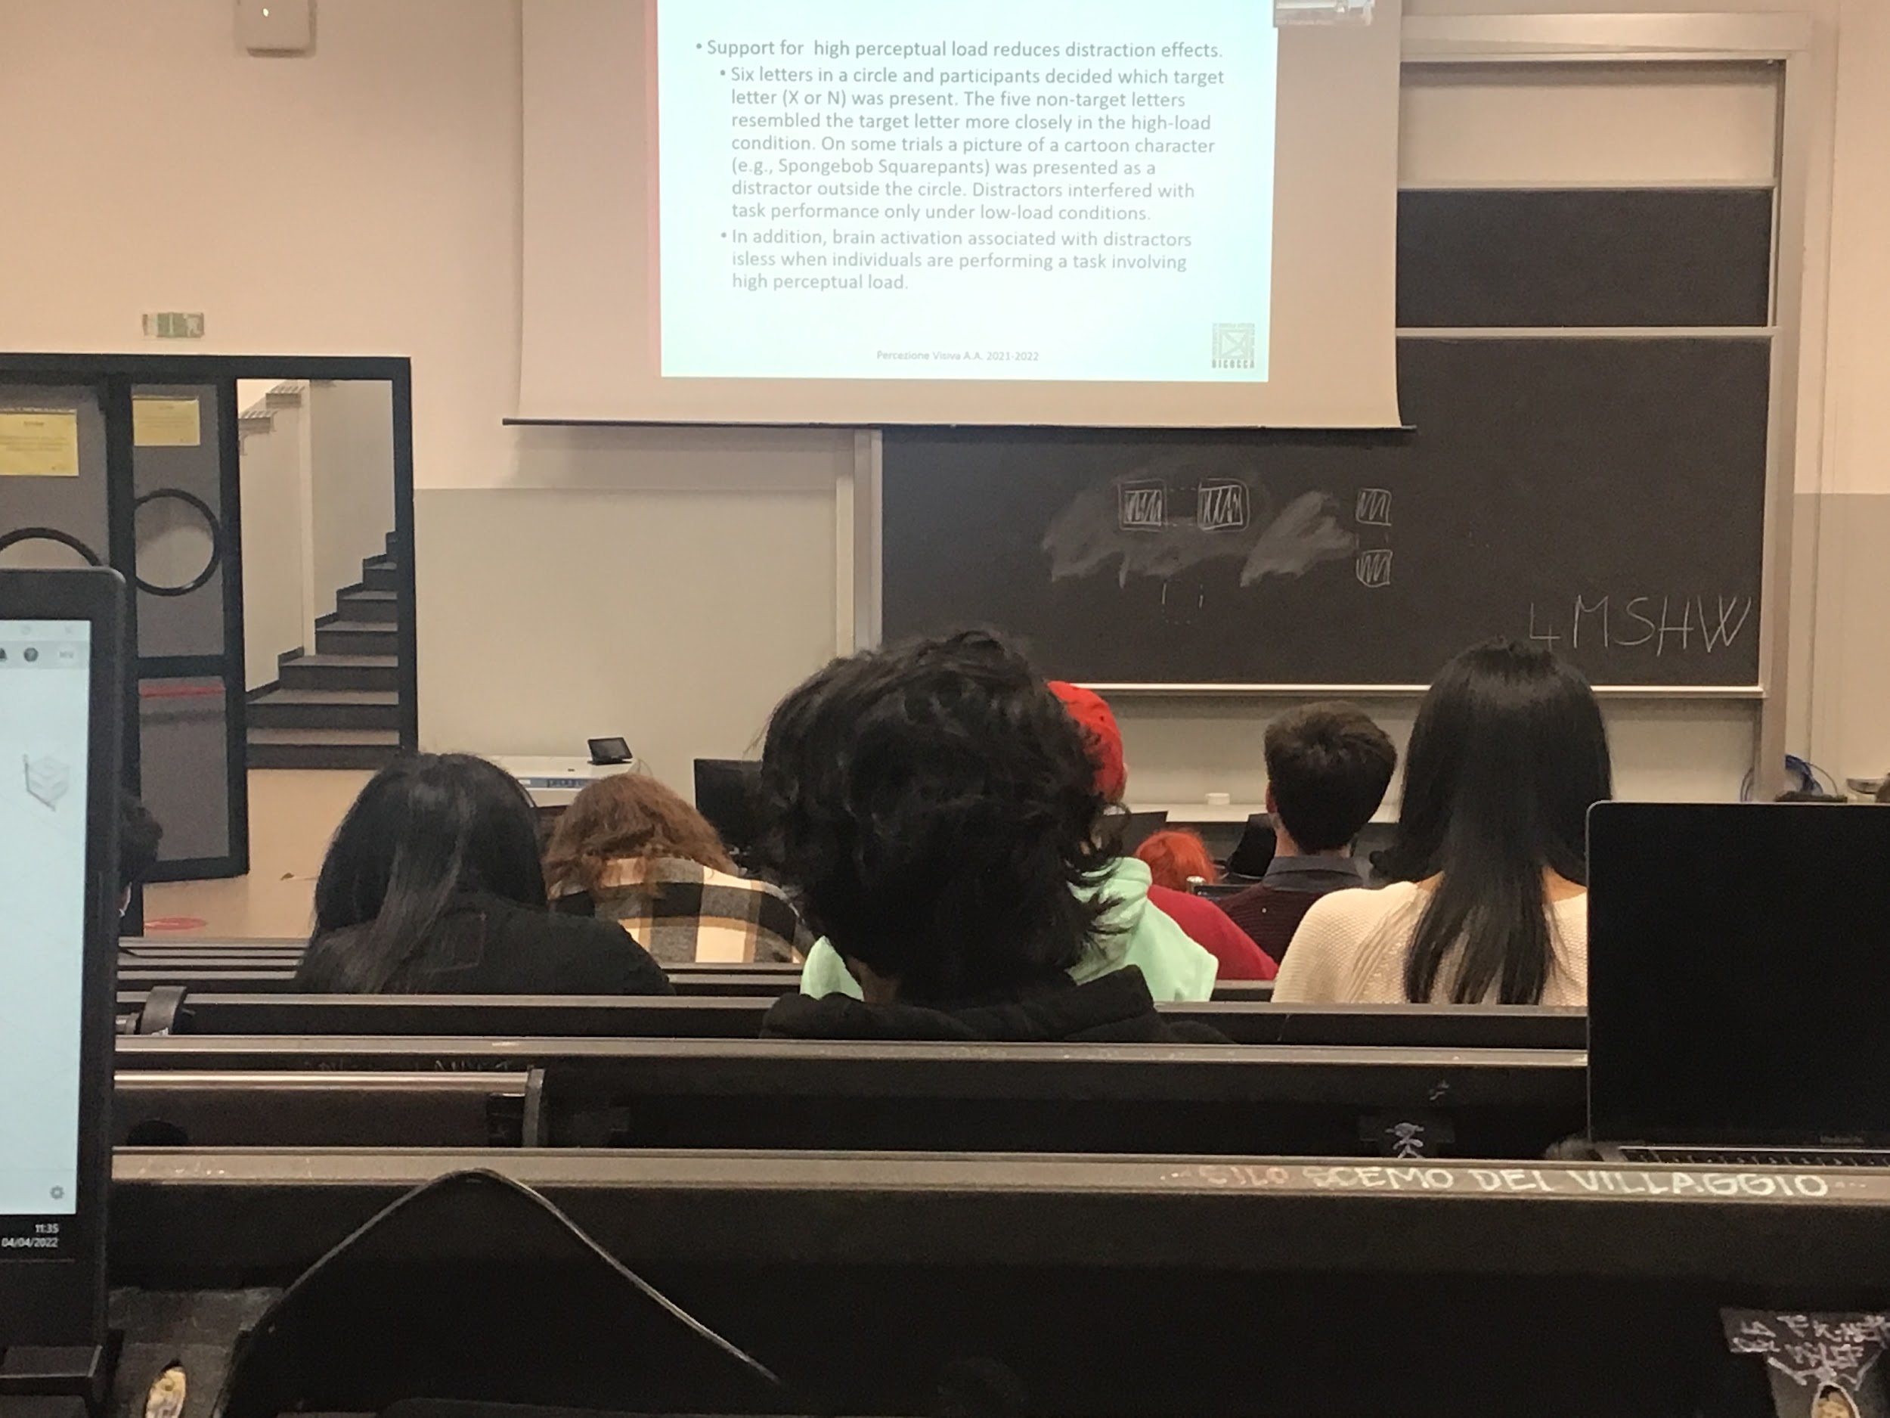

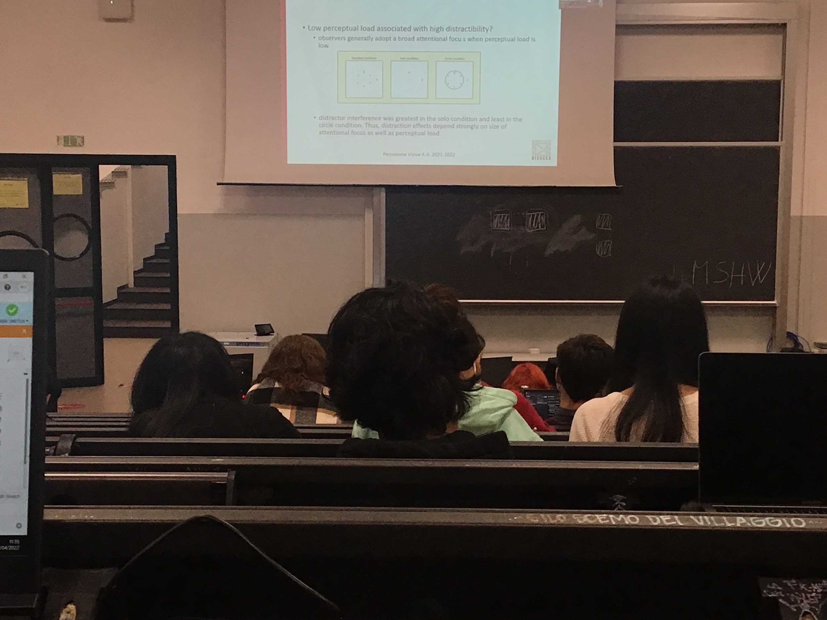

When the task is easy the high cognitive load reduces distraction, when it is hard it increased distraction

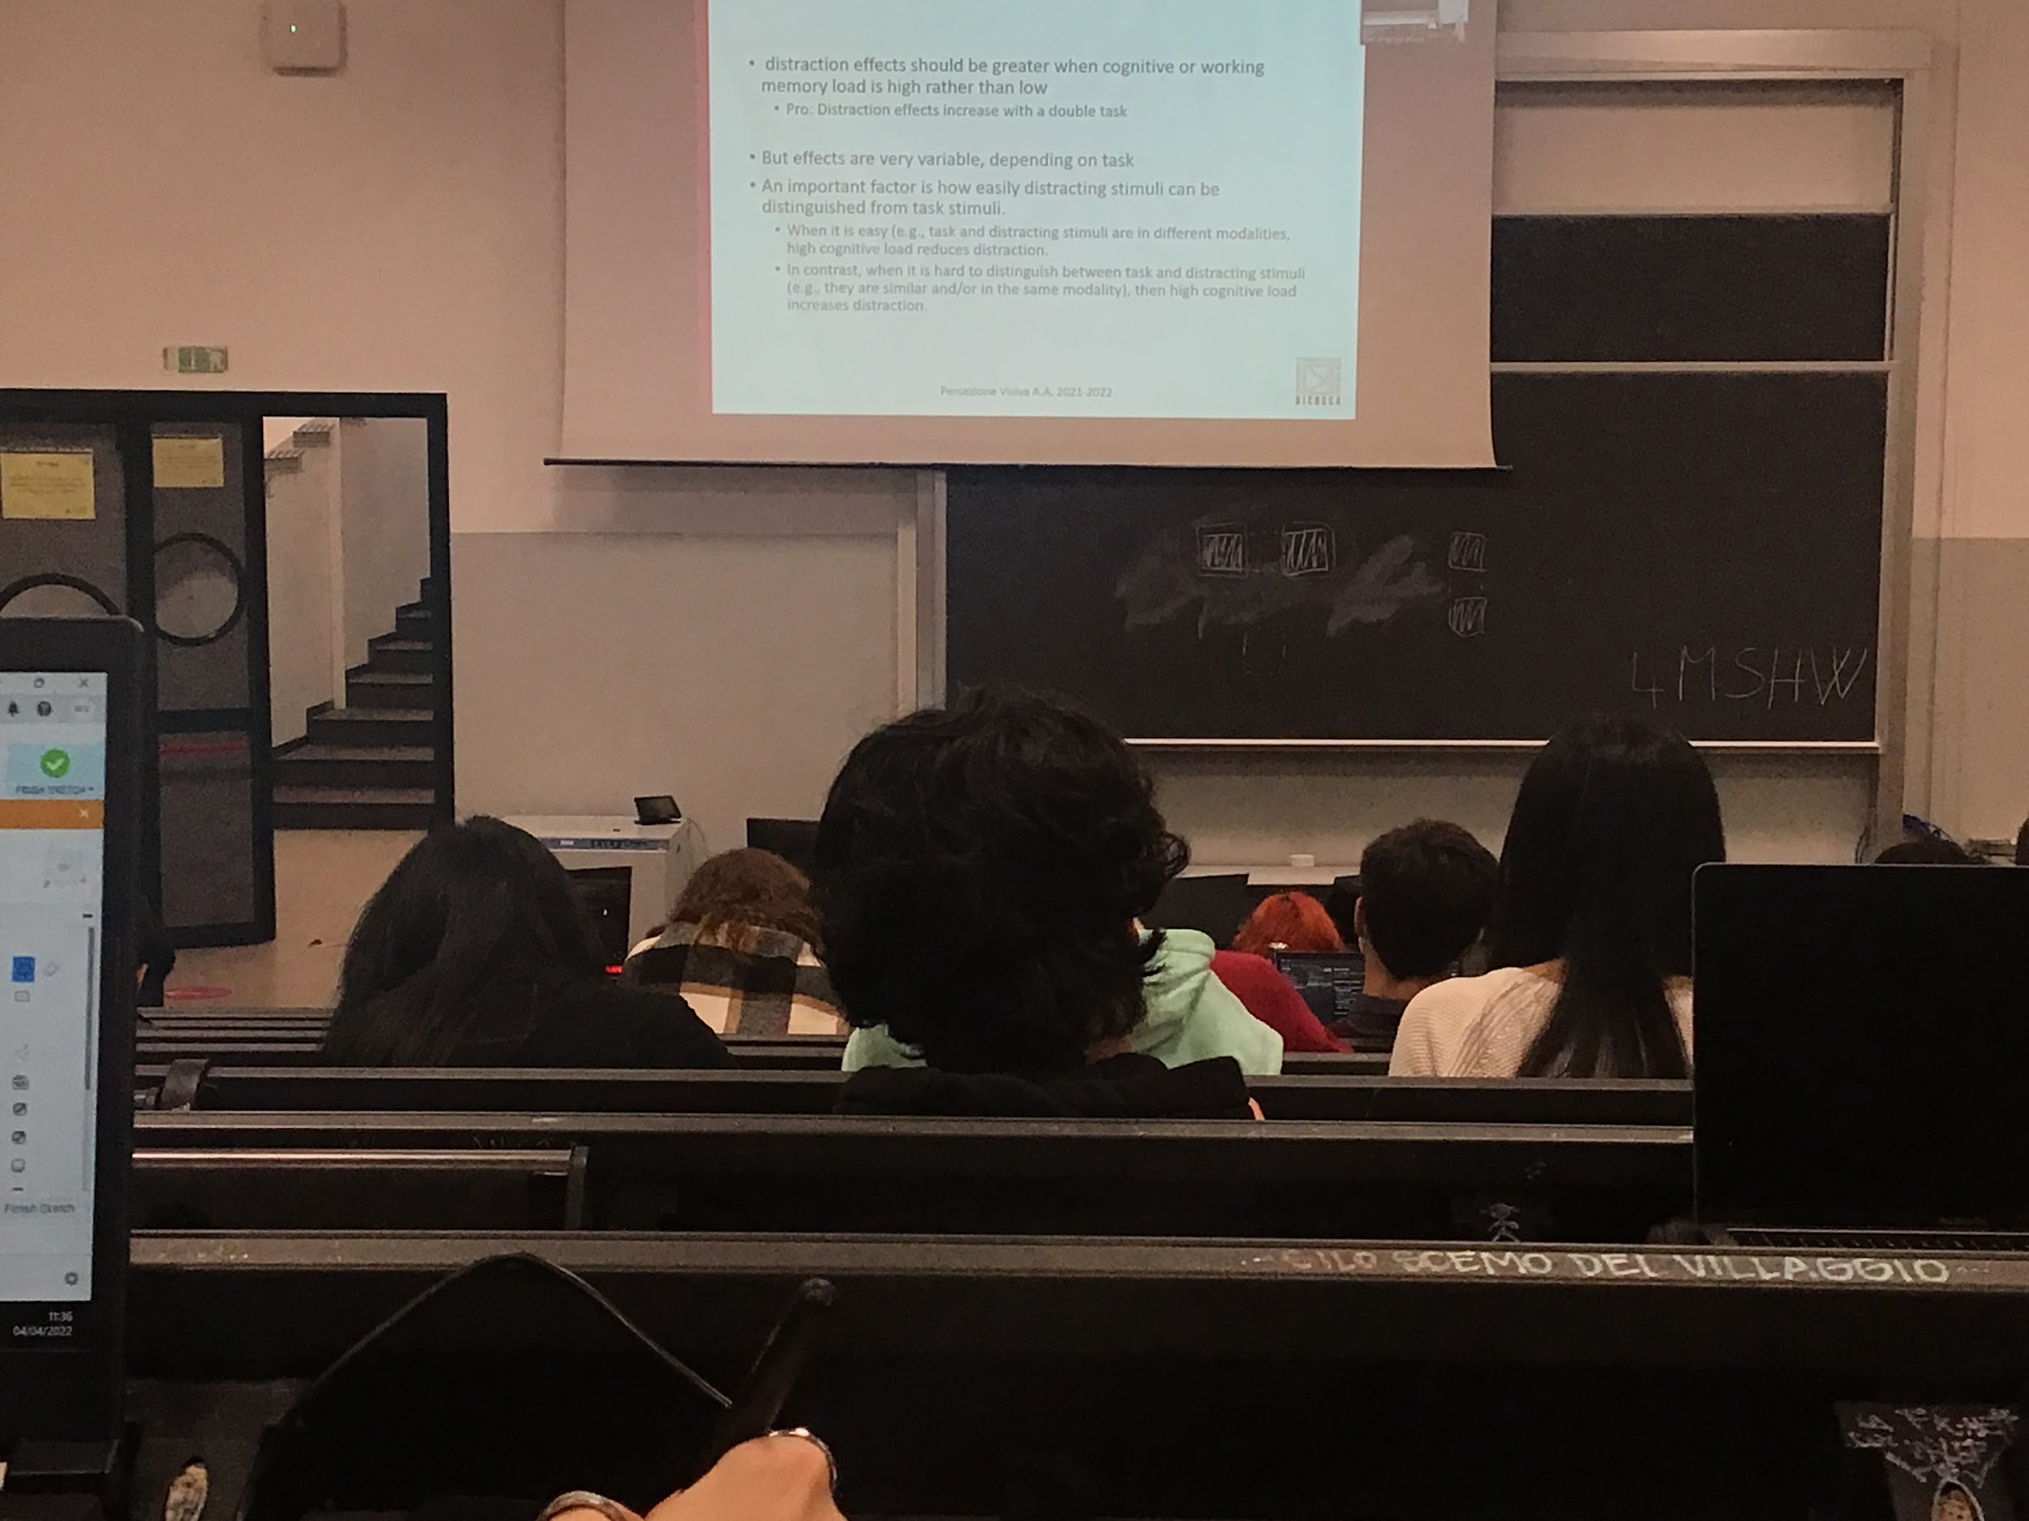

The perceptual load affect on perceptual process are automatic, the cognitive load needs control

Problem with this theory: Perceptual load and connive load very clearly defined, their implications are not clear, theory not perfect

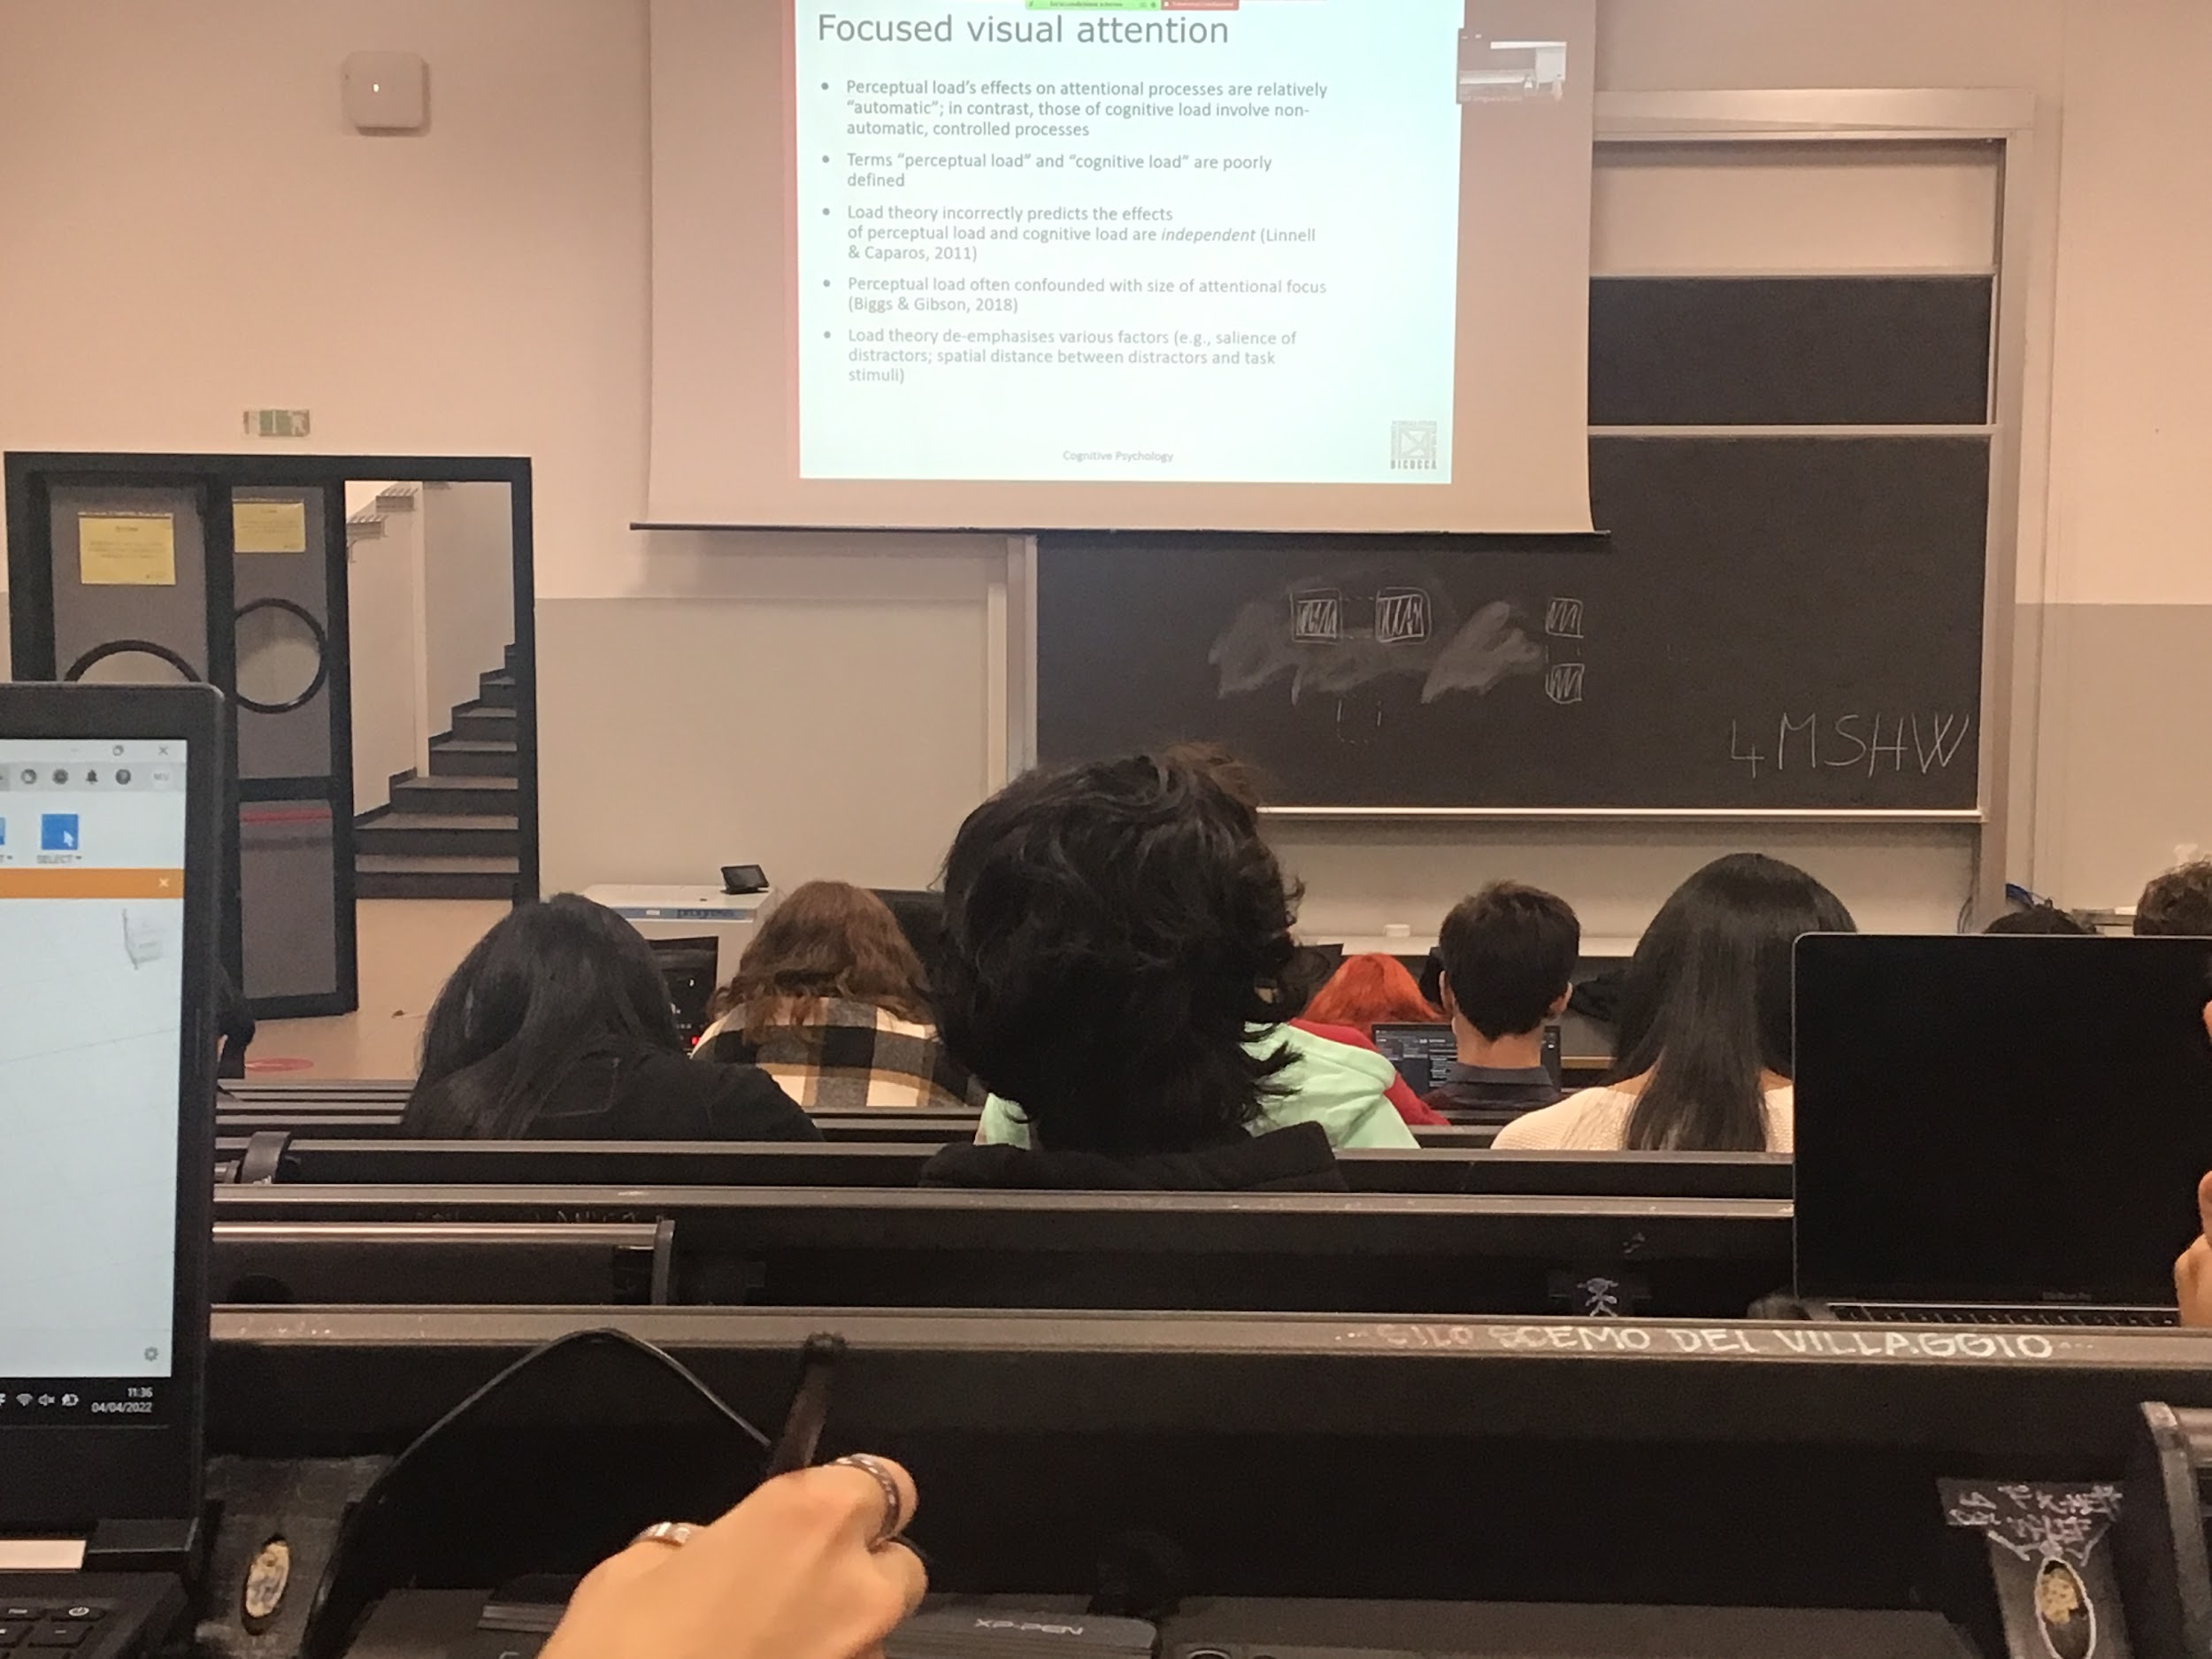

The problem is that perceptual load and cognitive load are not really define

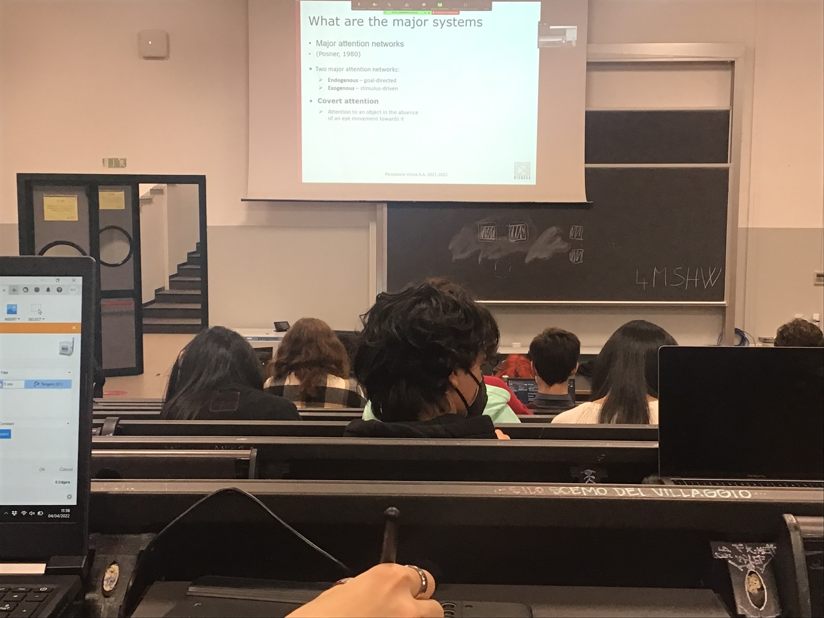

What are the brain areas dedicated to attention?

We have to focus on two major category of attention

* **endogenous**: with the poser paradigm. Attention that moves form the inside, asked to move our attention in a given position, voluntary attention. Voluranry moving our attention
* **Exogenous**: stimuli automatically attract attention to you

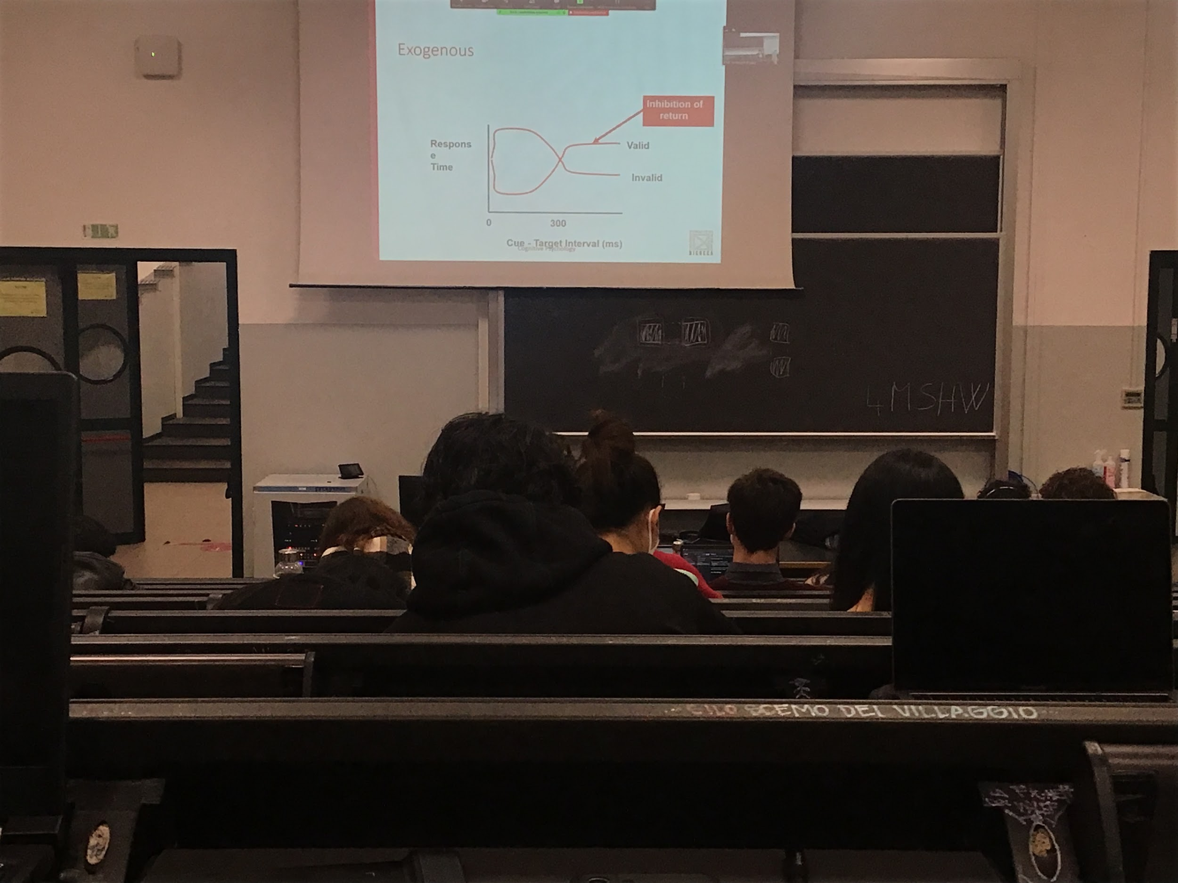

The difference between endogenous volounary and extrogenous automatic attention are many

* when you have to move (endogenous attention) depends on you and it takes time to decides where to look
* In the endogenous you can keep the attention forever. In the exogenous case you have inibition of return

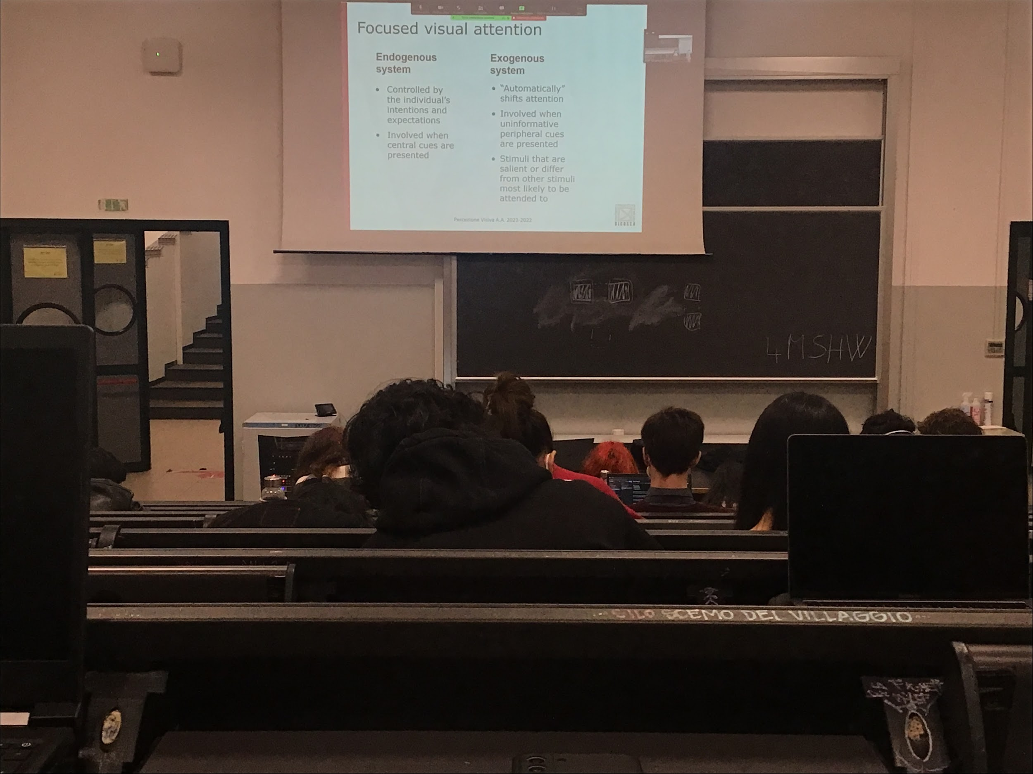

Two different types of attention that can induce in different ways in the poster paradigm

* **Endogenous system**: controlled by the individual intention and expectation, central cue are printed and have to be decoded
* **Exogenous system**: automatically shift attention, involved when peripheral cue are presented, stimuli that are salient and different from other stimuli (loud noise, flashing light…)

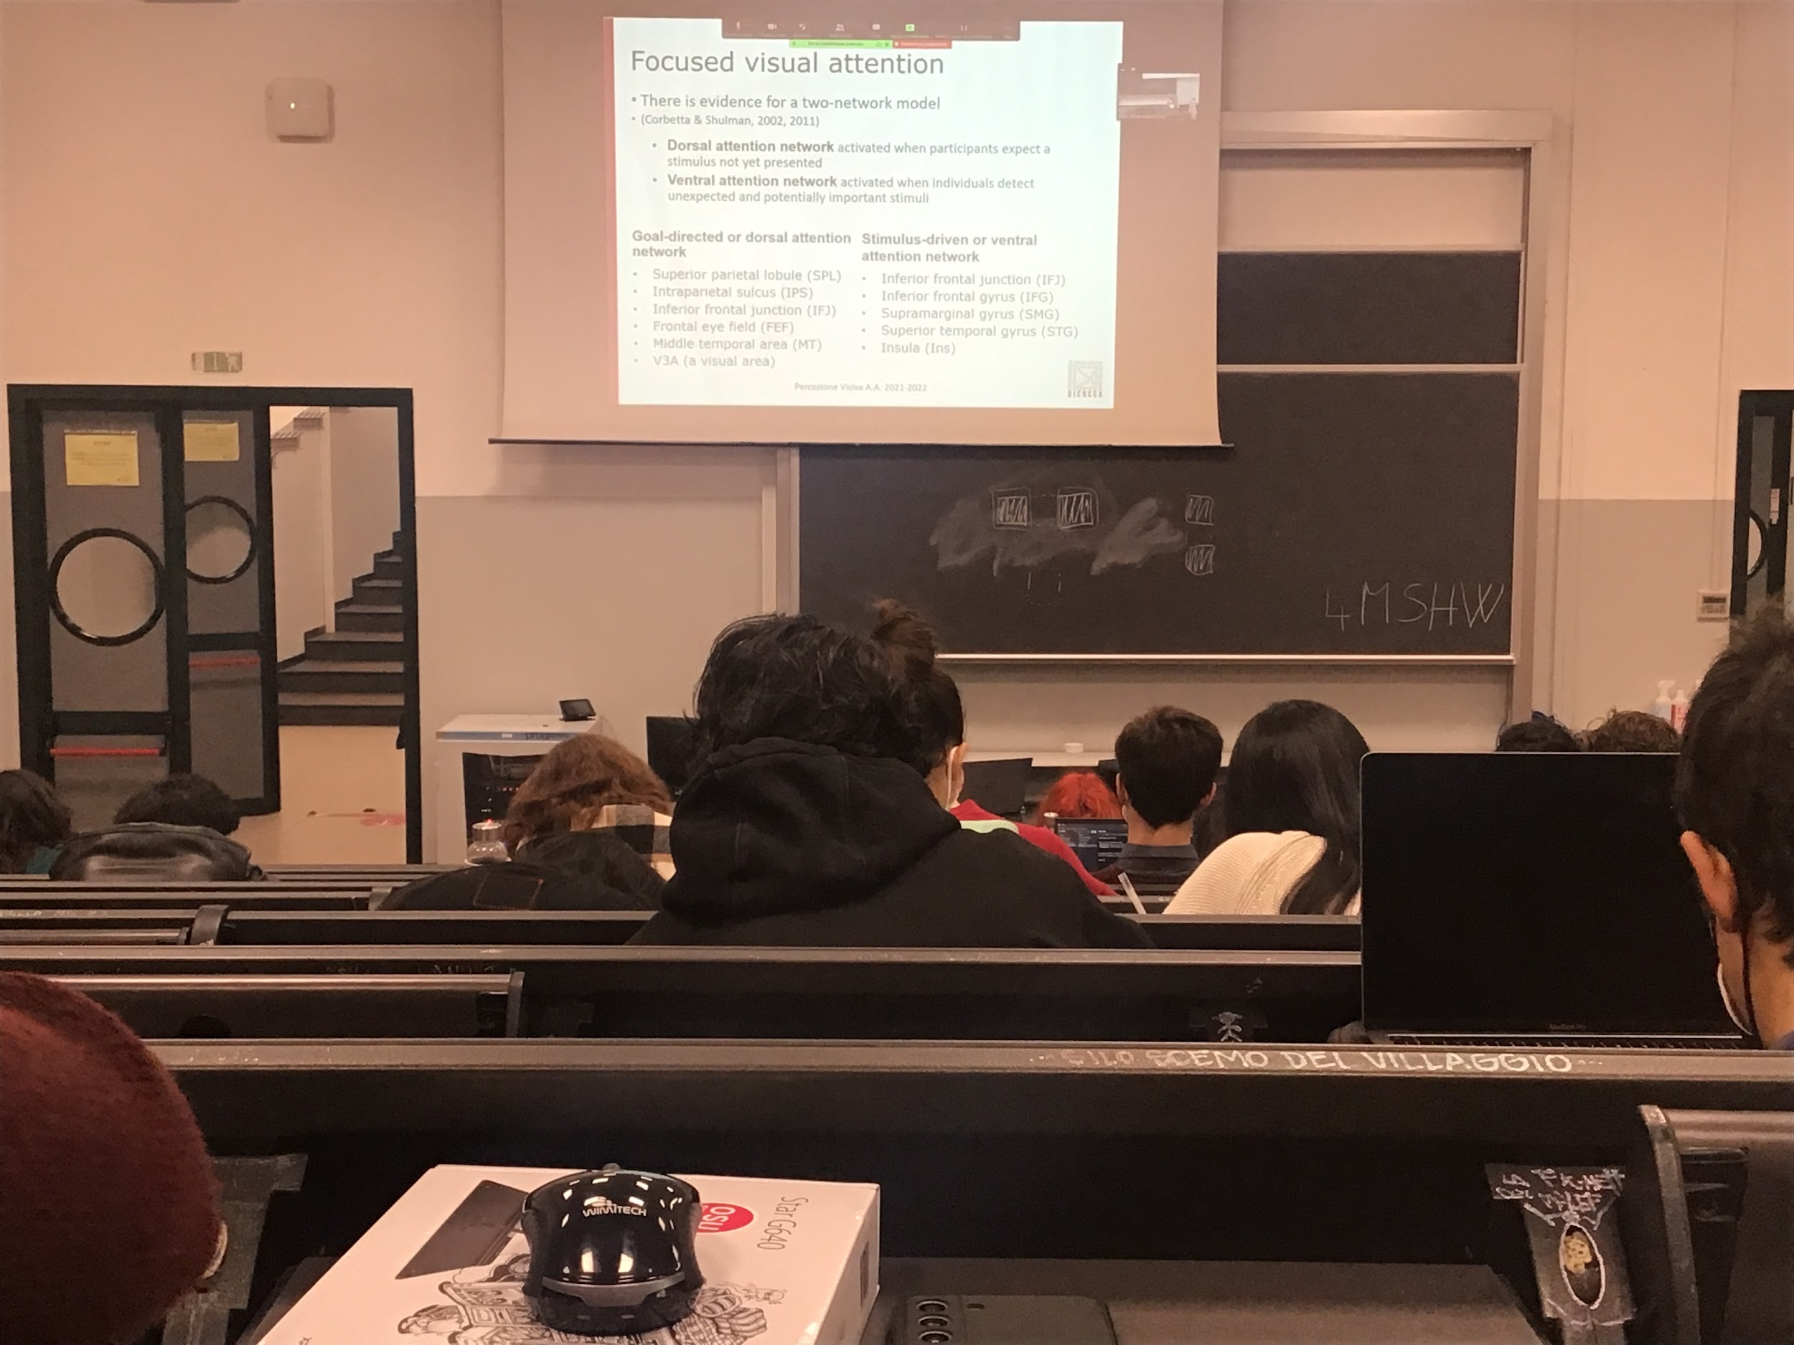

We see that there is evaded that these two types of attention actually are associated to two different group of brain areas

* Dorsal attention network: voluntary attention
* Ventral attention network: activated when attention is attracted automatically

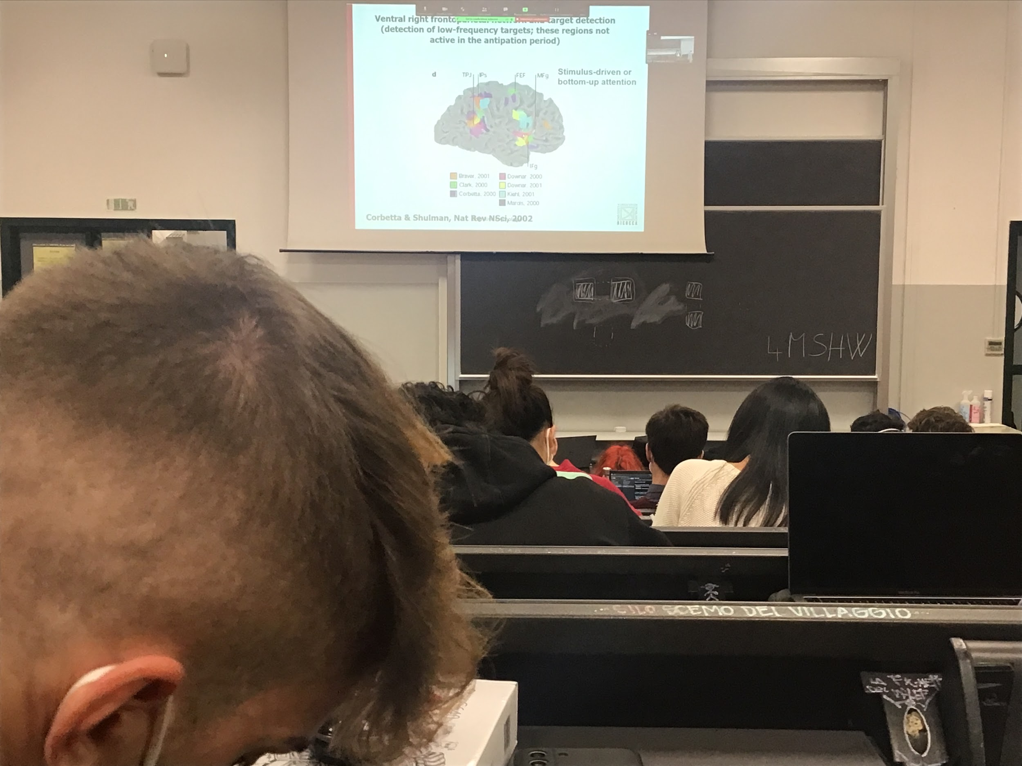

Different brain areas are active, two completely different sets that light up

These two types of attention are elaborated in different areas, the effect at the end is more or less the same

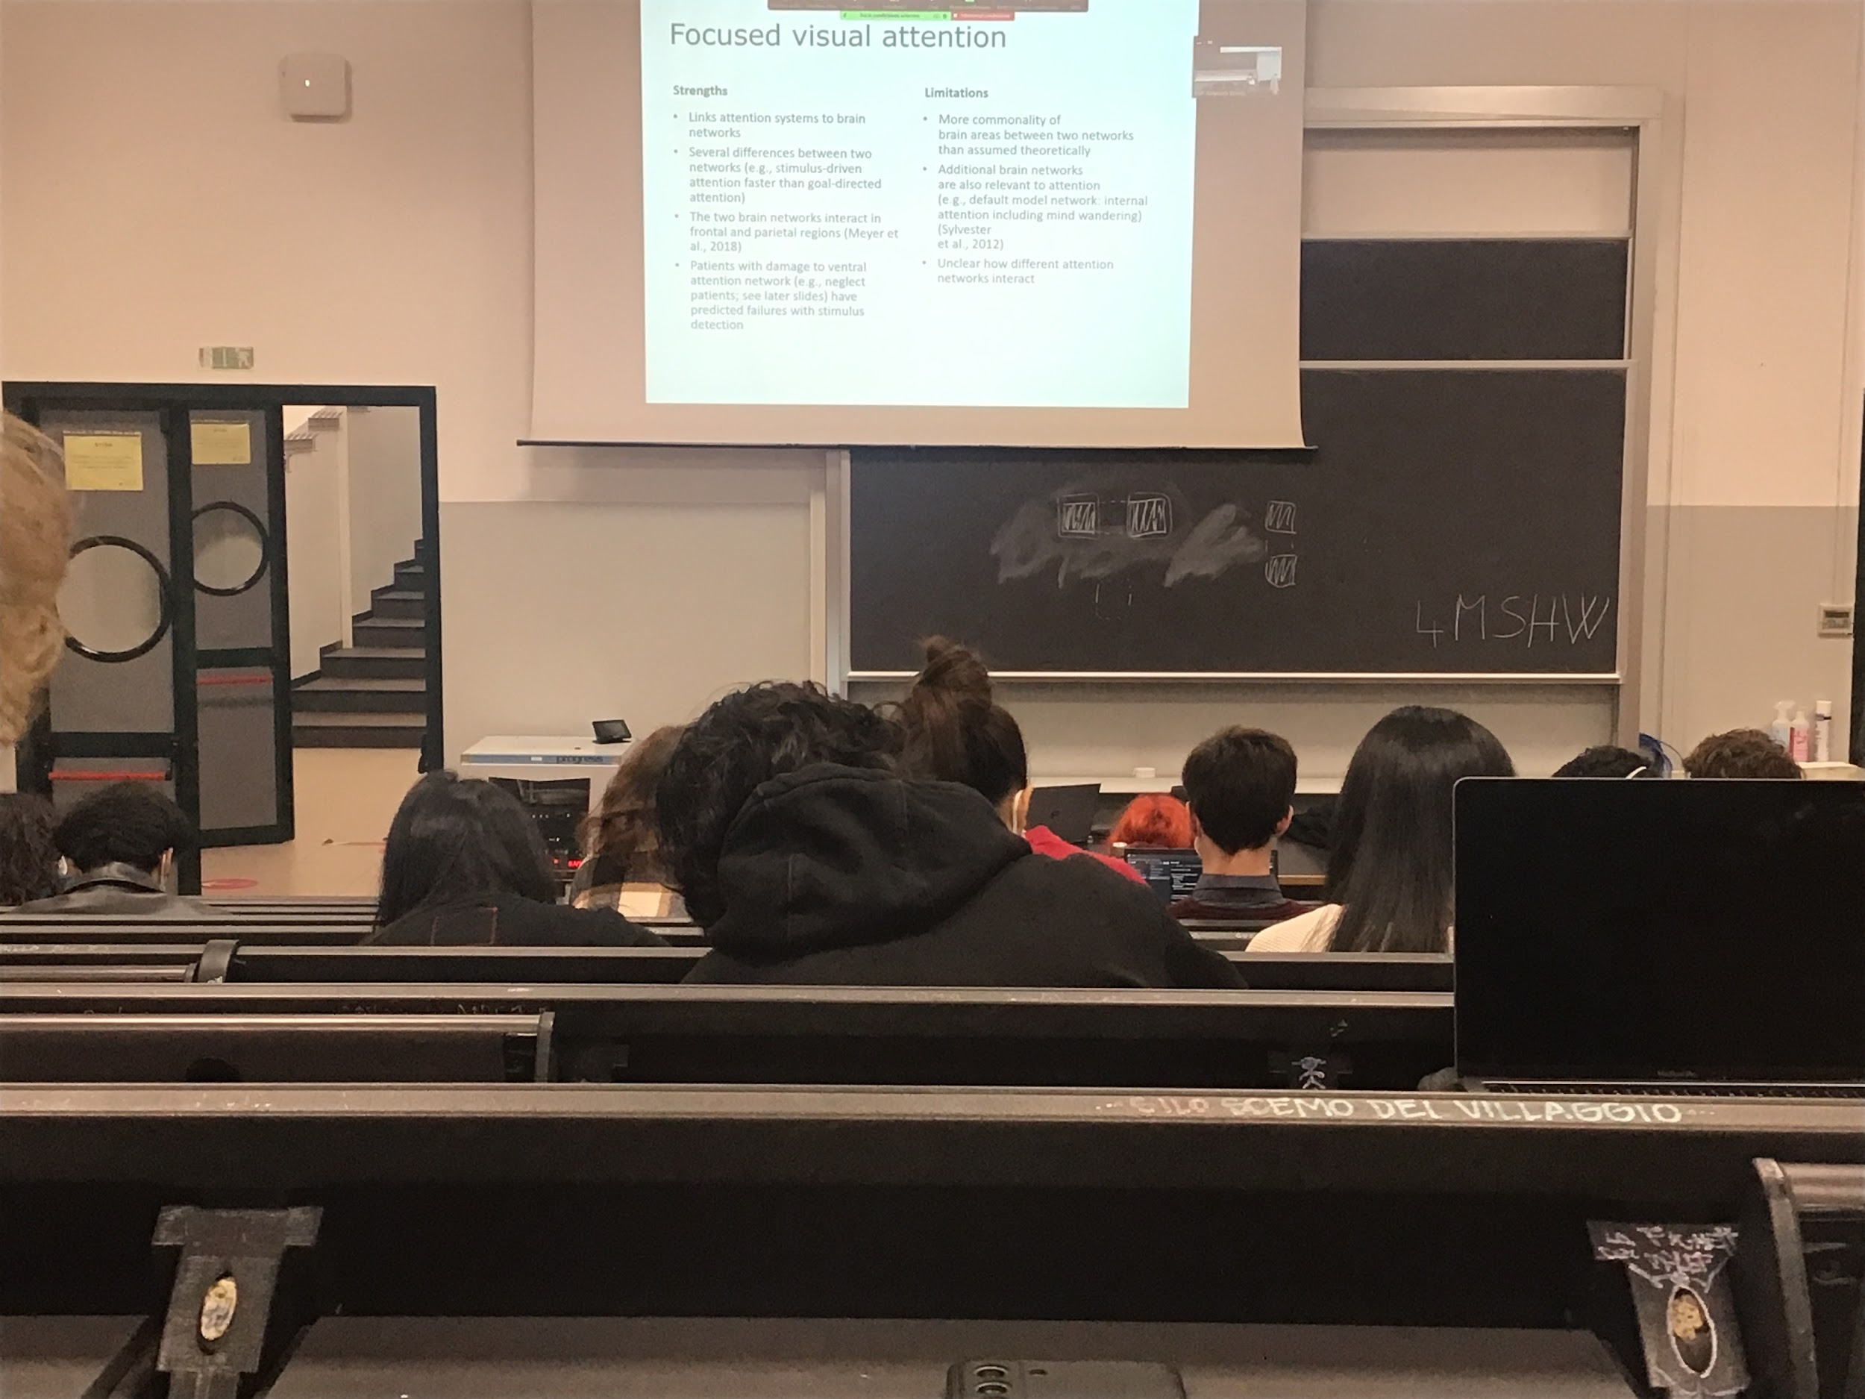

We do have focus visual attention, we have two different networks

There is some overlap between the two networks, some areas are active in both (the final goal is the same: select informations that are interested in)

Problem: the activity of the brain network is built up comparing activity in areas, but it **does not mean that the same neurons are active**, not sure that the common areas means that they are actually working the same neurons